S.NO. | Particulars | Page.No.
1.1 | Introduction | 2
2 | Spiritual wing
2.1 | Sadhan Camps | 5
2.2 | EHV Programs | 10
2.3 | AIP’s Visit to TN | 13
2.4 | Pavitra Parthi Yatra | 15
2.5 | SSSBPT-TN | 19
2.6 | Radio Sai initiative in Tamil | 20
3 | Service wing
3.1 | Prasanti Seva | 22
3.2 | Medical Camps | 25
3.3 | SSS Moblie Hospital camps | 34
3.4 | Disaster Management Programs | 36
3.5 | ROWL/ SRP PRograms | 42
3.6 | SSSRVTC | 44
3.7 | SSSVJP | 46
4 | Educational wing
4.1 | Quantitative Info reg. Balvikas | 55
4.2 | Qualitative info reg. Balvikas | 57
5 | Miscellaneous
5.1 | Activities at Sundaram | 89
5.2 | Activities across the State | 96
6 | Sri Sathya Sai Trust- Tamilnadu | 109
7 | Conclusion | 111

Introduction:
The Sri Sathya Sai Seva Organisation was founded in the 1960s by Bhagawan Sri Sathya Sai Baba to enable its members to undertake service activities as a means to spiritual advancement. The Sathya Sai Organisation derives inspiration, guidance and strength from Bhagawan Baba’s mission and message of propagating the truth of man’s inherent divinity, which is proclaimed and preached by all religions of the world. In consonance with this truth, the Organisation has as its main objective selfless love and service and is exemplified by the activities and service projects undertaken by the members of the organization. It’s a humble attempt to collate the colossal work done by the members of the Sri Sathya Sai organization, Tamilnadu which has given an opportunity to revisit, ruminate and revise our approach towards the projects undertaken with an objective to place our wholesome efforts at the Divine Lotus feet of our Beloved Bhagwan.

Statistical Information:
A. | CENTERS | Total Numbers | Total No. of members
 | SAMITHIS | 391 | 21980
 | BHAJAN MANDALIS | 429 | 7850
 | TOTAL | 820 | 29830

B. | SPIRITUAL ACTIVITIES | Total Numbers | Total No. Attended
 | DEVOTIONAL SINGING UNIT | 6578 | 70708
 | COMMUNITY BHAJAN CENTER / BHAJANS HELD | 540 | 61120
 | SEVEN HOUSEHOLD BHAJAN | 6578 | 70708
 | NO. OF CLUSTER / HOUSES / BHAJAN HELD
 | NAGAR SANKIRTAN | 4140 | 40300
 | STUDY CIRCLES | 912 | 14524
 | CONFERENCE / RETREATS | 23 | 2320
 | SADHANA CAMPS | 85 | 14530

C. | EDUCATIONAL ACTIVITIES | Total Numbers | Total No. of Students
 | BALVIKAS CENTERS : (i) URBAN | 1703 | 14357
 | BALVIKAS CENTERS : (ii) RURAL | 379 | 6801
 | BALVIKAS CENTERS : (iii) SCHOOL | 516 | 30962
 | BALVIKAS CENTERS : TOTAL (i+ii+iii) | 2598 | 52120
 | BALVIKAS GURUS: | 1643
 | B.V. GROUP 3 EXAM PASSOUTS – YEAR 2011 |  | 1373

D. | SERVICE ACTIVITIES | Total Numbers | Total No. of Beneficiaries
 | VISIT TO:
 | LEPROSY VILLAGE | 578 | 20740
 | CORRECTIONAL HOMES
 | ORPHANAGES
 | DISABLED / OLD AGE HOMES
 | HOSPITAL | 318 | 16875
 | CAMPS:
 | NARAYAN SEVA | 3657 | 381898
 | VETERINARY CAMPS | 6 | 2560
 | MEDICAL AWARENESS CAMPS | 691 | 61720
 | EYE CAMPS | 120 | 9494
 | BLOOD GROUPING CAMPS | 2 | 570
 | SERVICE CAMPS | 13 | 912
 | VOCATIONAL TR. CENTERS | 64 | 950
 | FREE COACHING CENTERS | 672 | 60700
 | MEDICAL CENTERS | 129 | 33010
 | DENTAL TREATMENT CAMPS | 3 | 321
 | NATIONAL NARAYAN SEVA | 917 | 46507
 | BLOOD DONATION CAMPS | 4 | 264

E. | STATISTICAL DATA | CURRENT PERIOD
 | NO. OF SLUMS / VILLAGES ADOPTED | 49
 | ADOPTED UNDER SSSVIP
 | NO. OF BENEFICIARIES | 10850
 | SSSVIP BENEFICIARIES
 | NO. OF SEVADALS GENTS:
 | GENTS: | 1728
 | MAHILA: | 1218
 | TOTAL: | 2946
 | NO. OF SECURITY SERVICE | 560
 | TRAINED SEVADALS (P.S. Members)
 | NO. OF REGISTERED YOUTH GENTS:
 | GENTS: | 2192
 | MAHILA: | 1448
 | TOTAL: | 3640

F. | YOUTH ACTIVITIES |  | NUMBER CONDUCTED | NUMBER OF PARTICIPANTS
 | Veda Recitation & Bhajan Training Class: | Gents | 197 | 731
 |  | Mahilas | 168 | 391
 |  | Total | 365 | 1122
 | Youth Study Circle: | Gents | 44 | 268
 |  | Mahilas | 58 | 187
 |  | Total | 102 | 455
 | Summer/Winter Course on Indian Culture & Spiritual: | Gents | 10 | 376
 |  | Mahilas | 7 | 313
 |  | Total | 17 | 689
 | Awareness Programme involving local Schools/Colleges: | Gents | 63 | 7695
 |  | Mahilas
 |  | Total | 68 | 12403
 | Disaster Management Programs | Gents | 151 | 12455
 |  | Mahilas
 |  | Total | 172 | 17639
 | SRP PROGRAM | Gents | 5 | 99
 |  | Mahilas
 |  | Total | 5 | 99

2.1 Sadhana Camps:

The state of Tamilnadu has been given the opportunity to perform Parthi Seva thrice in a calendar year. March 15th to March 31st, May 1st to May 15th and from October 15th to November 15th. The state conducts a series of Sadhana camps exclusively for the sevadals who have volunteered to do Parthi Seva prior to the Parthi seva period every year in all the Sai districts of the state. The camps are organised separately for gents and mahila sevadals in each of the Sai districts in Tamilnadu.

Objective of the Training / Sadhana Camps:

- To emphasise the importance of Parthi Seva.
- To explain the various service opportunities and requirements at different duty points and / or sectors.
- To elaborate the rules and regulations to be followed by the volunteers during the period of Parthi seva.
- To encourage the new devotees/ members/ youths to take part in the Parthi Seva.

Apart from the above Sadhana Camp a one and half day intensive workshop was organised across all the districts of Tamilnadu entitled “SAI SANDESAM” with three basic purposes -
- Assessing the progress of the organization in the District.
- Aspiring to expand the Sai movement in the District., and
- Actualizing the Sai activities with renewed commitment, Zeal and enthusiasm.
Accordingly, the schedule was charted out for the one and half day program which will encompass all the facets of the Sai organization. The first day would be presentations from the district office bearers and Samithi conveners regarding the various projects that is being implemented in their respective Districts and / or Samithis.
On the second day the state office bearers would showcase the various projects that is being announced by the organization and its effective way of implementing the same in the District. Accordingly, the schedule has been drawn up to accommodate the aforesaid points-

Day 1: Saturday
2.30 Pm | Meeting with Office Bearers of the District | Topic
 | Update and action taken by the district | Sai one
 | Submission of Reports by individual samithis | Conveners
5.30 Pm | Drawing up plans for implementation w.r.t various wings of the org.
 | Status of the adopted village and a short | SSSVIP
 | Identifying School Drop Outs for RVTC | SSSVIP
 | Current status and efforts to increase the no. of BV Units | DEC
 | Nagar sankirtan, Narayan Seva, Bhajans, & Vedam Training | Spiritual
 | Medical Camps, Visit to Orphanages, other service projects | Service
 | Conducting Various training programs incl Vedam | Educational
7.30 PM | Status of various Projects
 | Current status | SSSVJP
 | Current status | SRP
8.30 PM | Dinner
9.00 PM | Disaster Management- Ways and means to influence the youth into our Org

Day 2: Sunday
8.30 AM | Flag Hoisting
9.00 Am | Bhajans
9.30 AM | Service Wing
 | Introduction and Induction of New Sevadal Members
 | Discipline, Duty and Devotion
 | Importance of Seva - Building the Right attitude
11.30 AM | Educational Wing
 | Training modules for existing and prospective Gurus
 | How to conduct an Effective BV Class
 | To increase BV centers and the no. of gurus from the BV parents
 | Available alternatives to enhance Edu wing.
01.30 PM | Lunch
02.30 Pm | Spiritual Wing
 | Bhajan Vikas
 | Veda Vikas
03.30 Pm | SSSBPT initiatives
 | increasing the subscriber base of SS
 | Increasing the circulation of Sai Literature
04.30 Pm | Unveiling the District Projects
 | To increase the number of Bhajana Mandalis in the District
 | To increase the participation of Active workers
 | To Increase the number of members in the organization
 | To Upgrade the existing BMs to Samithis
05.15 Pm | Maha Mangala Aarthi

Almost all the districts of Tamilnadu conducted the above program starting from the month of March and concluded it in the month of June 2017.

Objectives of "Sai Sandesam":

1. To gauge the current position/ performance of various samithis in the district.
2. To inspire the Samithi conveners to embark on the state initiatives if not done earlier.
3. To showcase the various available avenues and increase the participation of samithi members in the various projects of SSSSO.
4. To make sure that all the samithis expand their current activities and inspire to adopt/ embark on State/ National level projects.

Points deliberated during the “Sai Sandesam” workshop:

1. To highlight the current contribution of Chennai South district. Being the largest district and having state headquarters in their zone, the participation from all the samithis in general and samithi members in particular becomes absolutely essential for the performance of the state in all parameters.

2. The movement of Sai organisation depends heavily on the performance of Sai devotees/ members of the samithi. Hence each and every member should be aware of the State initiatives and national projects. Members should be ready to embrace any new initiative and contribute their might.

3. The all-round performance of SSSSO in various projects is very essential to the development of the district and of course the State.

4. The youth strength has to be increased by devising appropriate projects like SSSVJ, DM and create opportunities for all the youths to participate/ lead the projects as project heads. This will enhance their participation and develop a sense of belonging to the organisation (Job satisfaction).

5. The mahila vibagh should be encouraged to engage themselves in SSSNNP, Temple cleaning, taking BV classes and last but not the least conducting regular Bhajans at home and at Samithis.

6. Bhajan Vikas and Veda Vikas have become increasingly significant to improve the quality of our rendering and this in turn would attract more crowds.

7. Conducting regular community Bhajans at Public places would definitely reach the masses and would in turn entice the visiting audience to join us.

8. Our motto of "Transforming ourselves to transform the world" should not be forgotten. Every passing day should make everyone feel that we are one step closer to our Lord and have gained spiritually.

Apart from the above, we had conducted the Sadhnana camp on Nine-point code of conduct for all the District presidents’ and state level office bearers on 20th and 21st January 2018 at Sundaram, Chennai.

As per the Guide lines given by the All India President, SSSSO, Tamilnadu Conducted Sadhana Camp for all the District Presidents, State level office bearers, Trustees of Sri Sathya Sai State Trust & Sri Sathya Sai Books and Publications Trust of Tamilnadu and one or two District Coordinators (Youth) per District totalling 78 attended on 20th and 21st of January 2018 at Sundaram. It was one-and-a-half-day program. 3 District Presidents missed the opportunity of attending the Camp due to unavoidable reasons but their representatives attended the camp.
On the First day of the camp, Nine Point Code of Conduct was taken up as a theme and all the divine codes were discussed thoroughly. Each and every point was assigned to a team of District presidents and State level office bearers. After a thorough preparation all the teams projected and explained their assignments well and were moderated by the State Youth Coordinator.
In the Key note address and at the summarization session, National Vice president and State President explained the importance of following the Divine Codes and insisted all the District office bearers and SLOBs to be the role model for the samithi level office bearers and Members.
The second day program was started with Omkaram, Suprabatham and Nagara Sangeerthanam and almost all the participants of the camp attended. Dr.V.Mohan shared with the participants some of the important points about State Trust activities and also delivered general health tips to the participants.
State President emphasized about extending the same Schedule of the Sadhana Camp in the District level and is to be Completed in all the Districts before March 2018.
All the District Presidents gave the Scheduled date for their District level Sadhana Camp before the end of the meeting.
The Sadhana Camp concluded with Maha mangala Aarathi to Bhagawan.
Subsequent to the successful completion of the Sadhana Camp on 9 PCC for the Dp’s and SLOB’s, similar camps were conducted at the district level so as to percolate the content to all the District level office bearers and Samithi Level office bearers. Accordingly, the sadhana camp on Nine-point code of conduct were conducted at various districts as per the enclosed table-

District wise Sadhana camp
Sl. No | District | Date | Presiding DP/ | SLOB
1 | Madurai | 04-02-2018 | DP- Chennai East/ DP-Dindugul
2 | Tirupur | 04-02-2018 | DP- Erode | NVP
3 | Trichy | 04-02-2018 | Kanchi South
4 | Theni | 18-02-2018 | DP - Cudddalore
5 | Coimbatore | 18-02-2018 | DP- Kanchi North, DP - Tiruchi
6 | Tanjore | 18-02-2018 | DP- Nagai
7 | Tuticorin | 18-02-2018 | DP- Kanyakumari
8 | Dindigul | 18-02-2018 | DP -Madurai
9 | Vellore | 18-02-2018 | DP - Tiruvallur
10 | Nagai | 25-02-2018 | DP - Tanjore
11 | Chennai North | 25-02-2018 | DP - Theni | Sri.Bhoopal
12 | Kanchi North | 25-02-2018 | DP -Coimbatore
13 | Kanchi South | 25-02-2018 | DP-Chennai West
14 | Tiruvellore | 25-02-2018 | DP- Vellore | TNSP
15 | Salem | 25-02-2018 | DP-Tirunelvelli | TNVP
16 | Kanyakumari | 25-02-2018 | DP- Virudhunagar
17 | Cuddalore | 25-02-2018 | DP - Pondicherry
18 | Dharmapuri | 04-03-2018 | DP Nilgiris
19 | Chennai south | 04-03-2018 | DP-Villupuram | TNSP
20 | Chennai East | 04-03-2018
21 | Erode | 11-03-2018 | DP-Salem
22 | Tirunelveli | 11-03-2018 | DP- Tuticorin
23 | Villupuram | 11-03-2018 | Dp - Chennai South
24 | Virudhunagar | 11-03-2018 | DP- Dharmapuri
25 | Namakkal | 11-03-2018 | DP- Tirupur | TNVP
26 | Chennai west | 18-03-2018 | DP-Tiruchi | NVP
27 | Pondicherry | 18-03-2018 | DP- Chennai North
28 | Nilgiris | 18-03-2018 | DP-Namakkal
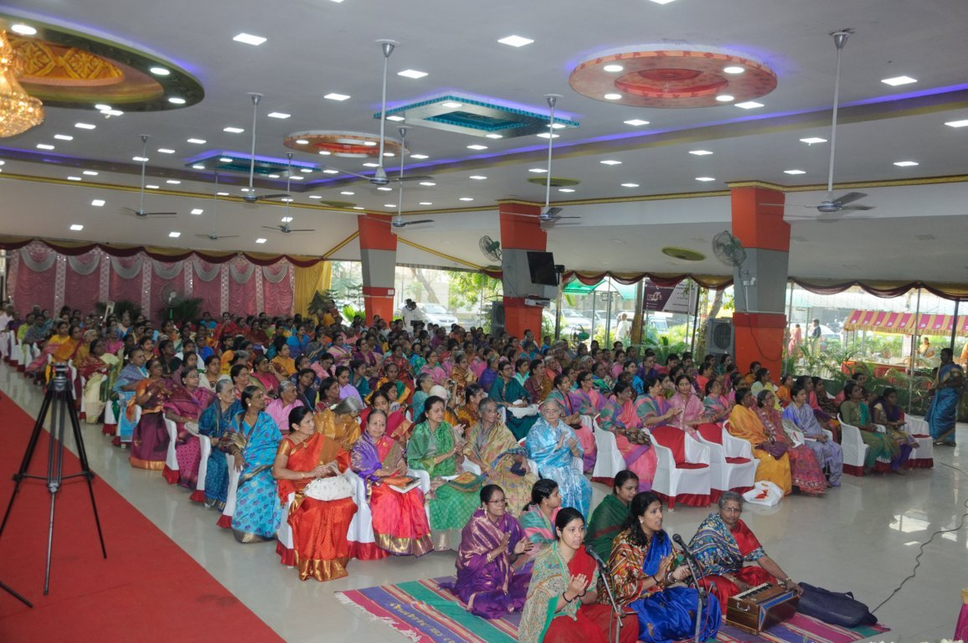
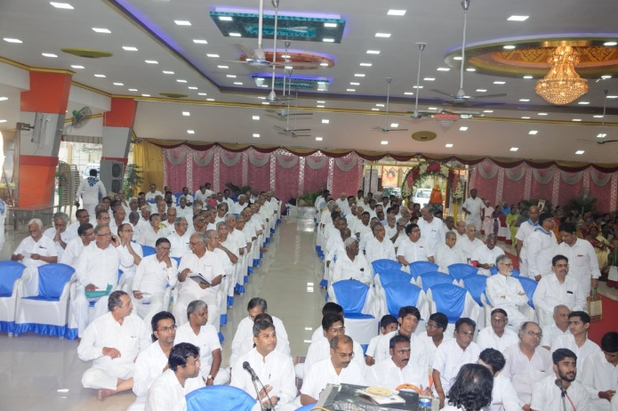
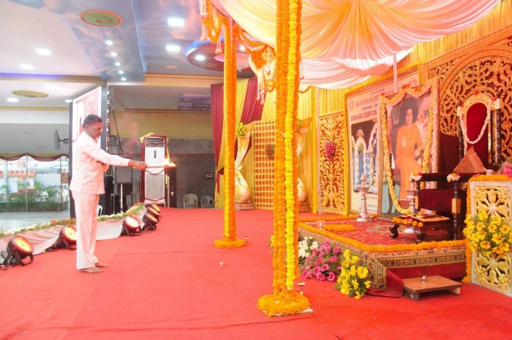

Sadhana Camps at Chennai Metro West District:
- As a part of Spiritual Awareness Study Circle is being conducted uniformly once in a month in all 30 samithies in CMW District.
- A panel of speakers has been identified (Out of 37 speakers, 29 are Balvikas Gurus) who are doing this exemplary seva in communicating Divine Message to all the Samithies.
- The contents of every month topic is being prepared by a team of dedicated members and is forwarded to all the speakers through emails in advance.
- Briefing session to speakers is held every month for clarification and clearing of any doubts on the contents of the topics.
- The copy of contents of every month topic is also forwarded to all the samithi convenors through emails, with a request to inform their members in advance, about the topic and its contents so that they will interact on the day of study circle.
- The Roster is also prepared in this connection giving all the details with Phone numbers.
- The feedback of convenors is obtained in convenors meeting and suggestions, if any, are incorporated in next month.
- The feedback from various samithies about the Study Circle methodology is encouraging and a lot of members involve themselves and interact during the study circle session.
- The initial time granted to speaker is 30 minutes and 20 minutes for interaction. Many a times, there are reports that it extends up to 1 hour 10 minutes in many samithis
The details of Study Circle conducted on various Topics are given below:
- June 2017 – Purpose and Importance of Study Circle.
- July 2017 – How fortunate are we to be a Member of Sri Sathya Sai Samithi? Role and Responsibilities as a member.
- August 2017 - Spirituality in Day to Day Life.
- September 2017 - Seva is the Pathway to reach Lotus Feet of our Bhagawan.
- October 2017 - What is Avatar? How to recognize the Divine Being and Derive Benefit from HIM.
- November 2017 – Namasmaran-Highest Sadhana.
- December 2017- Shravanam, Mananam and Nidhidhyasanam. During the month of December 2017 recapitulation on the previous six months’ topics was done.
- From January 2018, 9 point code of conduct is the topic. January topic was NINE POINT CODE OF CONDUCT AND ITS RELEVANCE IN DAILY LIFE- REGULAR STUDY OF SAI LITERATURE
Ramayana Saptagam
A seven day saptagam on Ramayana was conducted by the alumnus of Sri Sathya Sai University students at SriRengam samithi of Trichy district from 24th March 2018 to 1st April 2018. On the concluding day “Sita Rama marriage ceremony” was conducted by Sri Veda Murali of Karur district.
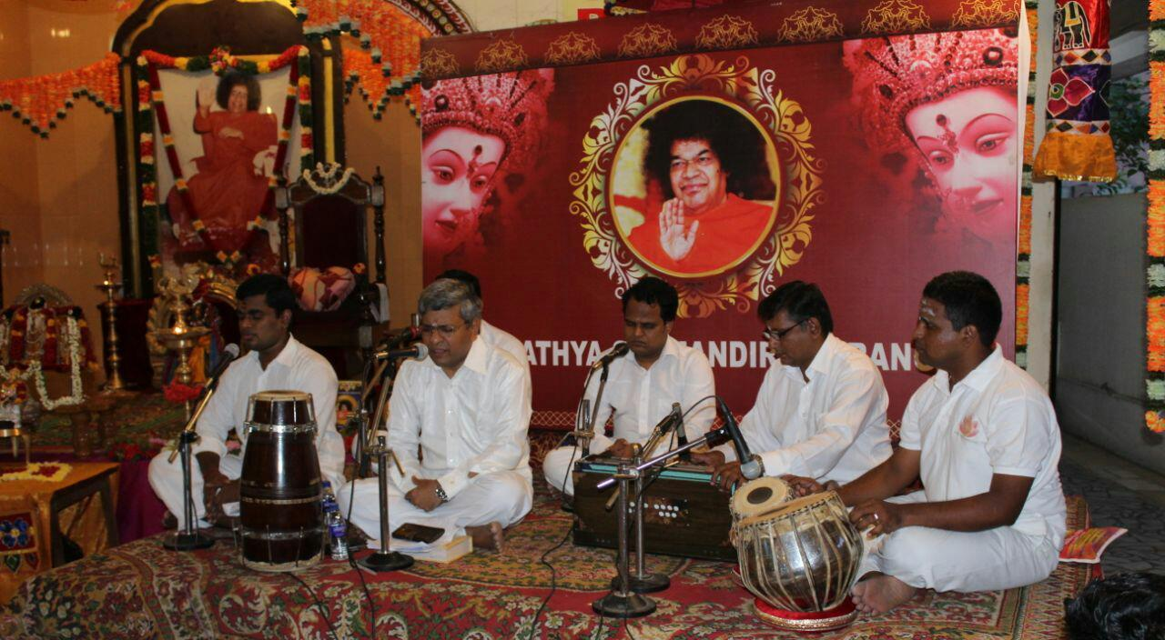

2.2 EHV Programs:
EHV programs at various institutions organised by SSSSO-TN:
The SSSSO-TN have organised EHV programs at various educational institutions and at various Samithis in the State. The EHV programs are designed as a one day awareness courses which targets both the students and teachers with the twin objectives of-
- Understanding the import and significance of “Human values”.
- The benefits arising by practising them in our daily lives.
Salient features of the EHV programs:
- Best suitable for present generation students in all educational institutions
- Suitable for improving working atmosphere in engineering industries/ IT Company etc
- To improve life style of general public.

Faculty members:
- Thiru. V.Viswanathan, State Spiritual Awareness Program - Faculty Member
- Thiru.Ganapathy, State Spiritual Awareness Program Coordinator
- Mr and Mrs. Thangamani, Virudhunagar

The utility of the program cannot be undermined as it trains the young minds to follow the Dharmic way of life and influences the tender hearts to adhere the human values. Many feedbacks were received from both the student’s community and the teaching fraternity about its usefulness and having a compelling effect on the perception of the students and bringing about a positive transformation in the behaviour of the students.
Feedbacks from the students and the teachers are collected at the end of each program. Some of the responses are worth mentioning as they not only motivate the facilitators but also become visiting cards for other institutions to invite us for such programs.
CONSOLIATED STATUS OF EHV PROGRAMME CONDUCTED
FROM JAN 2017 to JUNE 2017
S.No | INSTITUTION | PROGRAMME | No of STUDENTS | No of FACULTIES | No of PROGRAMMES
 |  |  |  |  | STUDENTS | FACULITIES/OTHERS
1 | COLLEGES | SAI EHV | 346 | 122 | 2 | 3
2 | SCHOOL | SAI EHV | 3622 | 226 | 16 | 2
3 | SCHOOL | EHV THROUGH MAGIC | 413 | - | 3 | -
4 | SAMITHY /BALVIKHAS /OTHERS | EHV THROUGH MAGIC | 165 | 2 | 4 | -
5 | ENGINEERING INDUSTRY/I.T INDUSTRY | SAI EHV/OTHERS | - | 141 | - | 6
6 | GENERAL PUBLIC/SAMITHY/SCHOOL | PARENTING | - | 950 | - | 7
TOTAL |  |  | 4546 | 1441 | 25 | 18

The EHV programme was conducted in Government Schools and Colleges, Private Schools and Colleges and as well as in B.ED colleges.

Following are some of the feed Back's that we received during JAN 2016 to JUN 2016:

1. "It is a very motivating speech. Students enjoyed the session. As our college if for the rural students, thus kind of speeches are helpful in building their character and leading them to successful life"
- Prinicipal, Periyar University College of Arts and Science , Mettur Dam
2. "Learning through magic was totally a unique experience for the children and the teachers. It was more effective way to teach values. "
- Principal Sri Sathya Sai Vidaypeeth, Sri Sailam, Kerala
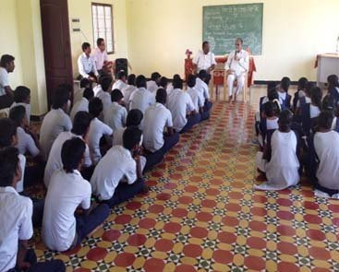
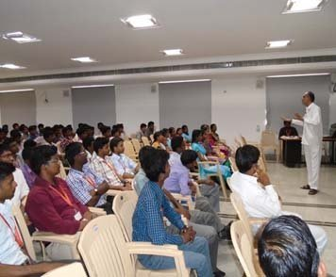
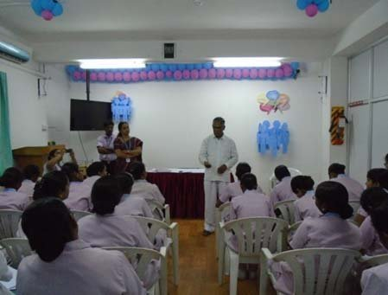

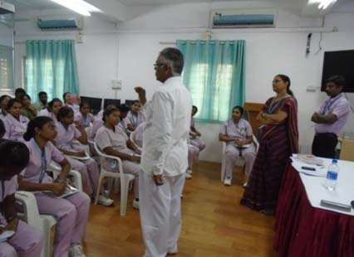

2.3 All India President’s Visit to Tamilnadu

State level conference 2017
Sri Satya Sai Seva Organizations, Tamil Nadu State level conferences were held at Chennai, Erode and Madurai districts from July 22 to July 25, 2017 in well planned manner. All India President Sri. Nimish Pandya has been travelling across the country to all states to take note of the various Sai activities undertaken, hold deliberations and provide suggestive measures for enhancement of Sai aeva activities. In this connection he graced the conferences held in the three districts of Tamil Nadu accompanied by the State Presidents of Andhra & Telengana, Karnataka and Orissa.

Chennai district conference
Chennai conference was held at Blue Lagoon Resort along East Coast Road on July 22 from 8 am which commenced with hoisting of Prasanthi flag. In this conference national and state level coordinators, district coordinators, trust members, district and samithi educational, service, spiritual wing coordinators, samithi conveners participated. Sri. G. Varadhan State President delivered the welcome address. Sri. Meenakshi Sundaram, Radio Sai Tamil coordinator made a video presentation on birth and growth of Sai Organisation in Tamil Nadu. Sri. Vijaya Krishna, State youth coordinator, Sri. Thyagarajan disaster management coordinator, Mr K.M. Rao, and Mr Ramakrishna on rural VTC and Sri. Venkatesh Prasanna, state vidya jyothi coordinator delivered speeches with regards to respective departments. During the post lunch session Dr Sri. V Mohan, Convener Sri Sathya Sai Trust, Tamil Nadu addressed the gathering. Following course Sri. G Varadhan, State President announced regarding new balvikas centers and new bhajanmandalis which were inaugurated by All India President. Mr V Srinivasan, former All India President participated in the conference and delivered special address. After the key note address by All India President, he along with Sri. N. Ramani, National Vice President held discussions with the gathered delegates. This program concluded with cultural programs by balvikas children of Chennai metro south district. In this conference 12 districts namely, Chennai metro east, west, north and south districts, Kanchipuram north and south districts, Tiruvallur district, Pondicherry, Cuddalore, Vellore, Villupuram and Nagapatinam districts participated. Senior Samithi members were honored in the conference. Next day mahila conference was held in the august presence of state mahila spiritual, educational service and other department coordinators

On July 23rd All India President made a visit to three Sai seva activity centers of Chennai metro west district. He visited the Sai Krupa free medical aid center functioning at Anna Nagar West Samithi since 1984 and held interactive discussion with 15 medical practitioners and felicitated them.

Then he made a visit to Bharathi Nagar in T Nagar wherein Nithya Narayana seva is underway for more than 4 years at Amman temple and participated in the Narayana seva to the beneficiaries. After that he made a visit to Padma Sheshadri School, T. Nagar surveyed the coaching classes held for the visually impaired for the past several years, held interaction with the students and the volunteers and took group photographs with them.

Erode conference
Erode conference was held on July 24th at Kasturba Mandapam in Velalar Women’s College, Erode. The conference commenced at 1.30 pm presided over by district and samithi coordinators and members around 2000 in number of the seven districts of Erode, Coimbatore, Tiruppur, Dharmapuri, Salem, Namakkal and Nilgiris. All India President was welcomed by a dance performance by balvikas children. Sri. Rajendran District President, Erode district delivered welcome address. A video presentation regarding the activities undertaken in all departments of all the districts was held. All India President inaugurated 43 bhajan mandalis and 16 BV centres comprising of all districts. All India President distributed Sai One ID cards to district presidents, coordinators and samithi conveners and delivered key note address.

On that day morning the All India President made a visit to ongoing Sai seva activities undertaken in Erode district. At Therkupallam samithi free tuition classes and Nithya Narayana Seva (midday meal) for about 300 children has been underway since 10 years. On that day All India President distributed kits containing rice, dal and oil to 100 beneficiaries. He also handed over 3 toilets out of the ongoing 9 toilets project at Sathya Nagar to the beneficiaries. He also made a visit to Chittode village industrial training center and distributed electrical equipment kits to 9 students undergoing training, inaugurated tailoring institute and an hostel in SMHSS premises, Chittode for mahilas. A skill school for Mahilas was also inaugurated.

Moreover, All India President made a visit to Sri Sathya Sai Vidya Jyothi School, Karungalpalayam Government Middle School and presented mementos to gurus and teachers. He also made a visit to Erode east samithi and delivered a special addressed to the gathered devotees.

Madurai conference
Madurai Conference was held at Ananda Nilayam on 25th July. In this conference district presidents, coordinators, Samithi conveners, Samithi coordinators and members about 250 in number hailing from 9 districts Madurai, Tutucorin, Tirunelveli, Trichy, Theni, Kanyakumari, Virudhunagar, Dindugul and Thanjavur participated. Sri. Narayanasami, District President, Madurai delivered welcome address. This was followed by a special address by All India President. Honoring of doctors and senior members serving in the Organization with shawls followed course. All India President inaugurated bhajana mandalis and balvikas centers comprising of the 9 districts.

In the morning All India President made a visit to the ongoing Sai seva projects undertaken in Madurai district. Early in the morning at 5.30 am SSSVIP rural mahilas carrying mulaippari (sprouting or germinations of 9 cereals in a basket or clay mud pots to propitiate village Goddess) in a grand procession to receive All India President. All India President interacted with the rural folk and inaugurated a bhajan mandali there. He then made a visit to the Sri Sathya health center at kutladampatti.

In all the 3 conferences All India President insisted to all the delegates that self-transformation is the only way to societal transformation. Moreover, he insisted on self-improvement and that through our exemplary lives we need to set an example to others. With summing up address by Sri. K. R. Suresh, State Vice President the Madurai conference came to a close with maha mangala arathi offered to Bhagawan.

2.4 PAVITRA PARTHI YATRA

TAMIL NEW YEAR & GAYATRI JAPA YAGNA AT PRASHANTI NILAYAM.
PRASANTHI NILAYAM 14-04-2018

As part of Tamil New Year day celebrations, “Viswa Shanthi Gayathri Japa Yagnam” , for World Peace and Harmony, was performed at Poorna Chandra Hall from 10.00 AM to 12:30 PM, on 14th April 2018, Saturday. Around 1000 devotees from Tamilnadu participated in the event. This is the second successive year that this yagnam is being conducted at Prashanthi Nilayam as part of the Tamil year’s day celebrations.
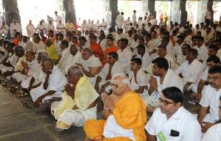
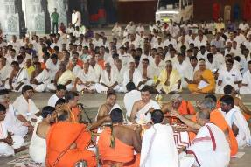

TAMIL NEW YEAR EVENING PROGRAM AT PRASANTHI NILAYAM
PRASANTHI NILAYAM 14-04-2018

Celebrating Tamil New Year Day the state contingent under the auspices of Sri Sathya Sai Seva Organisations - Tamil Nadu presented a musical evening featuring an Instrumental Violin concert by famed Padmasree Kalaimamani Kum. Kanyakumari at the Sanctum Sanctorum today in Prasanthi Nilayam. Hundreds of devotees from the state are in Prasanthi Nilayam attending the holy beginning of the vernacular new year in the Divine Presence. This evening the artist was accompanied by Kalaimamani KV Prasad on Mridangam, Sarvasree Sai Rakshit and Bangalore Rajsekhar Chakravarthi on Violin and Morsinghrespectively.
Inauguration of Nine Bhajan Mandalis Of SSSVIP affiliated villages of Tamil Nadu under the Adarsh Gram Project followed next.
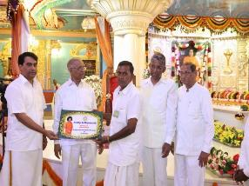
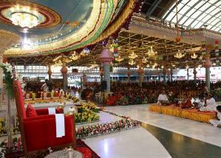

SRI SAI ARADHANA MAHOTSAVAM IN PRASANTHI NILAYAM.
PRASANTHI NILAYAM 24/04/2018.
Rejoicing The Presence that is most incomparable, a host of Carnatic musical talents from Andhra Pradesh, Karnataka, Tamil Nadu and Maharashtra combined their hearts and souls presenting a unique offering of “Sai Pancharatnas” this morning on the auspicious Sri Sathya Sai Aradhana Mahotsavam in Prasanthi Nilayam. 'Sai Pancharatnas' has been an established tradition on the auspicious 24th April morning in Prasanthi Nilayam over the years, the day Bhagawan chose to halt His physical sojourn. Sai Pancharatna Kritis are fashioned in the popular Thyagaraja Pancharatna tradition and as the name indicates is a compilation of 5-gems that are set to five different ragas, focussing on different tenors.
The Kritis were: Pranamaami Sayeesha… in Ragam Gambhira Nattai, in Adi Taalam, Sadaa Bhavayami in Ragam…Mayamalava Gowla, in Adi Taalam, Charana Sevanam… in Ragam Arabhi, in Adi Taalam, Kaliyuga Avataari… Ragam Todi and Sathya Sai Avatara Vaibhavam… in Ragam Madhyamavarthi, in Adi Taalam. All the songs were composed by Dr R Vasanthalakshmi of Sathya Sai Mirpuri College of Music and music was composed by Sri Raj Kumar Bharathi, great grandson of illustrious freedom fighter and Tamil poet Subramanya Bharathiar.
A CD on the Sai Pancharatna Kritis was released during the occasion.
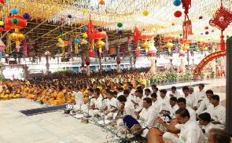
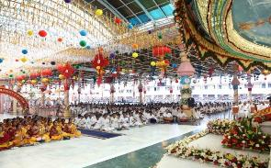

'Manasa Bhajare Gurucharanam' - Dance Drama By SSSO - Erode, TamilNadu.. -16.06.2018
PRASANTHINILAYAM

Parthi Yatra contingent from Erode district of Tamil Nadu offered a dance drama entitled "Manasa Bhajare Gurucharanam" this second evening of their 3-day Parthi Yatra at the Sanctum Sanctorum in Prasanthi Nilayam. The presentation in Tamil with English mix was themed after Bhagawan's eternal message, teaching and preaching the humanity of the path to salvation. Episodes from the illustrious life, namely, the epochal birth, leaving the 'Maya' at the age of 14 responding to the cosmic call, His first message to humanity, 'Manasa Bhajare Gurucharanam' explaining the purport in detail, Adi Shankaracharya's eternal message of 'Bhaja Govindam' that has won repeated references in Bhagawan's Divine discourses, Shankaracharya's message of Bhaja Govindam that depicts 'money is not everything', 'to look beyond the externals to understand and realise the inner reality of Atman and so on were depicted conveying the masterly golden message for all times. The programme concluded with a summary of Bhagawan's teachings ending with 'Manasa Bhajare Gurucharanam' that formed a part of the epochal Bhaja Govindam. Bhagawan's mellifluous bhajan 'Manasa Bhajare...' followed next. 108 children, Balvikas, Sai Youth along with Sathya Sai Alumni participated in the 70-minute presentation. Over 1000 devotees are participating in this 3rd Pavitra Parthi Yatra by the SSSO-Erode.

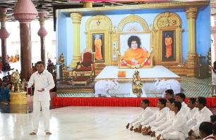
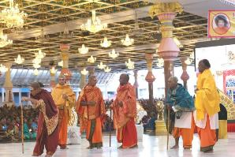
Sthree Dharma Bodhini Drama By SSSO - Erode, TamilNadu.. -17.06.2018
PRASANTHINILAYAM
On the third and final session of the three-day Pavitra Parthi Yatra by the SSSO of Erode district of Tamil Nadu, Sri Sathya Sai Women Alumni along with Balvikas Alumni and Mahila Members Of The SSSO presented a skit entitled 'Sthree Dharma Bodhini' this august Sunday morning at the Sanctum Sanctorum in Prasanthi Nilayam. Themed after Bhagawan's teachings and preachings on 'Sthree Dharma' the presentation highlighted the greatness of women with virtues galore as epitome of supreme dedication and devotion. Interspersed with songs and dance sequences, with commentary from the backdrop, the presentation turned out to be 'sailent' reminder of women being role models in society guiding and guarding their wards showing the right path. Depicting the illustrious story of Mother Easwaramma, the Chosen Mother Of Bhagawan Sri Sathya Sai, the presentation highlighted how selfless, holy desires meant for societal transformation touches the Divine to bring fulfilment. Mother Easwaramma's three desires for an elementary school, a hospital and a well was blessed by Bhagawan that later turned out to be mammoth Sri Sathya Sai projects, serving the humanity at large. The presentation also touched upon the 'Sri Sathya Sai Sthree Dharma Bodhini', a welfare project meant for women run by the Sri Sathya Sai Seva Organisations inculcating ancient culture and traditional values in society, in the women of present time.
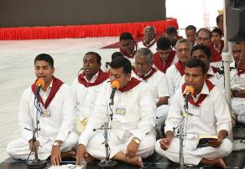
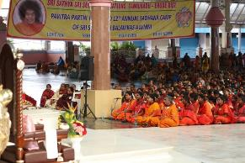

Kanchipuram Parthi Yatra
PRASANTHI NILAYAM-23.6.18
Two thousand devotees from the Kanchipuram North district of Tamil Nadu are on 2 day Parthi Yatra to Prasanthi Nilayam. Celebrating the mighty Divine Presence Bala Vikas children along with Bala Vikas alumni and Bhajan Vikas children from the district presented a beautiful musical offering entitled 'Madhuram Sai Ganam' this evening in Prasanthi Nilayam. They began with an invocation, singing Premaku Roopai Nilachina Sai Ki Swagatam and flowed on with a string of devotionals that include Kyse Jiyu Mein Na Tere Bina..., Jagata Janani Bhavatarini Mohini Tu Navadurga..., O' Sai Maa... Priyamaina Bandhama..., Namami Guru Charanam...Namami Guru Charanam..., Hum Ko Tum Se Pyaar Kithna... followed by a medley of bhajans.
A string of dance offering next had the traditional Kavadiyattam dedicated to Lord Muruga, The Lord Of Palani followed by a Rasa leela dance and Saint Annamacharya's famous Brahmamokkade..., Brahmam Is One And One Only and ended with a thematic 'Vasudhaiva Kutumbakam'.
Bhajans by the district Bhajan Vikas followed and the session ended with Mangala Arathi to Bhagawan.
Earlier, in the morning, the Balvikas contingent from the group numbering over 400 took out an impressive palanquin procession entering the Sanctum Sanctorum at the Sai Kulwant Hall depicting the rich cultural and spiritual heritage of Bharat. Veda chanting and bhajans, both morning and evening, were offered by the specialised groups from the district.
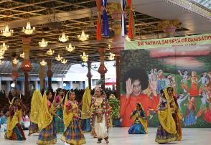
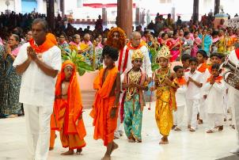
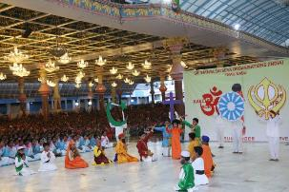

2.5 Sri Sathya Sai Books and publications Trust, Tamilnadu
The SSSBPT, TN is actively involved in spreading the message of Sai by Publishing books and periodicals in Tamil language. The SSSBPT, TN takes pride in announcing that all the 3600 speeches of Bhagawan have been translated into Tamil language and brought out into 46 volumes entitled “Arulamutham” (Nectar Divine). This series of books have become best sellers in the state. Furthermore, it is to be noted that all Vahini series and Sathyam-Sivam-Sundaram series are also available in Tamil language. The Sanathana Sarathi in Tamil language has a base of 22,000 subscribers. Recently a newly renovated permanent book stall for daily sale of Sai literature started functioning at Sundaram from 9.00 am to 8.00 pm.
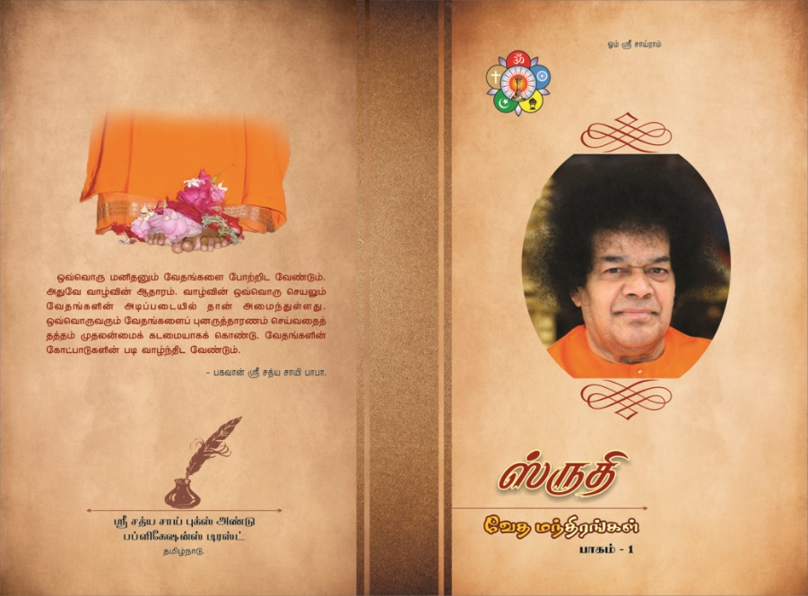
During October 2017, With the abundant blessings and grace of our Beloved Bhagwan, Sri Sathya Sai Books and Publications Trust, Tamilnadu have brought out a Tamil Transliterated book of a popularly sold vedam book - "Shruthi". This book contains the Tamil scripts of all the Vedam portions that are being chanted at Prasanthinilayam on a daily basis.

"Mantras, or sacred sounds, are used to pierce through sensual, mental and intellectual levels of existence (all lower strata of consciousness) for the purpose of purification and spiritual enlightenment. "By sound vibration one becomes liberated" (Vedanta-sutra 4.22)".
Most of the Spiritual organizations in India have their own material on this primordial knowledge that was regularly chanted, carefully preserved and effectively passed on to the next generation through Guru- Shishya Parampara. Technological advancement helped many spiritual organizations to properly codify and bring it out as a book with the intention of preservation and dissemination of these vedic treasures, though contained only Sanskrit and English scripts. It is to be noted that very rarely we have these literatures in Tamil scripts.
It is a hard work of six months by the dedicated team of SSSSO members under the leadership of our State Vedam Coordinator, Sri. Shyam to carefully choose and type the Tamil scripts that properly spell out the correct utterance of each word. This book can help the various recitation styles that allow the complete and perfect memorization of the text and its pronunciation, including the vedic pitch accent.
With the National agenda of organizing a National Vedic conference on the eve of Bhagwan's Birthday celebrations (20th and 21st November 2017), more than 500 learners and chanters have enrolled themselves to participate in this grand event from Tamilnadu. Availability of "Shruthi" book in Tamil at this juncture would definitely help both the professional chanters and amateur learners to learn, memorize and prefect their chanting with accuracy.
2.6 Radio Sai in Tamil:
It was the Divine Sankalpa that the Tamil programme in Radio Sai was inaugurated on 14th April 2010, the same day when the Tamil New year Day was celebrated at Prasanthi Nilayam.

The Tamil programme is being broadcast on every Saturday between 7.30 p.m. and 8.30 p.m.
Episodes broadcast so far include interviews with eminent personalities such as
- Judges
- Sathya Sai Institute Alumni
- Musicians
- Celebrities and
- Senior Devotees
The programs were categorized under the following heads:
- Deivathin Kural
- Aatmartha Anubhavangal
- Seva Projects
- Sai Arogya
- Shravana Manjari
- Sandeha Nivarani
- Chinna Kathai
- Parthivasanum Paintamizthenum

The increased reception from the devotees had initiated the Radio Sai (TAMIL) team to cover / produce the following:
- A new serial called Book review has been introduced during this period. A speaker would review books written by / on Swami and give a presentation for 15 mts. This has also been received well by the listeners.
- More focus has been given for service projects during this period of 6 months.
- The Radiosai Tamil Team has requested District Presidents and other office bearers to capture any service project and send the audio file to us for broadcasting in Radio Sai.
- The Radiosai Tamil Team now requests the State Office to encourage regional coordinators for capturing regional service / spiritual programmes.

The Radio Sai Tamil team had aired the following episodes during the period Jan 2017 to June 2017

- Aatmartha Anubavangal:

  - Sri. K.R.Premkumar, Senior Devotee from Chennai
  - Sri, Mayur Nath Davey, Member, Sundaram Bhajan Group
  - Smt.Neeraja, Grand Daughter of Kuppam Sri Radhakrishnaiah 4
  - Dr.Smt.P.Rama Devi, Sr.Devotee and Retired Director, Children Hospital, Egmore, Chennai
  - Sri.V.S.Raghavan, Mridnagam Artist and Alumnus, Sri Sathya Sai Mirpuri College of Music, Prasanthi Nilayam.
  - Sri. Rajkumar Bharathi, Music Director and Great Grandson of Maha Kavi Subramania Bharathiyar.
  - Dr.Lakshmi Narayanan, ENT Specialist, (Madurai Chettiar Family),
  - Sri, Abhishek Hariharan, Asst.Professor, Brindavan Campus and
  - Sri.Murugan, Sr.Devotee, Coimbatore
  - Sri.S.Ashwin, Alumnus, Brindavan Campus
  - Sri.B.Ramkrish, Alumnus, Sri Sathya Sai Mirpuri College of Music
  - Sri.V.Ramadoss, Sr.Devotee, Ambattur Samithi
  - Sri.K.G.Tri Murthy, Sundaram Bhajan Group Member
  - Sri.Chandrashekar Tandapani, Senior Devotee, Chennai
  - Sri.K.Ramakrishnan , Alumnus- Brindavan Campus
  - Sri.V.Sairam, Sundaram Bhajan Group Member
  - Sri. Sri.V.Sairam, Sundaram Bhajan Group Member
  - Sri.R.Rajagopal, Alumnus, Prasanthi Campus (Repeat Edition)
  - Sri. Sri.V.Viswanathan, Sr. Devotee, Chennai
  - Sri.G.Muralidharan, Alumnus, Brindavan Campus
  - Sri.G.Muralidharan, Alumnus, Brindavan Campus, Concluding Part
  - Smt.Soundariya Sriram,Nanmangalam,Chennai in four Parts
  - Sri.S.V.Iyer, former SUNDARAM Custodian
  - Dr.G.Sridhar, Alumnus, Prasanthi Campus

- Seva Paramo Dharmaha - Unique Seva experiences - Conversation with

  - Sri.B.Ramesh, Member, Sri Sathya Sai Books and Publications Trust (Tamilnadu)

- Radio Satsangh: Sai Arulamudham - Talk by Sri.P.Srinivasan
  - Sai Arulamudham - Talk by Sri.P.Srinivasan
  - Life is a Game; Play It - Talk by Smt.Sundaravally Suresh, Faculty, Boys School, Puttaparthy
  - Nine Code of Conduct - Talk by Smt.Sundaravally Suresh

- Shravana Manjari - Reading of Vahini series by Mahilas
- Transformation story by past Bal vikas Student Kum.Pooja Kumar
- Deivathin Arulurai with Tamil Translation ( 2009 Convocation address in 5 parts)

  - Daiva Preeti, Papa bheeti and Sanga Neethi (25-02-2009)
  - Money comes and goes, Morality comes and grows - Jan 2009
  - Love God and Meditate on HIM - Feb 2009
  - Develop Self Confidence to gain success in Life - Feb 2009
  - Know Yourself, you will know everything - Jan 2009

- Sai Arogya-

  - Conversation with Sri.Thirumalai (Super Speciality Hospital Beneficiary - Repeat Edition)

3.1 Report on Prasanthi Seva – March 2017 (16.03.2017 To 31.03.2017) and May 2017 (30.04.2017 to 15.05.2017

Prasanthi Seva for May– 2017 (30-04-2017 to 15-05-2017)
Tamilnadu Prasanthi Seva was carried out smoothly from 30.04.2017 to 15.05.2017 in 2 batches. Deployment of Sevadals of both March and May month was carried out under the guidance of Ashram Authorities. The response of Sevadals from the Districts were satisfactory in both March and May Month Service.

With the Blessings and Guidance of Bhagawan, the following activities were also undertaken apart from the regular security and utilities service, as directed by the Ashram authorities.
- Eswaramma Samadhi area was cleaned thoroughly.
- White washing of walls was done wherever necessary.
- Beautiful Rangoli was painted around the Samadhi area by Mahilas.
- About 110 chairs were moved from Satsangh hall to mother Samadhi area and returned back after the function.
- Flower decoration was done over Samadhi by Mahilas.
- On Eswaramma day 110 kits containing washing soap,bathing soap,tooth brush,tooth paste and biscuit packets were distributed to the inmates(gents and Mahilas) of sheds 29 and 30.
- Through cleaning of baking trays,and 1st and 2nd floors of western canteen.
- Complete cleaning of godown,labeling and stock taking in the book stall.
- Cleaning of rice,rava in the South Indian canteen.5.Providing large tubs and trays for washing plates and cups in Seva Dal Canteen.

- During the function crowd controlling was effected both by Gents and Mahilas Sevadals.
- Prasadam distribution was done after the function.
- Lot of trees fallen down in the ashram area due to rain were cut and removed to wood yard.
- 250 bags of Rice brought from Shed No.39 to the South Indian canteen Rice Storage area for cleaning, polishing and bagging.
- Vegetable lorry load was unloaded three times in the south Indian canteen.
- 2 trucks of Granite stones and two trucks of sand were shifted from wood yard to North Block N6 behind.
- Assistance given for constructing a wall behind N6.
- From Electrical scrap yard in the maintenance area, cables were segregated and bundled separately in the usable form.
- Same like, usable switch boards were segregated and kept.
- Electrical store room area materials were rearranged and kept.
- Maintenance scrap yard area was cleaned; Scrap materials and usable materials were segregated and arranged properly.
- Three ladders (Heavy Weight) kept in the eastern side of Mahilas Toilet near maintenance workshop, were brought down and kept for some repair work.
- Cots were rearranged in C7, C8 – Bhaktha Nivas Shed. Rooms were also cleaned.
Hall above North Indian canteen was cleaned thoroughly.

- Apart from the above routine seva, more than 15 youths from the district of Erode participated in the Annual Parthi Maintenance Seva. Their services have been highly appreciated by the officials at Prasnthinilyam and invited them to come regularly for such special seva year after year and receive Bhagawan’s blessings.

Parthi Seva by the Tamilnadu Sevadals (15th Oct 2017 to 15th Nov 2017)
With the Abundant Blessings and Divine Grace of our Beloved Bhagwan Sri Sathya Sai Baba Varu, Tamilnadu got the blessings of rendering Prasanthi Seva from 15th October 2017 to 15th November 2017. Seva was carried out smoothly from 15th Oct 2017 to 15th Nov 2017 in 3 Batches. Deployment of Sevadals was carried out under the guidance of Ashram Authorities.

The details of number of Sevadals who rendered their services are given below against their allotment 750 for Gents and 750 for Mahilas.

Sevadals Reported:OCT/ NOV – 2017 ( 15th Oct to 15th Nov 2017)
Gents |  |  | Mahilas
I Batch | II Batch | III Batch | I Batch | II Batch | III Batch
608 | 611 | 635 | 720 | 707 | 635

During the service period , Deepavali festival was celebrated and special lunch was arranged with sweets and Ice creams for all the Sevadals. During Akhanda Bhajan, Tamilnadu Sevadals were given opportunity to sing Bhajan Songs in Bhagawan’s abode for one hr.
Arrangements were made for serving Tea for all the sevadals in all the batches during night shift at 11.00 pm and at 2.00 am. Snacks / biscuits were given along with tea at 2.00 am
Sevadals were trained with Jyothi meditation by Sri. Natarajan of Tirupur.

Before taking up Seva, all the Sevadals were briefed regarding the Ashram rules and the discipline to be maintained by the respective Sector Leaders. Guidance obtained from the Ashram Security officers then and there about the requirements of Ashram and acted accordingly.
During this period, the following additional Seva was carried out apart from the regular security and utility seva.
- Airport duty was carried out once.
- Ratham cleaning was carried out in Kalyana Mandapam.
- Loading and unloading of Gas cylinders for Four times from the Gas godown area to South Indian canteen. Every time 50 empty cylinders were returned and 50 full cylinders were brought.
- Sevadals deployed for Luggage alight from the Primary school when the children were proceeding on leave and lifted to the respective floors on their return.
- Additional Sevadals were deployed for maintaining discipline during Akhanda bhajan in the mandir area.
- Bed spreads were changed in North Block. About 200 mattresses were carried from the store and placed it in the rooms of N4.
- Sevadal assistance were given for Vegetables unloading Six times.
- Shirdi Sai Temple in GH area was cleaned in view of the Aruthra festival (Star birthday of Bhagwan)
- About 200 bags of Rice were moved from the rice godown to main canteen Rice Godown on two occasions.
- 200 chairs were removed from the ground floor of the Sat Sangh Hall and placed the same in the First floor. Subsequently 250 chairs from the first floor of the Sat Sangh were transported to North India canteen First floor and were returned back to Sat Sangh hall.
- 100 nos. of oil tins were unloaded from the truck and stacked in the North Indian canteen.
- Waste material near by the toilet of S1 area was removed and disposed off.
- 75 oil tins were unloaded from the vehicle and stacked in the Eswaramma Welfare trust.
- About 600 Oil tins in the ground floor of the SIC were rearranged and kept in the adjacent room.
- 150 chairs were taken from the shed area and placed in North Block (N4) rooms.
- VIP Guest House ( Srinivasa Guest House) rooms were cleaned thoroughly. Sevadals deployed for Five Days.

Mahilas:
A lot of cleaning work was taken up in almost all the sectors. In the second batch, cleaning of Rice, Rava and Wheat was taken up in the South Indian canteen. In the III batch, even though the strength was less, all the sevadals co-operated and we were able to do many extra tasks. Cleaning of Rice, Dhal, Mustard, Cummin, Seaseme seeds and Ground Nuts were cleaned for Akanda Bhajan. Tamarind extract and cutting green chillies and ginger in large quantities were also done by Mahilas from all the sectors. Stalks of almost of three bags of red chillies were removed by the sevadals. Tamarind rice mixing for the Akanda Bhajan prasadham was done by almost 100 mahilas from all the sectors. Swamy gave us yet another opportunity of serving prasadham after the completion of Akanda Bhajan. Co-operation from all the Mahilas was very heartening. They came forward in large numbers to help whenever needed. The team work and unity in all the sectors was highly commendable.
In all the batches, our mahila sevadals had a hard time in washing the big vessels in the Western canteen. In spite of the fact that there is a dish washer in the Western canteen and the South Indian canteens, it is not used. Some steps have to be taken to reduce the long working hours in the canteens. Steps should be taken to provide proper accommodation and food during the take-over periods from one State to another State.

3.2 Medical camps

Medicals Activities during 01-01-2017 to 31-12-2017 in TN by SSSSO
Type of Camp – (General / Diabetes / Eye, etc) | No of Camps held during the year | No. of Beneficiaries | No. of Doctors Participated | Number of Paramedics participated | No. of Sevadals participated | Rough cost of expenses
SSS Mobile Health Unit, Chennai | 129 | 31930 | 1392 | 1060 | 4426 | 45,15,945
General Medical Camp | 562 | 29,790 | 786 | 1,468 | 2,129 | 13,95,100
Eye camp | 120 | 9,494 | 120 | 192 | 418 | 4,38,000
Dental Camp | 3 | 321 | 2 | 4 | 9 | 16,050
Diabetic Camp | 35 | 8,610 | 15 | 45 | 113 | 4,30,500
Mental Health Camp | 7 | 907 | 11 | 11 | 114 | 25,250
Any other camp | 27 | 3,331 | 19 | 48 | 69 | 1,66,300
Total | 754 | 52,453 | 2345 | 1,768 | 2,852 | 69,88,145

Medical cover and counseling for expectant mothers-
A unique program organised by the Mahilas of the Sri Sathya Sai organisation, Chennai metro (South) district, is the prenatal and ante natal medi care for the expectant mothers from the economically weaker sections of the society. This medical camp was inaugurated 19 years ago. Expectant mothers from adopted villages and SSSVIP villages are brought to this medical centre for treatment. Experienced gynaecologists offer their services every fortnight. The treatment includes educating the expectant mothers regarding the health and hygiene, precautions to be taken during pregnancy and providing them with ‘Sai Protein’ required for 10 months. The new born baby is provided with a small kit containing the essential items like rubber sheets, nappies, baby powder, soaps and shampoo. A total of 5 mahilas are involved in organising the camp with a minimum of 2 spealist doctors at every camp. So far 732 mothers have been benefitted by this seva.

Sai Kripa Free Medical Aid Centre

“Sai Kripa” means the bountiful compassion of the Lord. True to this statement, Swami inaugurated the “Sai Kripa” free medical aid centre for the underprivileged and the sick, another living illustration of His love in action, at Kilpauk, Chennai on 15th January 1978 on a small note. This later blossomed into a multi-speciality centre in 1979 at Abbotsbury, Mount Road, Chennai and later shifted to a place adjacent to Sundaram, making every Sunday a Sai day catering to the health needs of the needy in and around Chennai.

A panel of 20 doctors of various specialities and a dedicated team work of 70 Seva Dals (40 gents and 30 mahilas), inclusive of paramedical and pharmaceutical disciplines, are immersed in this noble seva every Sunday from 8:00 a.m. to 1:00 p.m. attending on an average of 250 patients every week. The programme starts with bhajan, registration and general check–up, followed by clinical tests, if any, specialist advice if need be, concluding with free medicine distribution and Narayana Seva for all the patients. For further treatment, patients are referred to neighbouring hospitals in Chennai.

Besides this, a concerted effort is made by all the doctors to understand the patient first before prescribing anything. Keeping their sensibilities, rural conditions and other factors in mind, a lot of thinking is done on how the medicines are to be dispensed, how rural camps should be organised and how to better understand the pains and suffering of this often-neglected and poor section of the society. All this has resulted in better care to the patients and their numbers keep increasing every Sunday. Striving continuously to improve their services, the doctors at Sundaram have also recently started a “Young Adults Health Care Programme” to guide the youth in the villages who suffer from alcohol abuse, drug abuse, anaemia and improper health education. “Sai Kripa” is pioneering the mission of ‘Health for all’ as its prime perspective.

As an extension of “Sai Kripa” dispensary functioning near Sundaram similar “ Sai Kripa” dispensaries started functioning at various Samithi premises across the state providing medical aid to the needy patients.

Sai Kripa Medical Centre, Tondiarpet
Sai Kripa medical centre has been functioning since 1992 catering to the medical needs of the down trodden and the needy every Sunday at Tondiarpet. This centre has been operating under the supervision of two doctors accompanied by 6 seva dals and on an average 50 people are being benefitted every week through this seva.

“Sai Kripa” Dispensary at Ashok Nagar
A new Sai Kripa centre was inaugurated at Ashok Nagar Samithi premises on 1st December 2013 by National Vice President Sri. N. Ramani. Since then the samithi members and the medical fraternity have been rendering a dedicated service to serve the poor patients. On an average 40-50 patients were treated every week at this centre.

Medical Seva at SaiKrupa, Anna Nagar
- This service is in existence for the last 30 years.
- Swami visited this place thrice.
- Weekly 1000 patients treated

Free Clinics run by SSSSO-TN during 01-01-2017 to 31-12-2017
No. of clinics held in the year | No. of Beneficiaries | No. of doctors who participated with undergraduate qualification | No. of doctors who participated with postgraduate qualification | Number of Paramedics participated | Number of Sevadals participated | Rough cost of expenses
494 | 23,95,000 | 39,763 | 201 | 820 | 342 | Rs.48274800/-

Tie-ups with the major hospitals to allot one/two beds for the patients referred to them through Sri Sathya Sai Health care program.
This is another initiative by the organisation wherein they have tied up with other hospitals in the city that have come forward to provide one/ two free beds in their hospital for inpatient treatments to those referred to them under Sri Sathya Sai health care program.
A Decade of Dedicated Seva – Liquid Love Donation

Blood carries the essential nutrients for the survival of the body; it ceaselessly on the move serving untiringly and without bias. Hence, Swami rechristened blood as “Liquid Love” which enlivens the divine dictum of love in action, true seva.

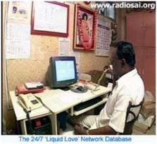
With population explosion posing problems, societal unrest rampant, social and ethical degeneration, diseases within and disasters all around, the need for blood is ever on the rise. This melted the hearts of the Sai fraternity. Thus, on 6th December 1998, Sri Sathya Sai Seva Organisations commenced a programme called “Liquid love”. It was started in a small way and within a short span of time, it bloomed with an elaborate information counter and a data bank manned by three volunteers, 24X7 for catering to the blood transfusion requirements for nearly 25 hospitals in the city of Chennai in cases of emergencies and post surgeries.

With a need-based software and a database of more than 7,500 donors comprising of all blood groups which is constantly updated, it serves on an average 100 patients a month who are undergoing surgeries and some receiving 2-3 units of blood, including rare blood groups. Owing to the excellent coordination existing between the hospitals and the liquid love volunteers, the needy are served at the required moment. The number of shields, trophies, and citations awarded by the Madras Voluntary Blood Bureau stand as testimony to the yeoman service being rendered by this set-up in Sundaram.

Medical Camp at Madurai:

A special medical camp exclusively for SRI SATHYA SAI SEVA ORGANISATIONS members was conducted on 20/05/2018. Please find below a brief report on the camp:

PLACE OF THE CAMP : SRI AMBIGA EDUCATION CAMPUS, ANNA NAGAR, MADURAI 20
TYPE OF THE CAMP : SPECIAL
NUMBER OF OUT PATIENTS :126
NO. OF DOCTORS PARTICIPATED:4
NAME OF SPECIALITIES : GYNAECOLOGY, ONCOLOGY, CARDIOLOGY
NO. OF CASES REFERRED FOR
HIGHER INSTITUTION : 2
DETAILS OF INVESTIGATION
DONE : BLOOD PRESSURE, RANDOM BLOOD TEST FOR BLOOD SUGAR
BONE DENSITY, ECG
SUCCESS EVENTS/
HEART TOUCHING BENEFITS : AN ELDERLY PROFESSOR WHO WAS NOMINATED BY THE CAMPUS AUTHORITIES FOR OUR ASSISTANCE WAS VERY RELUCTANT TO COME FOR MEDICAL CHECK UP, AFTER SEEING OUR SEVADALS’ COMMITMENT AND LOVE, CAME FOR THE CHECK UP, FOUND THAT HIS BONE DENSITY WAS VERY LOW (T-SCORE), WAS OVERWHELMED BY THE DISCIPLINE AND LOVE EXHIBITIED BY US AND HAS PROMISED TO ATTEND THE SAMITHI EVERY WEEK.
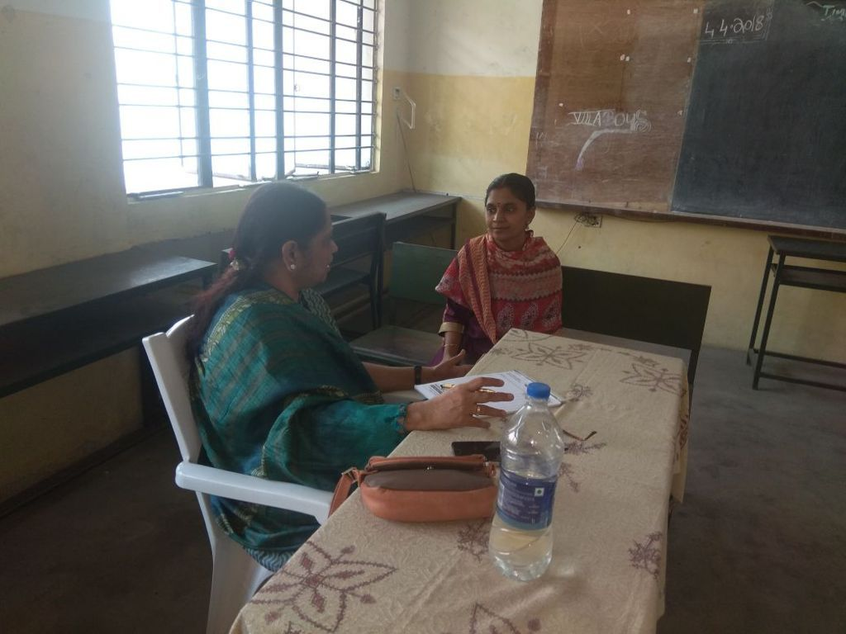
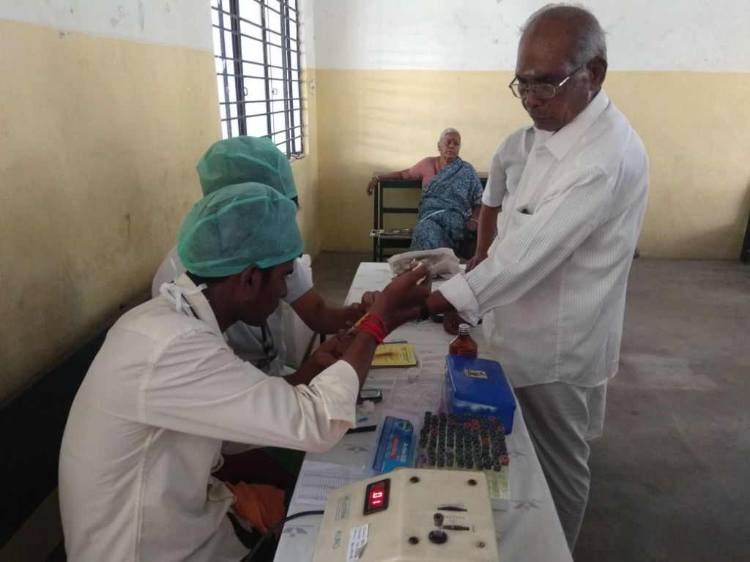

Medical camp at Sri Avvai Home by Chennai Metro West District:

With the Divine Blessings of Bhagawan Sri Sathya Sai Baba Varu, Sri Sathya Sai Seva Organisations, India, Tamil Nadu, Chennai Metro West, West Mambalam samithi in association with SRM Hospitals, Thambiah Road, West Mambalam conducted a free medical camp for the inmates of Sri Avvai Home, Kundrathur at their premises on sunday, the 5th of November 2017 as a part of Swami's 92nd Birthday celebrations

A team of doctors from SRM hospitals comprising of Dental, Physiotherapist & General Medicine along with paramedical staffs thoroughly checked all the patients with respect to BP, Oxygen level and Sugar test. Subsequently related medicines for the patients were also been prescribed and handed over to the patients by the doctors.

The programme started with bhajan's and Narayana seva has been served for all the inmates. There were about 50 Mahila senior citizens benefited out of the camp. Swami has beautifully blessed everyone and indicated his presence through a snapping of a flower garland from HIS photograph during the bhajans.

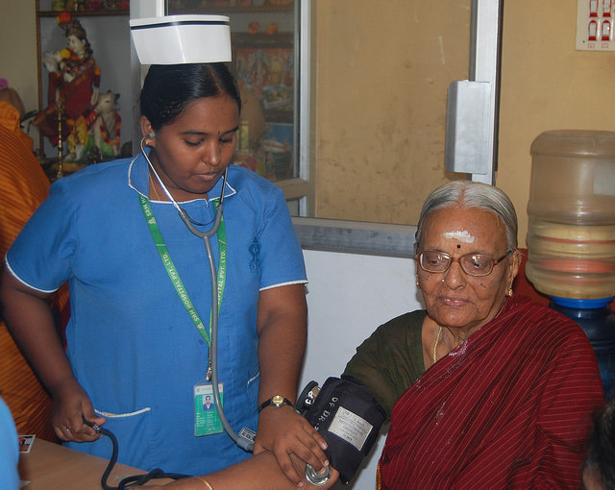
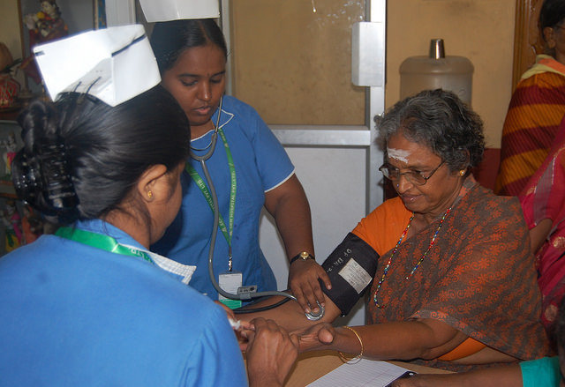

A round-up of Medical seva in the State of Tamilnadu –
(from the desk of State Medical Coordinator Dr.E.Prabhu)

We are regularly conducting Urban Health Camps every month in the underprivileged areas around major metros like Chennai, Madurai, Trichy, Coimbatore and Thirunelveli as well as in Rural Areas in remote several villages of our state, under aegis of their local Samithi. We have made every effort to implement our beloved Bhagwan’s Six point healthcare mandate to the maximum possible extent (i.e.) to provide State of Art Healthcare; Free Healthcare; Compassionate Healthcare; Comprehensive Healthcare; Preventive Healthcare & Nutritional Support and Timely Delivery of Healthcare. We have ensured that the best of healthcare reaches the doorsteps of the poor patients with the help of our Mobile Hospitals and other Patient Transport Vehicles. We have always perceived our beloved Bhagwan’s Divine Hands guiding us all along.

On 23.11.2017 at the Prasanthi Nilayam Birthday Medical Camp, we received a 4 months old baby girl from a village near Kancheepuram, who weighed less than 4 kgs. and had a large hole in her heart (Large Perimembraneous Ventricular Septal Defect with Pulmonary Arterial Hypertension). She was very poor and with the facilities available in our conventional cardiac hospitals were not suitable to operate her as she was grossly underweight. With prayers, she was referred to Dr. T. Sunder, who is our Cardiac Surgeon at Chennai Apollo Hospitals. She was in turn managed operated by Dr. Neville Solomon, Dr. Anuradha Sridhar and Dr. Mustafa Janeel Moosavi. They managed her since 24.01.2018 and now she is comfortable, with periodic follow-ups..

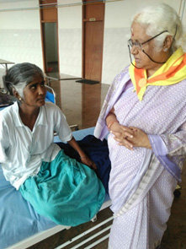
In another such incident, a 51 years old lady from Ratnam Korattur village in Thiruvannamalai Village had severe breathlessness and was found to suffer from advanced heart failure (Dilated Cardiomyopathy). She underwent Heart Transplantation at Tamil Nadu Government Multi Super Speciality Hospital, Omandurar Government Estate, Chennai on 22.02.2018. She is seen below with Smt. Chitra Ranganathan (State Mahilas Coordinator) on 04.06.2018 when she came for follow up.

In our Urban Healthcare Programmes, we have regular weekend medical camps being conducted in all major metros – Chennai, Salem, Trichy, Coimbatore and Thirunelveli. In Chennai alone, we have nine Sai Krupas, with the largest foot falls at R. A. Puram Sai Krupa and Anna Nagar Sai Krupa. A baby girl who had been evaluated in our Mobile Hospital and found to have total loss of vision since birth was evaluated fully at the VHS hospitals, free of cost and counselled to initiate rehabilitative measures as her eyes has severe structural abnormalities.

In our Urban Healthcare Programme, Medical Camps are conducted on Sundays mainly and the Mobile Hospital seva reaches the door steps of every participant especially in Chennai and will be progressively expanded to all major cities of our state.
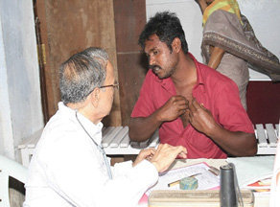
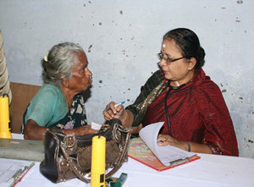
(Patient examined with love and Compassion in Sai Krupa Chennai)
In Chennai alone, there are about ten Sai Krupas supported by the ‘State of Art’ Mobile Hospital, on every Fridays, Saturdays and Sundays in the rural areas.
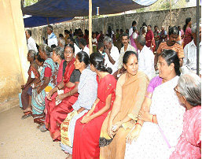
Similarly, regular Urban Healthcare Medical Camps, are also being conducted in other major metros – Salem, Trichy, Coimbatore and Thirunelveli in the weekends. In Chennai the largest foot falls at R. A. Puram Sai Krupa and Anna Nagar Sai Krupa. Every Mobile Hospital camp caters to the needs of about 350 patients, in the Slums in and around Chennai.
(O.P Waiting Area in R. A. Puram Sai Krupa in Chennai)
In all, 938 medical clinics were held in the calendar year 2017, in which, 23,95,000 patients were treated by 39,964 doctors, supported by 1162 paramedical and sevadal staff which would have otherwise cost the patient about Rs. 4,82,74,800/- rupees cumulatively.

All India Medical Conference at PSN on 19th and 20th August 2017:

More than 250 doctors and 26 paramedics from the state of Tamilnadu participated in this event. The objectives of the two-day conference were:
- To extend Gratitude to Bhagawan for giving them an opportunity to serve their Motherland
- To synergise thoughts of the doctors working under the Medical Mission of the Sri Sathya Sai Seva Organisations, India and come together to share their love and experience while working in the Medical Mission
- To discuss and deliberate as to how the present services being extended in different part of the country to be scaled further so as to bring holistic healthcare at the doorstep.
- To discuss ways and mean of expanding the Sathya Sai Medical Services to every nook and corner of the country.
- To discuss as to how preventive healthcare could be promoted using the platform of Sri Sathya Sai Seva Organisations, India.

Sri Sathya Sai Dhanvantari Seva awards

Dr V. Mohan, Member of the Board of Trustees, Sri Sathya Sai Central Trust, who himself is a Diabetologist, is a recipient of more than 150 awards in his illustrious academic career including the Padma Shri by the Government of India and the Dr. B.C. Roy award by the Medical Council of India gave a brief background of the Sri Sathya Sai Dhanvantari Seva award. He stated that this would be the greatest honour any doctor can receive because the name of the award itself carries “Sri Sathya Sai‟ as a prefix and „Dhanvantari‟ – the doctor of Gods in its name. This award was given to those who have selflessly toiled and rendered service in the Sri Sathya Sai Medical Mission for several decades in various States of the country.
The Award ceremony was conducted with great enthusiasm and applause from the delegates and the crowd, for the recipients who were stalwarts in their own fields. Dr.V.Mohan described the awards as a possession more priced than even the prestigious Noble Prize. Sri. R J Ratnakar Sathya Sai Trustee, All India President Sri Nimish Pandya, National Vice president Sri N.Ramani and the National Medical Coordinator Dr. Ram Manohar Rao took great pleasure in honoring all the awardees.

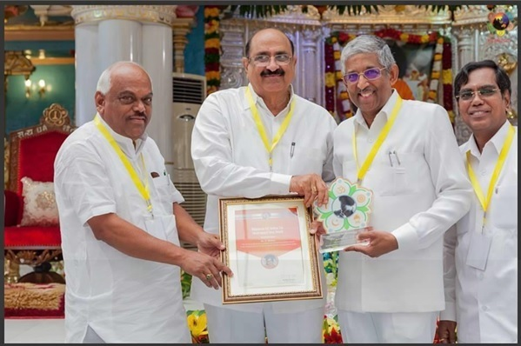

Apart from Sr.V.Mohan, two physicians from the state of Tamilnadu were honoured with Sri Sathya Sai Dhanvantri Awards for their notable contributions as part of the Medical seva rendered by them-

1. Dr Radhakrishnan was born on 15.10.1938. His father Sri M Bhupathi was the chairman of Coimbatore Municipality. He studied his M.B.B.S. in Madurai Medical College. He did his D.O., and M.S. in Madras Medical College. His first Dharshan of Bhagawan was on 1.01.1970 at Puttaparthi. He had an interview with Swami in 1973, in which Swami directed him to move to Coimbatore and later started his own hospital. In 1974, as per the advice of Swami he got transferred to Coimbatore Medical College as Assistant Professor in Department of Opthamology. He had attended his first medical camp of Sri Sathya Sai Seva Organisations at Idikarai village in 1976. He participated in all Medical Camps conducted by the Coimbatore district wing of Sri Sathya Sai Seva Organisations. Initially the camps were held on all Sundays in four villages, later every Sunday he conducted two camps both morning and afternoon in the adopted villages. On 19th of every month mahila camps has been organised at Sri Sathya Sai Mandir , 33, West Club Road, Race Course , Coimbatore, belonging to Sri Sathya Sai Central Trust. During Swamis 75th Birthday celebrations, Swami had blessed to conduct 75,000 cataract surgery in the Coimbatore zone and 25,000 cases were done in Coimbatore district. He has been attending all special Medical Camps at Puttaparthi since Swami's 65th birthday celebrations.
He has been the Coordinator for medical services of Coimbatore zone/district since 1981 and has served and organised more than 1500 free medical camps.
2. Dr. Thangavel, a native of Pudukottai district of Tamilnadu is a private general medicine practitioner. He has been associated with the organisation ever since 2000 when Tsunami struck the east coast of Tamilnadu. The organisation had conducted free medical camps during the peril. Impressed by the selfless seva of the Sai volunteers, He associated himself with the organisation in conducting many free medical camps in the Trichy district and had never missed to attend medical camps being organised at Parthi during Bhagwan's Birthday celebrations since 2000. Also, he had been regularly participating as a Cardiac Screening doctor at SSS Super Specialty Hospitals, PSN. Back home he is conducting medical camps at Kulipirai village on every second Sunday, at Kuppanampatti Village on every Third Sunday and free consultation is given to all the patients on all days at Konapet Village. He also attends the mobile medical camps at Chennai quite often. As a dedicated member of the local samithi at Pudukottai he had been involved in organising many medical camps issuing free medicines to the needy all by himself.

RELEASE OF THE BOOK, “AVATAR’S PRESCRIPTION”

This was followed by the release of the book, "Avatar's prescription" authored by Dr. Vijai Kumar, an ardent devotee of Bhagawan for over 5 decades, HOD Anesthesiology at Anna Cancer Hospital, Kancheepuram, Member of Sri Sathya Sai Trust TN and founder of Sai Krupa at Chennai. The book, penned with Swami's guidance, was released on this momentous occasion by Sri Sathya Sai Central Trust Member, Sri. R J Ratnakar, Sri Prasad Rao, All India President Sri Nimish Pandya, National Vice president Sri N.Ramani, National Medical Coordinator Dr. Ram Manohar Rao

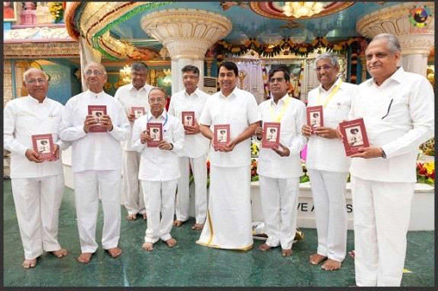

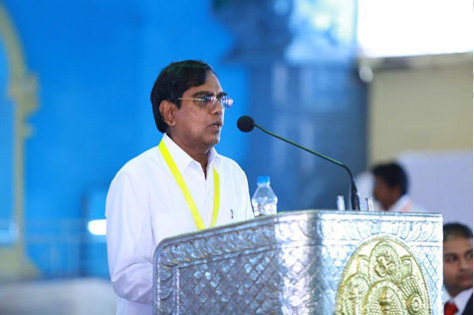
Dr. T. Ram Manohar Rao, National Medical Coordinator of the Sri Sathya Sai Seva Organizations, India gave a presentation on “Sri Sathya Sai Medical Mission- Opportunities for rendering Seva”. He laid out the rules and regulations guiding the Sathya Sai Medical mission in the form of Free clinics, Free Medical camps, Specialty camps, Mobile hospitals and Rehabilitation services. He provided the statistics of the Medical activities done under Sri Sathya Sai Seva Organizations in the year 2016. In terms of man-hours spent by doctors and paramedics, medicines and free surgeries performed, approximate cost estimate in terms of present market value at a conservative rate, in 2016 alone, ended up at over Rs 37 crores.
This was an estimate of the services which were reported in the stipulated time period. Hence, a great quantum of work is being carried out in the Sai Medical mission throughout the country with Bhagawan‟s grace.
He also guided the doctors about the specifications of procuring a drug license, maintaining records about the medicine stocks and the importance of proper documentation in patient care in out-of-clinic settings.

3.3 Sri Sathya Sai Mobile Hospital seva- Performance highlights:

With the divine blessings of our beloved Bhagawan Sri Sathya Sai mobile hospital was inaugurated by Sri. Saidai Duraisami, Honourable Mayor, Corporation of Chennai on 21st August 2014. This mobile hospital seva is being rendered in parts of Chennai and its adjoining districts of Tiruvallur and Kanchipuram on all Fridays, Saturdays and Sundays in the chronological order at 1. Sirudavur village, 2. Chennai Korukkupet, 3. Kodungaiyur, 4. Guruvaraja Kandigai village, 5. Red Hills, 6. Kannagi Nagar, Torapakkam, 7.Arasankazhani village, 8. Ambedkar Colony, Nanmangalam, 9. Karasangal village, 10. Arambakkam, Tambaram, 11. Nandambakkam village, Kundrathur and 12. Nandanambakkam Chennai Trade Centre respectively for the benefit of the down trodden people living in these areas from September 2014.

On an average around 200 patients inclusive of old people, men, women and children are benefitted through this camp. After consultation by speciality departments the prescribed patients are offered medical tests in the technologically advanced and medically infrastructural bus specially designed for the purpose and medicines are offered free of cost to the patients. Renowned and experienced doctors residing in the nearby areas of the camp sites wholesomely participate in the camp which is ably supported by the respective district seva dals.
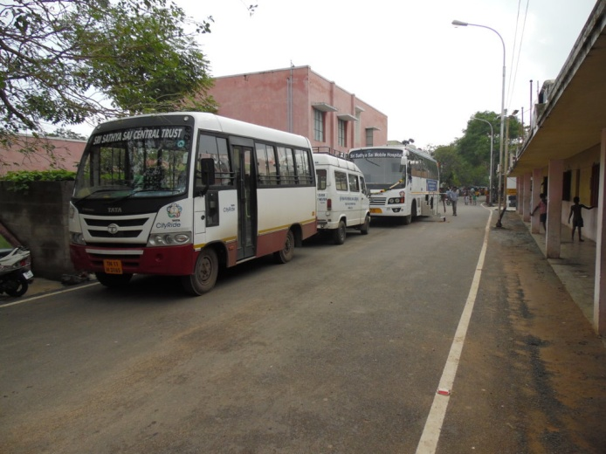
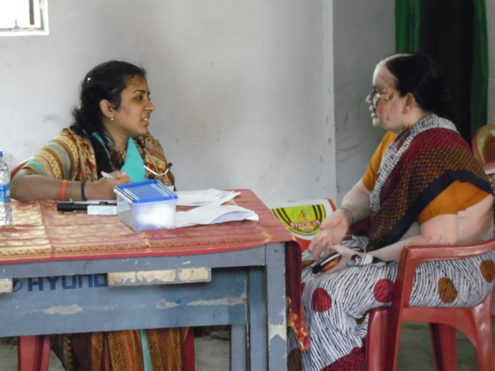
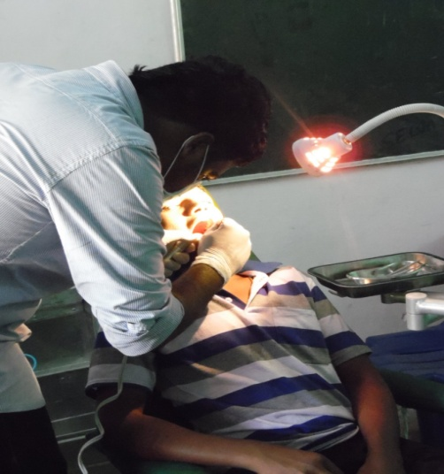

AUM SRI SAI RAM
SRI SATHYA SAI MOBILE HOSPITAL (TAMILNADU)
SSSMH CAMP HALF YEARLY REPORT FOR THE MONTH OF : APR 2017 to MAR 2018
A | No. of SSSMH camps planned | 132 | C | No. of Villages covered |  | 69
B | No. of SSSMH camps conducted | 129 | D | Total Population covered |  | 2,64,000
Out Patients Attended | Average OP | 258 |  | Male | Female | Total
 |  |  |  | 11481 | 21806 | 33287

Total No of Doctors/ Para Medics attended |  |  |  |  | Investigations done
 | General Physician | 549 | Radiographer | 81 | X-Ray | 394
 | Diabetologist | 142 | Ophtometrician | 137 | FBS | 706
 | Paediatrician | 120 | ECG Tech | 128 | PPBS | 413
 | Gyneacologist | 137 | Lab.Tech | 130 | RBS | 13053
 | Dentist | 197 | Pharmacist | 263 | Hb | 534
 | Ophthalmologist | 76 | Dietician | 62 | Creatin | 116
 | Ortho | 11 | Nurse | 110 | CHOLESTRAL | 83
 | ENT | 24 |  |  | Urine Albumin | 64
 | Surgeon | 1 |  |  | Urine Sugar | 60
 | Pulmonologist | 21 |  |  | Refraction | 392
 | Dermatologist | 39 |  |  | Scan | 147
 | Cardioligist | 0 |  |  | Blood Urea | 45
 | Radiologist | 49 |  |  | Pap Smear | 7
 | Others | 6 |  |  | ECG | 914
 | Total | 1372 |  | 911 | Total | 16928

Specialty clinic wise patient attended

 | No. of Antenatal cases issued with Sai Protein | 616
 | No. of Malnutrition Children issued with Sai Protein | 1237

3.4 SRI SATHYA SAI DISASTER MANAGEMENT TEAM – (Tamilnadu)

We all knew that Sri Sathya Sai Disaster Management program was started in the year 2002 and since then the faculty of trainers was conducting these specialized courses to the college students across the state. The course elaborately deals with the precautions to be taken in order to avert calamities caused by human errors, it teaches the participants how to react in the event of eventualities and rescue those in trouble. Since this is an action oriented course it assumed instant popularity amongst youth members of the State. The demand from many colleges to conduct such programs in their institutions/ organization is itself justifies the attractiveness and success of the program. Sri Sathya Sai Organisation, Tamilnadu has taken Disaster Management programs as a medium to reach out to the youth segment and has been successful in inducting a few youths into our organization.

Training Modules:

- DM Intensive training : This is purely for the Sai Sevadals / Sai Youths.
- DM Trainers Training Camp : The interested DM team members are trained to conduct various programs.
- Disaster Awareness Camp : A one full day course conducted usually for the college students. This also acts as a bridge between many college students and our Organization.
- DM Preparedness : For the School students (3 hours’ program).

So far the DM team of Tamilnadu have trained

- POLICE PERSONNEL,
- FIRE & RESCUE PERSONS,
- TAMILNADU SPECIAL POLICE COMMONDOS,
- FISHER MEN,
- FOREST DEPARTMENT PERSONNEL,
- PARA MEDICAL & NURSING STAFFS (GOVT.),
- CORPORATES,
- NSS, NCC, JRC VOLUNTEERS
- We are one of the regular trainers for the Police personnel from 2009 onwards
- Since 2008 we were also conducting the programs at Sri SATHYA SAI University, Puttaparthi.
- ACROSS THE COURNTRY TRAINIED MANY OF YOUTH AND SEVADALS.

OUR PROGRESS SO FAR in Training – (2005- Dec 2016) = 70184 Persons
Disaster Management - TN State RPT- Apr 2018 to Mar 2018
Program | No. of Programs | No. of Participants |  | Total Beneficiaries
 |  | Gents | Mahilas
Disaster Awareness | 82 | 4042 | 2880 | 6922
Disaster Management | 78 | 3864 | 2529 | 6393
Disaster Preparedness | 50 | 1989 | 1743 | 3732
Grand Total | 210 | 9895 | 7152 | 17047

Highlights during the period Jan 2017 to June 2017:
- During this period the Disaster Prepared program was conducted at Sai Vidhya Jyothi Project School at Chromepet.
- The Disaster Awareness was conducted at Royal Enfield which is one of the prestigious Manufacturing Industry at Orgagadam Industrial zone.
- The very special multiple Disaster Management training were regular at Virudhunagar District.
- We are very glad to share that the first and foremost more successful DM program was conducted at Coimbatore sector near Metupalayam.
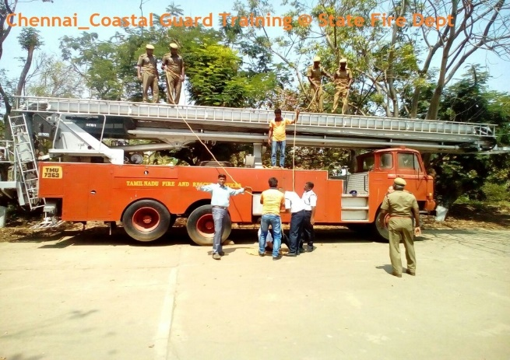
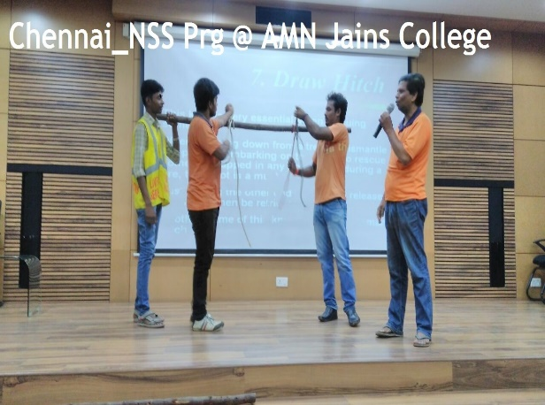
- The Tamil Nadu DM team got a chance to support for the All India Sai DMT for attending conference and to showcase the display of Sai DM Services at Delhi - NPDRR (National Platform for Disaster Risk Reduction - which is the National Disaster Management Authority, Government of India.)
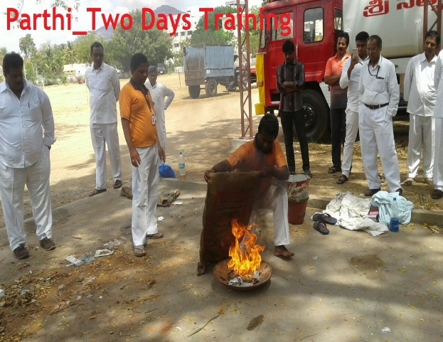
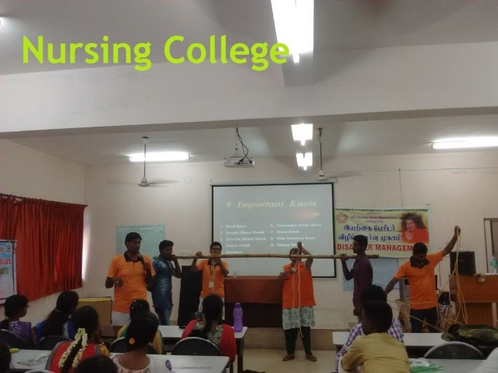
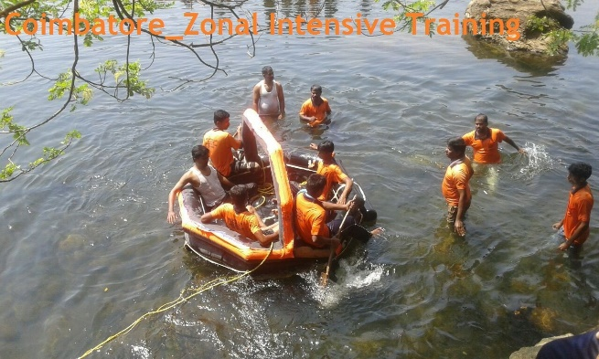
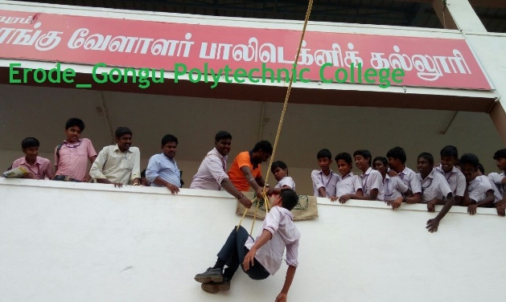

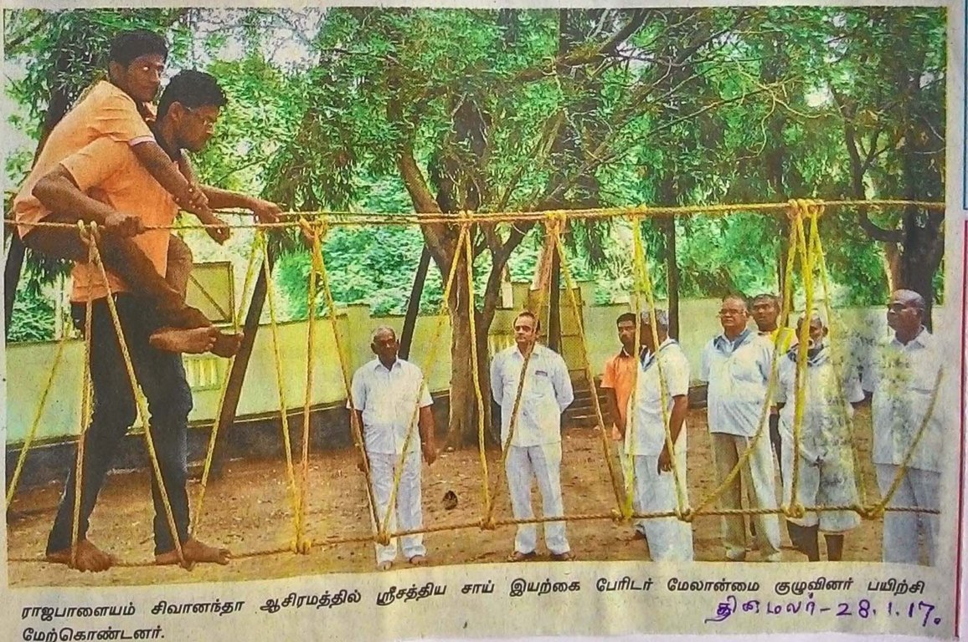
A four day intensive DM training camp was held for Gents and Mahila candidates separately at Rajapalayam Sivanandha Ashram. Mahilas were given training on for two days on 19th and 20th Jan 2017 and gents were given training on the next two days from 21st and 22nd Jan 2017. Totally 66 participants underwent the training of constructing rope bridge and rescuing victims from the flood and high storied buildings.
Highlights during the period July 2017 to December 2017:
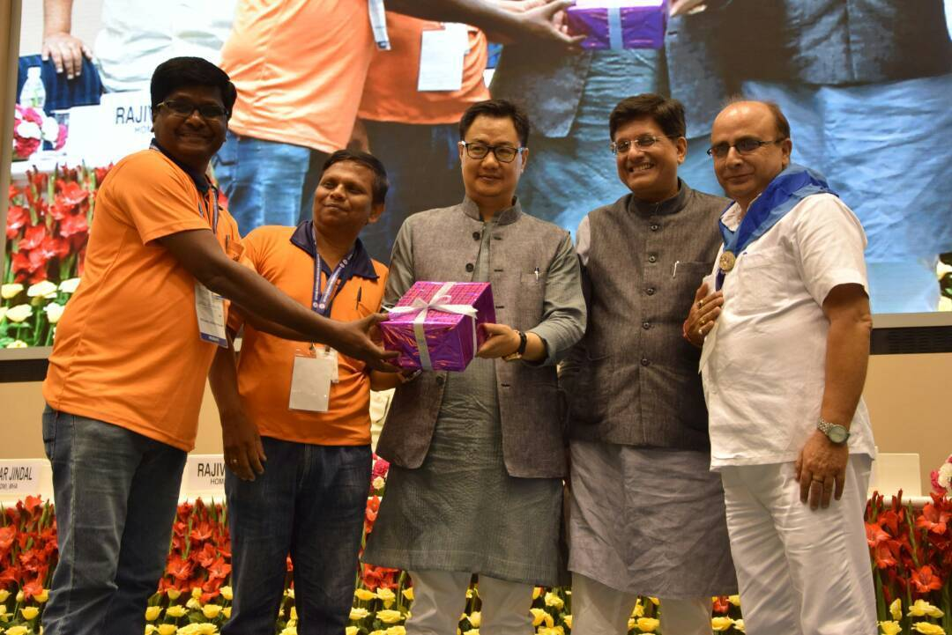
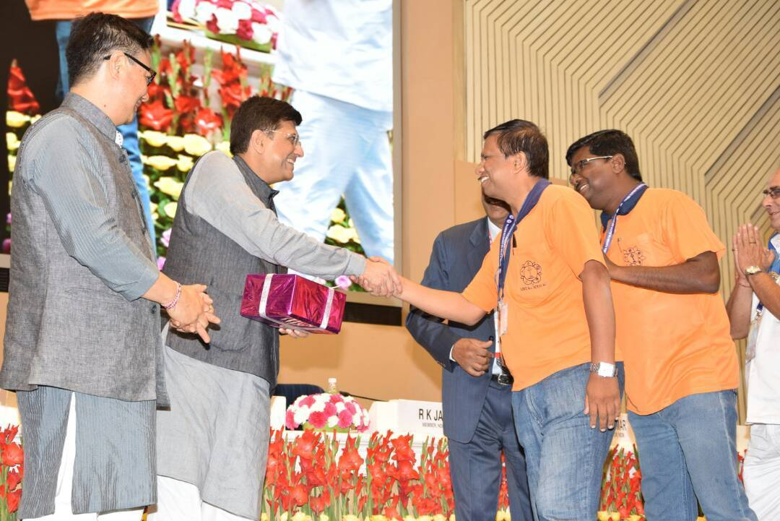
- The Second Meeting of the NPDRR with the theme 'Disaster Risk Reduction for Sustainable Development: Making India Resilient by 2030 was scheduled on 15-16 May, 2017 at Vigyan Bhawan, New Delhi, about 1000 participants from the Central Ministries, State Governments and Union Territory Administrations, Heads of institutions of national importance in the field of disaster management, representatives of Local Self Governments, Central Universities, Civil Society Organizations, Heads of financial institutions and Public Sector Undertakings, representatives of Media and professional experts participated in this national platform. Our DM team from Tamilnadu along with the National DM Coordinators participated in the above program. The Central Government acknowledged the selfless service rendered by the SSSSO-DM Team by providing training in DM across the length and breadth of the country.

- “Safety Orientation Program–cum–Safety Training Session 2017”, at Prashanthi Nilayam [ Friday 14th July 2017 to Sunday 16th July 2017] were provided to-
- Sri Sathya Sai Central Trust, Prasanthi Nilayam,
- Sri Sathya Sai Super Speciality Hospital Authorites,
- Sri Sathya Sai General Hospital Staffs
- Sri Sathya Sai University Authorities
- Prasanthi Nilayam Asharam Staffs.
- Sai Airport Staffs and many others.

The program combined sensitive presentation and practical demonstration on relevant topics such as – ‘Natural Calamity – Disaster Management’; ‘Safety Culture - Rescue Operations and Methods’; and ‘Emergency Preparedness Program – Safety drill’ has been well rendered and the whole session was exceptional and was very purposeful and created an awareness and self confidence among all the participants. The subject being vital and most sensitive, we would like to arrange similar program on safety related topics, for the benefit of various other units of our organization handling responsible activities.
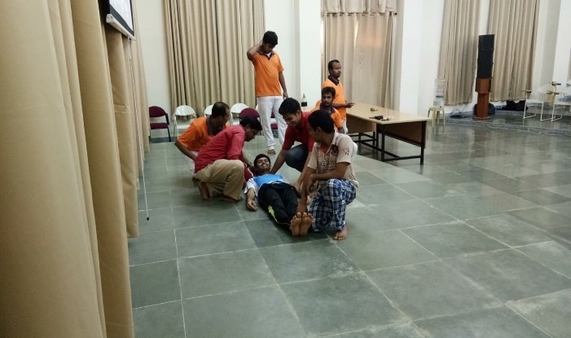
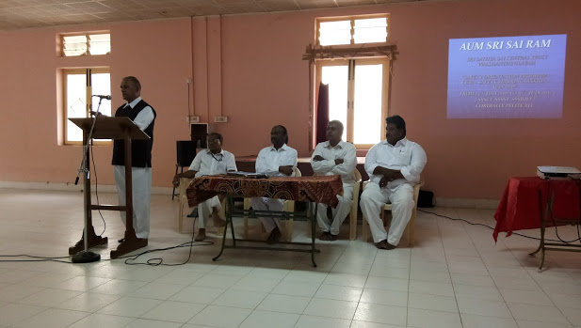
- The TN Disaster Management Commissioner had issued a circular to all District Collectors and DRO’s to utilize the help of SSSO-TN DM Team and provide training to the first responders and other field level officers in the District with respect to conducting a Disaster preparedness program and enhance the skills of the first responders during any disaster situation. Accordingly, the SSSSO-TN DM Team had provided training to around 4400 such government officials and staffs across 26 districts of TN. In all 37 such training programs were conducted to reach out to 2827 gents and 1578 Mahila government staffs.
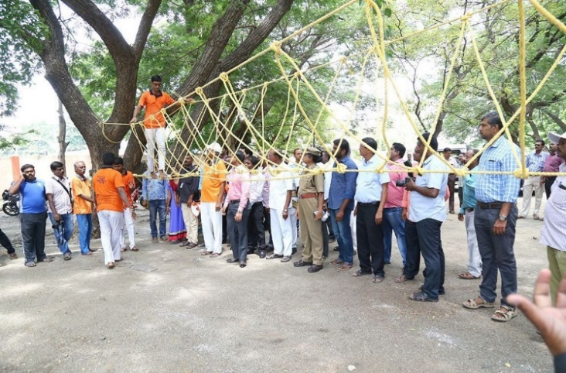
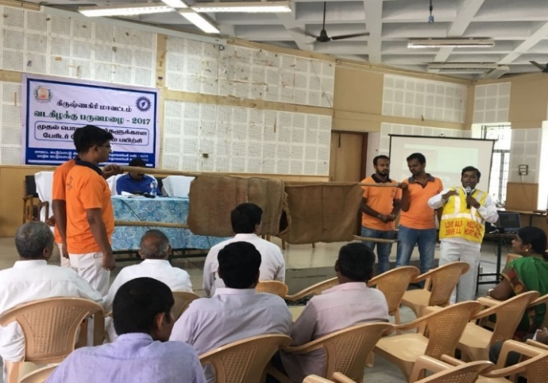
@ Krishnagiri District @ Madurai District
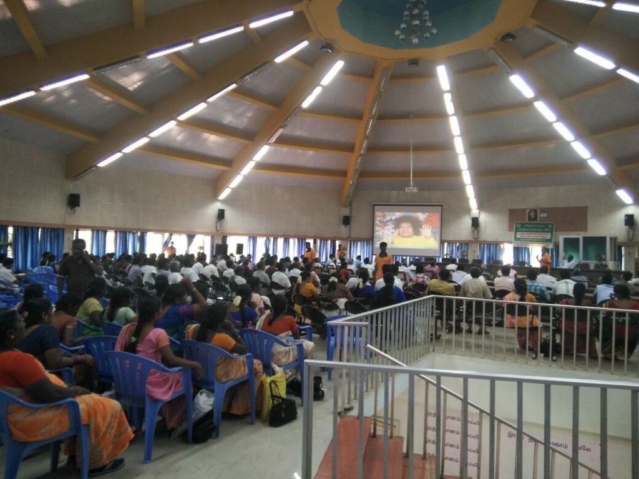
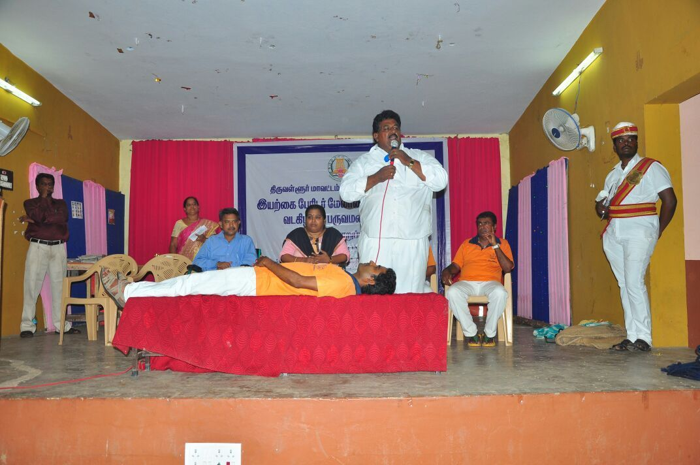
@ Theni District @ Thiruvallore District

- 5th State Level Flood Rescue Training for the Disaster Management Team of Tamil Nadu State was held on 25th December 2017 at Karur - Cauvery River near Mayanoor.
The training started with the basics and experience of Chennai Flood Service, practicing Aerial Ropeway technique, monkey crawling, preparing rope bridge, shallow crossing, human chain, rescue person from tree during flood situation, etc. After the basic training they were taken to the nearby Cauvery River, where all kinds of rescue exercises were practiced extensively with the ropes provided to the teams.
First Exercise was Aerial ropeway rescue, one rope tied across the river and people should use this rope to cross the flooded river which was followed by rescue using Life-buoy & Life jackets rescue. Then shallow river crossing, a method used to cross river during the low current flow, rescue by rope & pulley using a fire man’s chair knot over the heavy current water flow was practiced.
All these were practiced with full safety by tying a separate aerial rope at the other side of the river and 4 well trained swimmers were present there to rescue those who slipped in aerial rope or pulled by the heavy current of the river.
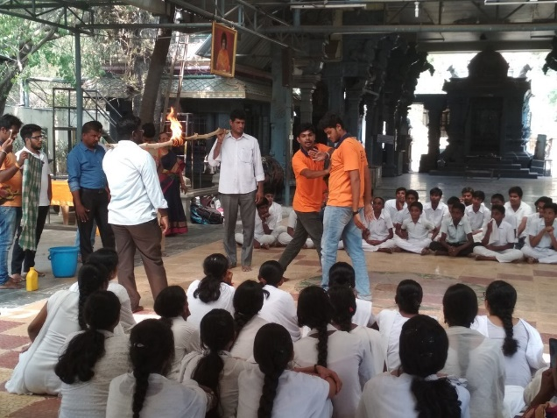
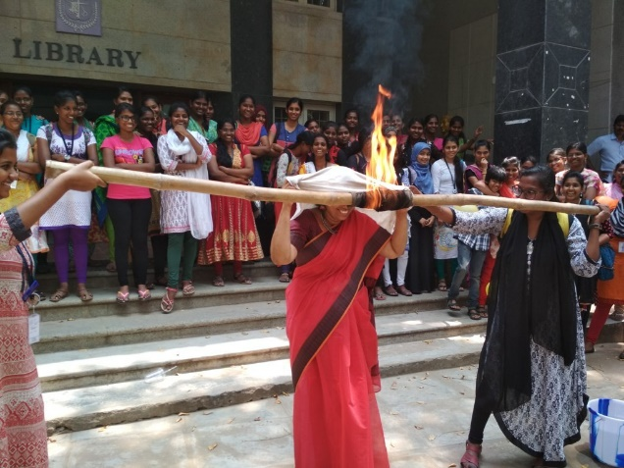
A Long rope bridge of 35 meters was prepared and brought to the river and the same was tied at the 2 ends and river crossing exercise was carried out. This is normally done only by the professional rescue teams like Fire & rescue team and NDRF.

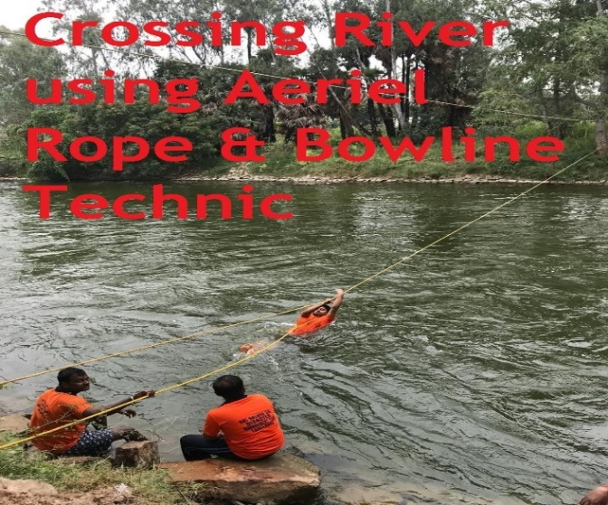
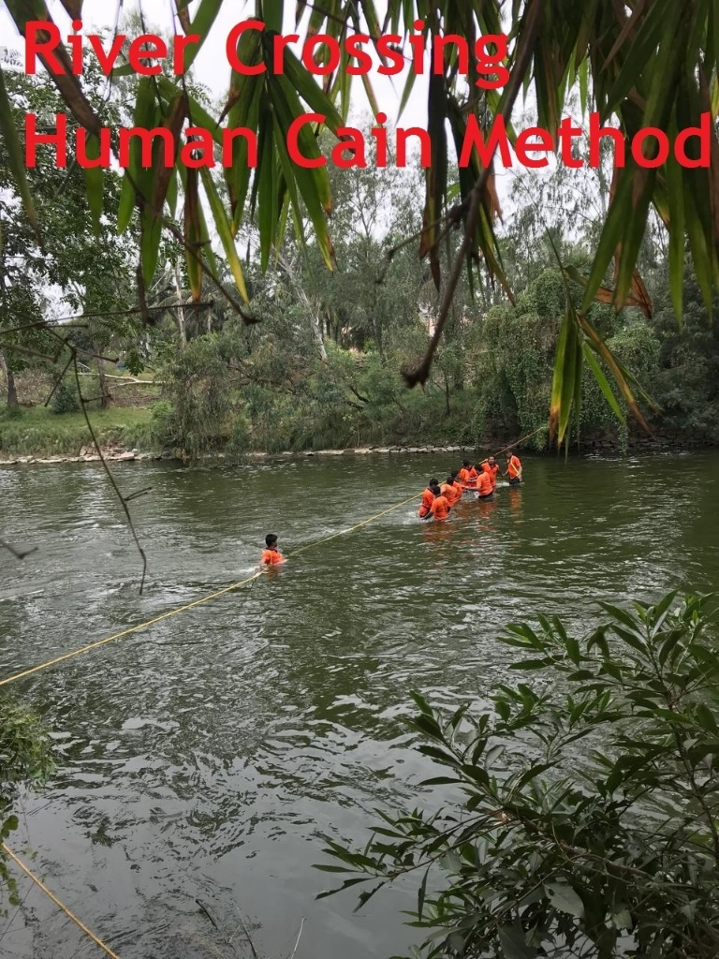
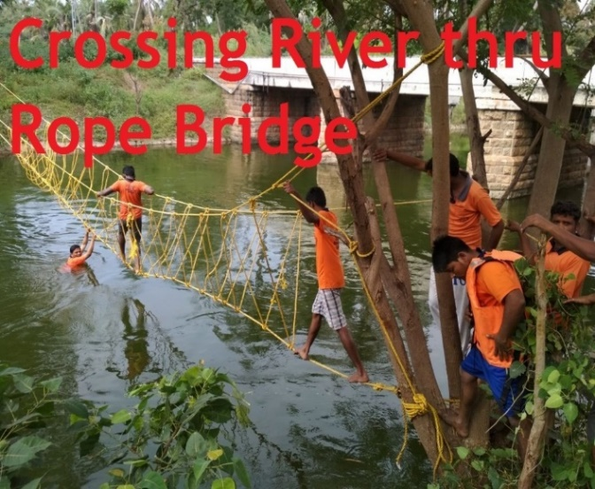
Two Days South Zone Level Intensive Training Camp conduct by Virudunagar Team for both gents and mahilas. The program was conducted from 03-01-2018 to 05-01-2018 wherein 58 Mahilas and 66 gents participated. The program was attended by District President Sri.Matchavel, Dr.Govindharaj, Sri.Palanisamy- District Fire officer and Sri. P/J/Ramkumar- Home guard area Commander.

3.5 Reach out with Love:
Bhagawan Sri Satya Sai Baba in His infinite mercy has given us two Super Specialty Hospitals, one in Puttaparthi and another in Whitefield, Bangalore. Both the hospitals are equipped with most modern equipments and offer free medical care for all patients. Every day poor patients unable to get good medical care due to the present day high cost of treatment flock to these hospitals. So far more than 62000 cardiac surgeries, 40000 Urology related surgeries and 13000 Neurology surgeries have been performed in these hospitals.
Sri Satya Sai Seva Organisation, Tamil Nadu has taken up a new initiative to reach out to all the patients residing in Tamil Nadu who have benefitted from the above hospitals. Sai volunteers in every district would go to the patients’ homes and enquire their well being. Invitation regarding a re-check up camp at the nearest Samithi is informed to them.
Doctors and other para medical staffs from the Sai medical fraternity would then conduct a thorough check up of their present health condition and guide them in leading a proper, healthy life. In some cases, patients who require further medical treatment were advised to contact the Super specialty hospitals. The Medical team would also instruct them the need for regular medications and tests to be done at regular intervals etc. along with some simple exercises to keep themselves physically fit.
The "Sai Rehabilitation Programs" (SRP) has been rechristened as "HRUDAYA SANGAMAM" in the state of Tamilnadu. During the preceding half year period of July 2017 to Dec 2017 around ten such patient contact programs were conducted across the state.

- HRUDAYA SANGAMAM EVENTS (JULY 2017 TO DECEMBER 2017)

S.NO. | MONTH | DAY | DATE | DISTRICT | DISTRICTS PARTICIPATED | NO. OF SRP BENEFICIARIES
1 | AUGUST | TUESDAY | 15-08-2017 | COIMBATORE | COIMBATORE | 41
2 | SEPTEMBER | SUNDAY | 24-09-2017 | VIRUDHUNAGR | VIRUDHUNAGAR | 7
3 | DECEMBER | SUNDAY | 17-12-2017 | ERODE | ERODE | 11
 | TOTAL |  |  |  |  | 59

(II) SRP PATIENT DISCHARGE SUMMARY - SSSIHMS WHITEFIELD & SSSIHMS PRASHANTHIGRAM
PATIENTS DISCHARGE SUMMARY | No. of PATIENTS | NO. OF PATIENTS CONTACTED (OVER PHONE/PERSONAL VISIT)
( 01.07.2017 TO 31.12.2017)
SSSIHMS, WFD | 89 | 80
SSSIHMS, PARTHI | 18 | 15
GRAND TOTAL | 107 | 95

(III) ALL INDIA DOCTOR’S CONFERENCE ON 19TH & 2OTH AUGUST 2018 AT , PRASHANTHI NILAYAM .
Attended the above Conference and presented PPT on Implementation of SRP in SSSSO TN at Sathsangh Hall on 19.08.2017.
(IV) FIELD VISITS
House Visits to the beneficiaries were undertaken along with SRP Coordinators in respect of the following Districts.
Salem – 06-08-17 - 6 Beneficiaries
Tiruppur – 14-08-17-10 Beneficiaries
Gudiyatham, Vellore – 10-09-2017 – 5 Beneficiaries
Kancheepuram – 15-09-17 – 2 Beneficiaries

(V) HOUSE BHAJANS
House bhajans have been conducted at the residence of SRP Beneficiaries as under;
- At Thindal, Erode District on 7.8.2017.
- At Olathur, near Padalur, Trichy District on 15.8.2017.
- At Vellore, Vellore District on 16.09.2017

(VI) AUDIO CALL CONFERENCE WITH SRP DISTRICT COORDINATORS on 24.10.2017
An Audio Call Conference was arranged on 24.10.2017 to discuss SRP progress in various Sai Districts. It was attended by good number of SRP District Coordinators. The programme lasted One hour. SRP Coordinators have expressed satisfactory over the Call Conference and very useful.
VII) PRASHANTHI SEVA OCTOBER-NOVEMBER 2017 BY SRP BENEFICIARIES
Few of the SRP Beneficiaries from the Tirunelveli, Erode, Vellore and Trichy Districts have participated in the Prashanthi Seva - OCTOBER-NOVEMBER 2017 Period.

3.6 Sri Sathya Sai Rural Vocational Training Centres- A special focus
“In earlier times Sathya and Dharma were the divine directives for students. Not only this, the students were exponents in carpentry, pottery and mason skills too. Only then they were competent enough to take up any work and make a living and earn righteously. “
- Bhagawan Sri Sathya Sai Baba
- (18th Convocation address delivered on 22nd November, 1999)

Bhagawan’s elicitation regarding olden times is very suitable for modern times. These are true in the sense, in villages; carpentry and pottery are modes of earning. These are not only earning modes but very much essential too. How is education in such villages? Let us analyze whether these children benefit after completing education?

The school going children besides education are greatly benefitted by attending bal vikas classes. The government has passed a law that everyone has the right to education. But the irony is that the students, boys and girls in villages discontinue their studies. The basic reason is that they need to take care of their younger brother or sister at home or to help their parents toiling in the fields. After taking care of their siblings and helping their parents, the children’s coming to school is a million-dollar question, rather never ever. That is why they wander in the streets and grow uncared.

Realizing this pathetic situation of these children, Sri Sathya Sai Seva Organisations have stepped up rural vocational training centres for the benefit of the young men and women of the villages to make a livelihood with a fairly decent earning.

With this noble initiative the young men are trained in skills like plumbing, electrical, mechanical, cell phone repair and computers.

For the young women are trained in soft skills like tailoring, typewriting, embroidery, beautician course and computers. After the three months course certificates are being awarded. After this course the trained young men and women are skilled either to take up a job or be self-employed.

Besides these courses, ethics, courtesy with a maturity to manners with how to move about in the society and basic arithmetic are also being taught to groom their personality in totality. With these they groom as ideal citizens of the society.

Our role is when we make a visit to our friends or relatives residing in villages let us make a point to identify students who have discontinued schooling, explain and convince their parents and also guide them to enroll their children in Sri Sathya Sai Rural Vocational Training Centres in their respective or nearby villages.

Let us undertake this noble seva to inculcate faith and hope in the minds of the young men and women from poor and downtrodden families and guide them to be self-dependent and gain self-respect in this society. All these courses are offered completely free. I t is to be noted and brought to the notice of the village mahilas that since fairly long time in Chennai metro and other districts the soft skills courses for mahilas are undertaken by mahila faculties.

- One of the three National initiatives envisaged, as our humble and loving offering to our beloved SWAMI before 90th Birthday and also, as part of 50th anniversary celebrations of SSSSO, is “Sri Sathya Sai Rural Vocational Training centers”(SSS RVTC) .These centres are proposed to be set up in rural areas in all the States. SSS RVTC will be unique, in that it is envisaged to train youth, from SSS VIP Villages and cluster of villages, in multi skills. The choice of skills is such that they shall be able to pursue their profession in the village itself.
- The suggested skills are: Plumbing , Electrical wiring , welding , Carpentry, Mobile phone servicing , Two wheeler servicing , Mason , Motor rewinding , Bicycle repair, Tyre Puncture sealing , Bicycle repair, Basic Tractor and farm equipment servicing etc,.
- Four Centres have already been started and functioning in Tamilnadu :
- Tirunagiri, Nagapattinam district. Started on 20.4. 2014
- Training in Plumbing, Electrical, Two wheeler servicing and Carpentry
- SSS RVTC coordinator: Sri. Thirunaganasambantham
- Nanmangalam , Kanchi North district : Started on 21.4.2014
      - Training in Electrical, Plumbing, Two wheeler and Carpentry.
      - SSS RVTC Coordinator: Sri.Ramakrishna and Sri. Jayaraman
- Thirukkurungudi ,Tirunelveli District : Started on 23rd November 2005
      - Training in Electrical and Plumbing
- Chitthode, Erode District: Started on 04-12-2014
      - Training in plumbing, masonry and electrical.

Apart from the above centres the Chennai metro district alone have around 11 vocational training centres functioning at various locations-
S.No. | Location | Coordinators | Contact Details
1 | T-Nagar | Smt.Pushpa Santhanam | 9444052743
2 | Puliyur | Smt.Meena Rajagopal | 9445117397
3 | Solinganallur | Smt. Priya Muralimohan | 9944000194
4 | Adayar | Smt. Girija | 9176733291
5 | Amudham Colony | Smt. Jyothi | 9445124750
6 | Perambur | Smt. Malathi Vijayalakshmi | 9741392962
7 | George Town | Smt.Saraswathi | 9941297891
8 | Madipakkam | Smt. Lalitha | 9626269135
9 | Chengalpet | Smt. Rajalakshmi | 7904185302
10 | Padappai | Smt.Vasanthi | 8220456325
11 | Guduvancheri | Smt.Sumathi | 9444673575

3.7 Sri Sathya Sai Vidhya Jyothi Project- Tamilnadu
Sri Sathya Sai Vidya Jyothi Project has been adopted in 93 schools in Tamil Nadu so far. The project has far flung reach with the whole-hearted involvement of more youth members and volunteers through youth and alumni meets and disaster management programs conducted in colleges. The interesting aspect is just as a sculptor who chisels idol in a stone besides engraving the form in his heart so also these volunteers too have been marching on the path of spiritual transformation through their involvement.

Pearls of love

The schematic approach to the project has various facets. They include:

The first aspect of the undertaken under SSSVJ is individual care. That is, sound mind in a sound body. The programs under this aspect include monitoring growth of the students, mother and child care, malnutrition eradication, etc. Besides these it also include inculcating moral values in children through regular balvikas and EHV programmes. A training program to empower teachers to handle bal vikas classes too is underway. To enhance the creativity of the students drawing competitions, arts and crafts classes are conducted. This is the gateway to Individual transformation.
The second aspect is environmental care. This includes providing environmental awareness to create a good ecosystem for effective learning. Also, basic infrastructure needs, such as, installation of RO, painting black boards, regular lavatory cleaning, construction of toilets, classrooms are catered to. This leads to Associational transformation.
The third aspect is community transformation. It implies tuning the young minds to see their very reflection in the society and serve them. These activities include celebrating all religious festivals in schools to bring communal harmony, swacchata se divyata tak (cleanliness leads to Godliness), dengue awareness etc. This kindles a concern for the society which is true Spiritual transformation.
Hence the SAI legacy of love flows incessantly through the Individual, Associational and Spiritual transformation making the Sri Sathya Sai Vidya Jyothi Project verily a manifested form of SAI tattwa making the students pioneer towards perpetual love in action.

The Programme has been successfully implemented in 96 Government schools across Tamil Nadu and Pondicherry . Through this project we are targeting nearly 1.8 lakh students getting benefitted. This will indirectly reach out to nearly 3.5 lakh parents and siblings. And, most importantly, more than 25,000 volunteers, from the rural sector and the urban sector will be coming together to make all this happen – which, in all it its glory, is verily nation building.

The program not only encompasses the children and teachers, but also the families, school management, community, government and the volunteers; all of them are considered as the stake holders who can positively impact and get impacted by this program.

This program shall be spearheaded by the youth of the organization with a special outreach program to rope in more youth in this noble nation-building mission. This program shall also provide a rare opportunity to the youth from the villages in building their own future society, helping their siblings get good education and character by assisting the volunteers from the organization. The Seva Dal, Mahila Vibhag, Bal Vikas gurus and other active workers of the organization will take active part to ensure its successful implementation. It’s shall be a teamwork of its kind exhibited by the organization time and again.
No of Schools adopted under SSSVJ in the state | 93
No of revenue districts in the state | 32
No of districts having organizational Presence | 30
No of districts where SSSVJ schools are located | 29
No of Samithis in the state | 392
No of samithis having adopted school | 135
Addition no of schools intended to be adopted (in the current academic year) | 7

Child-Centric Activities

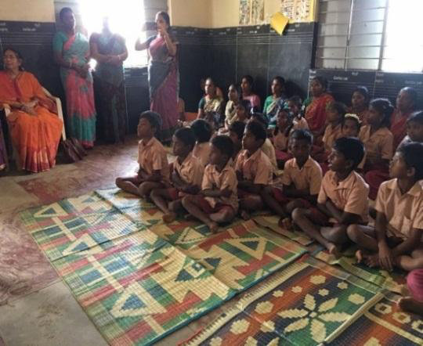
Health and hygiene session was conducted and stressed the importance of nail cutting, daily bathing, hand wash etc. at Panchayat middle school, Varapalayam.
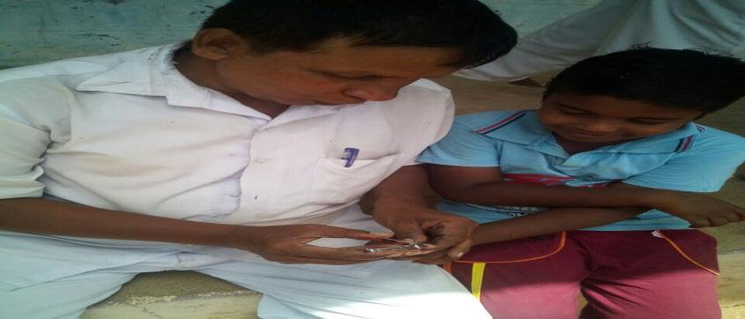

As part of health and hygiene program nails were removed of a student at Manikapuram Panchayat union middle school.
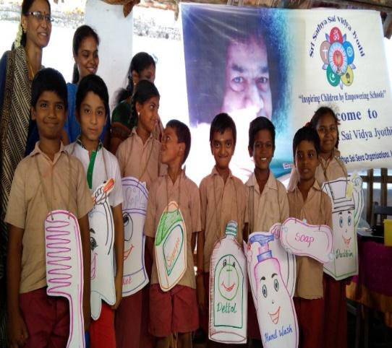

Health and hygiene session organized at Ramanujar middle school, students dressed like sanitary items and showed the importance of cleanliness.

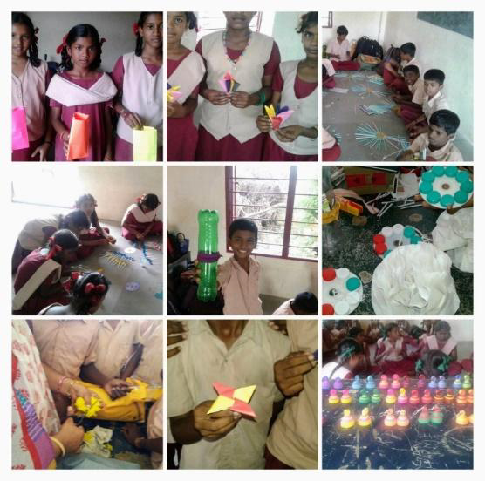
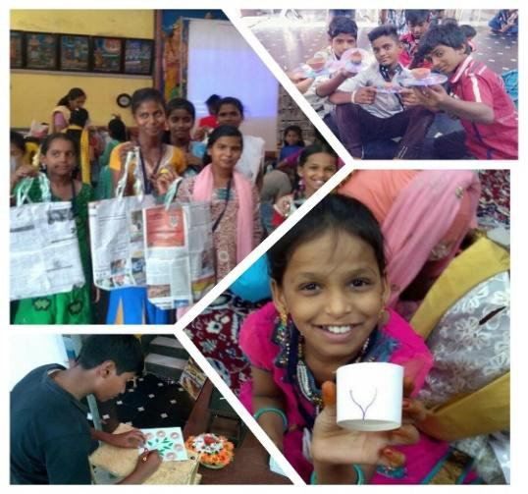
‘wealth out of waste”. Arts and crafts classes conducted at ramanujam middle school. Students were asked to make gift items using teacups, news papers, old CDs etc..

Wealth out of waste – crafts making class was conducted at old Perungalathur higher sec. school. To enhance the creativity of the students and to empower them to make useful things out of the waste. plastic covers, water bottles, newspapers, ice creams sticks, old magazines, plastic spoons and straws were used to make crafts.

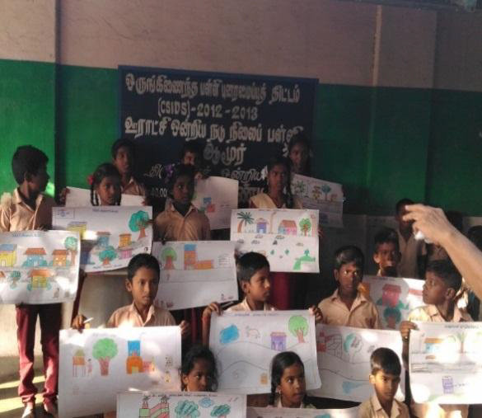
Drawing competition held at Siruthabvoor, kadambadi and amoor middle schools and certificates were distributed for all participants.
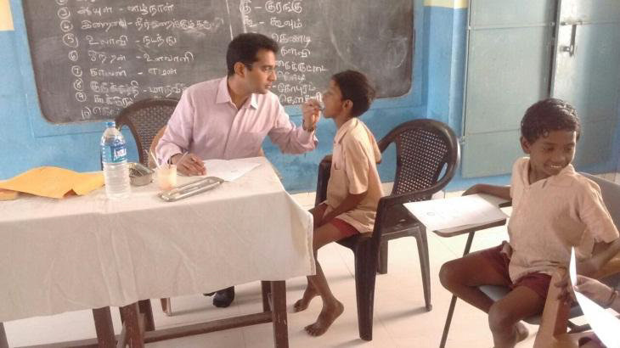

Dental care awareness and dental screening conducted at Corporation middle school, Kodungaiyur.

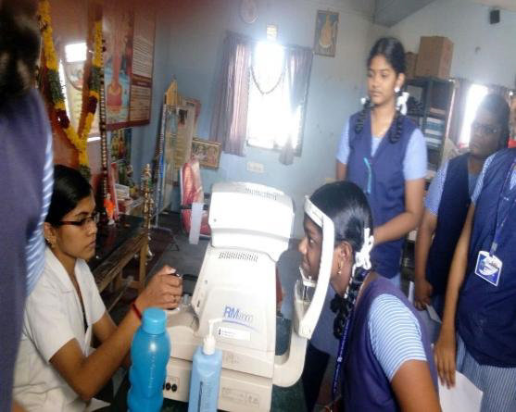
Eye screening program conducted at Baba matriculation school – kayatharu, students were provided glasses for correcting their visions.

Parent-Centric Activities

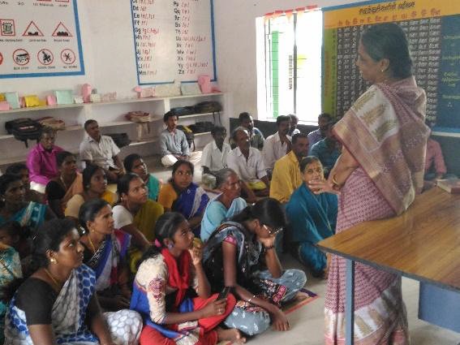
Around 50 parents attended the parenting session held at Siruthavore middle school . The program covered topics such as role of mother in creating good citizens , importance of listening , how to communicate with children in a positive way & Home sweet home etc.
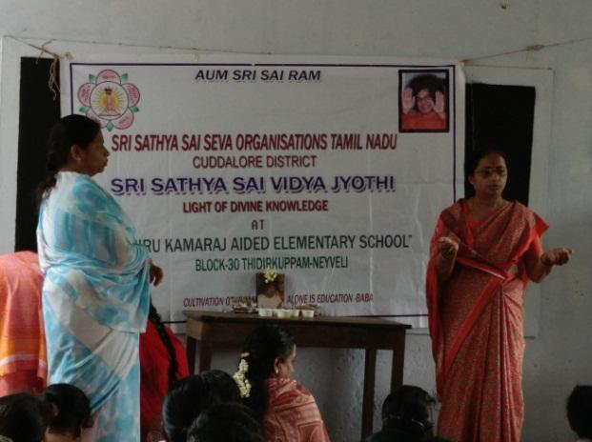

Parenting workshop on health of the children and benefits of Sai protein, conducted at Kamaraj middle school , Cuddalore . Easy way to prepare sai protein was also taught to mothers.

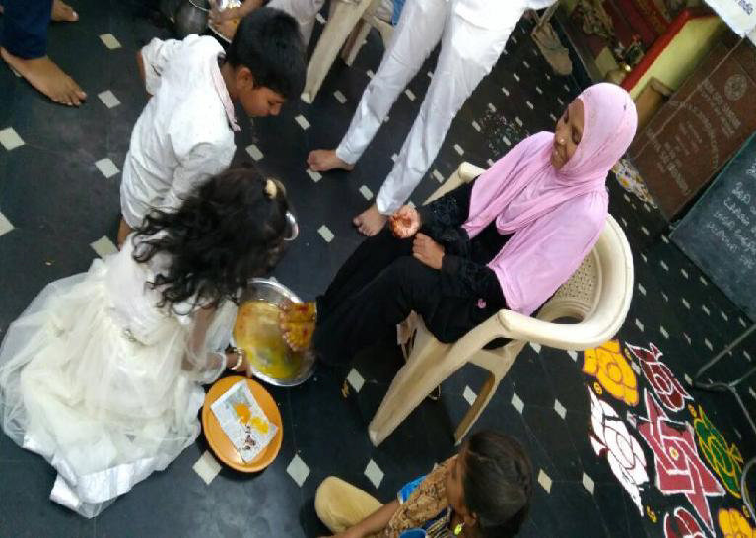

Mathru pooja was performed by the students during the summer camp for SSSVJ School at Vellore district.

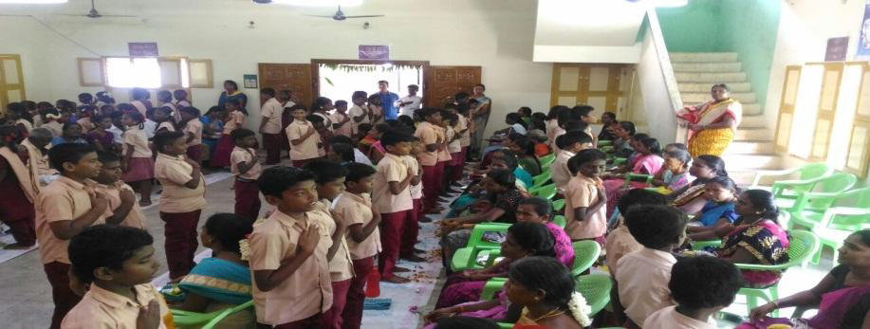
Students from Panchayat middle school Sengamala nachiyar puram performed mathru pooja as a mark of worshiping their parents. Parents expressed their Happiness and blessed the children.

Parent-Centric Activities

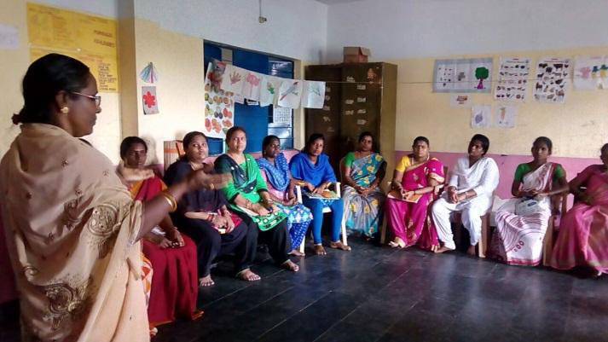
BV / Moral class training conducted to teachers at siragu Montessori school, Smt.Ramani Mohan Sairam spoke about inculcating human values to children.

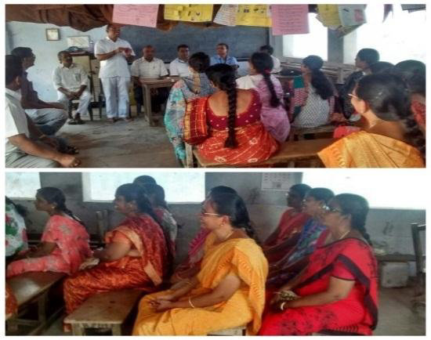

Special session on SSSVJ was conducted at Ramanujam Middle School on Dec 16, Feb.17 to energise teachers for SSSVJ. The role of teachers in SSSVJ was explained.

School-Centric Activities
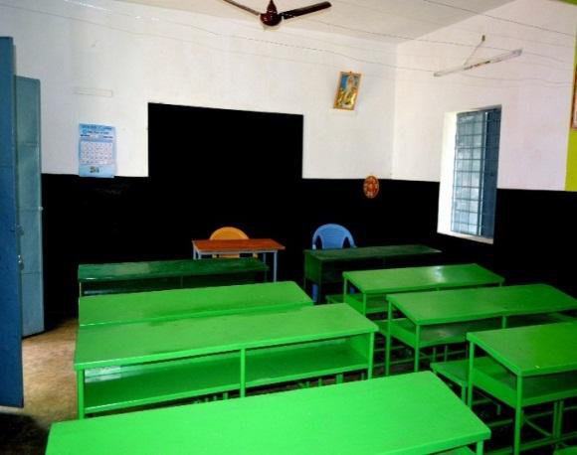
Renovation of school infrastructure like painted the whole school, class rooms, black boards, installed RO system, water storage tank with plumbing facility, electrical wiring, toilets repaired and old furniture repaired and pained at Siruthavoore Middle school. The completed infrastructure works were handed to the school authorities by the state president SSSSO TN.

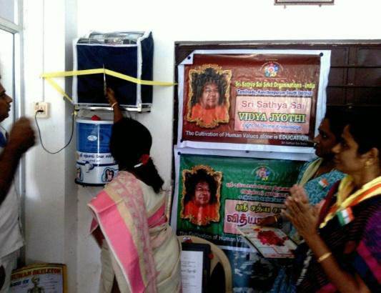
25 litre RO water purifier instrument with plumbing and pipe fittings from overhead tank were installed at the old perungalathur Hr Sec School.

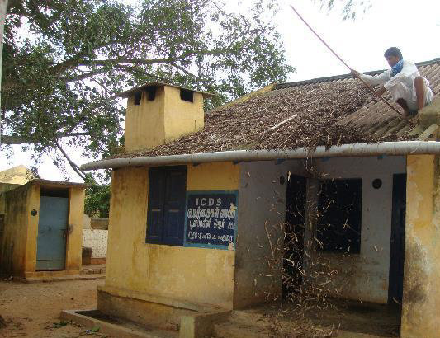
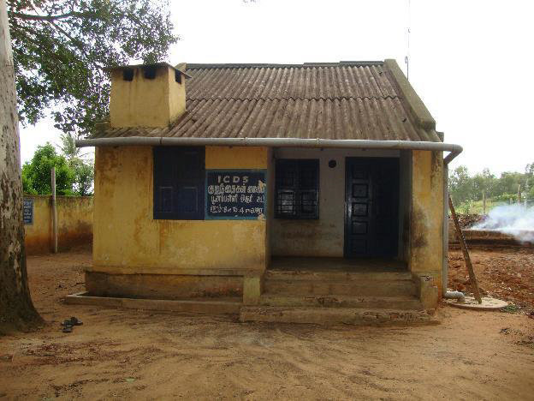
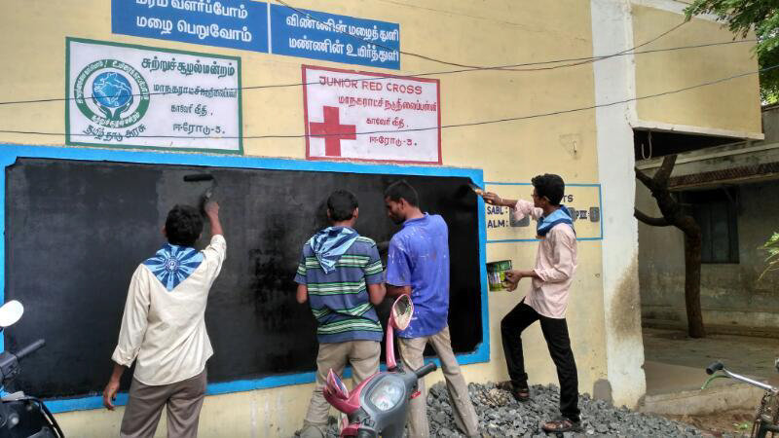
Roof cleaning works done at Panchayat middle school, Poonampalli.

10 youths from Erode team volunteered to paint 81 black boards at Corporation middle school, thirunagar colony, school management appreciated our youth team.
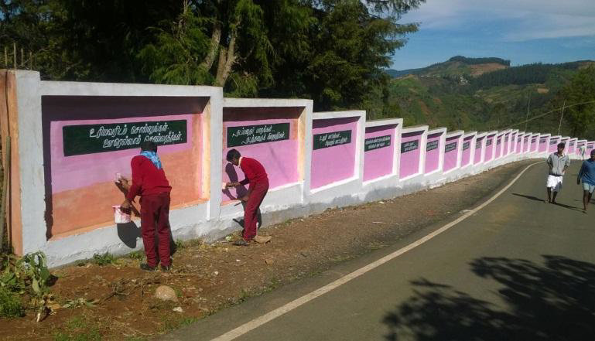
Students themselves painted the whole school premises and gave a new look At Yedakkadu Govt Hr Sec School.

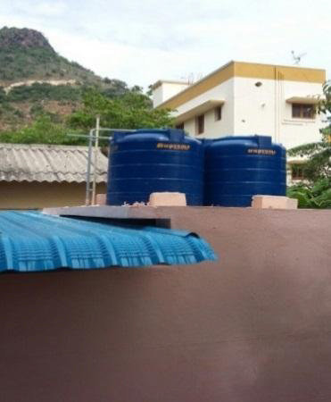
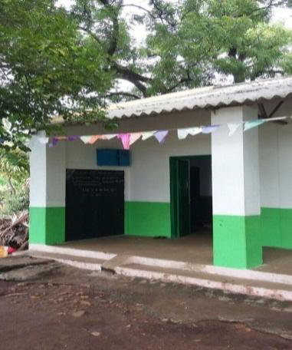
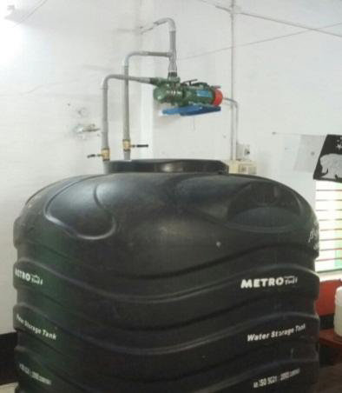
Infrastructure works completed at the Panchayat union primary school Perumal malai adivaram, Salem Dist. Most of the students of the school are from remote rural village and tribal areas. Infrastructure works like white washing of entire school, Fixing of toilet roofs, water storage tanks with complete plumbing works, new water connection provided with drinking water storage facility, new motor was installed.

Seed ball making
With the blessings of our Swamy we have conducted environmental awareness and seed ball making process at the siragu montissory school, Panchayat union middle school, Iyyathampattu , Saibaba Gorukulam, Nallattur, Tamil Nadu . Before introducing the concept of seed ball making to the children, we have conducted environmental awareness to children on the concept of climate change and the environmental pollution. We stressed on how we are contributing to these changes through our anthropogenic activities and the various impacts that we face as a result of ongoing climate change. We also emphasized on actions in order to mitigate the climate change as an individual and community through our day today activities. It is indeed important to
disseminate the knowledge of climate change to our children because they are one of the stake holders to tackle the issues.
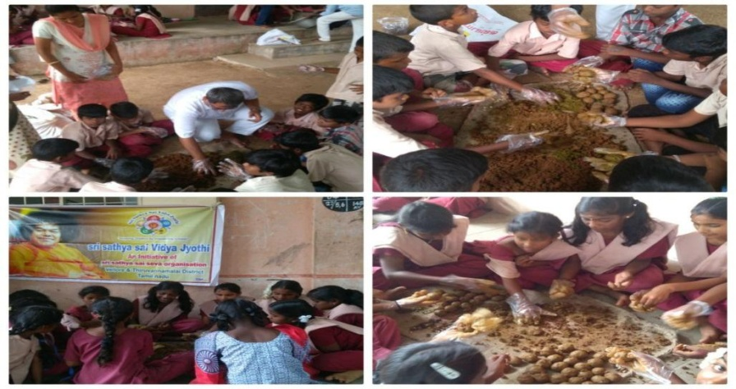
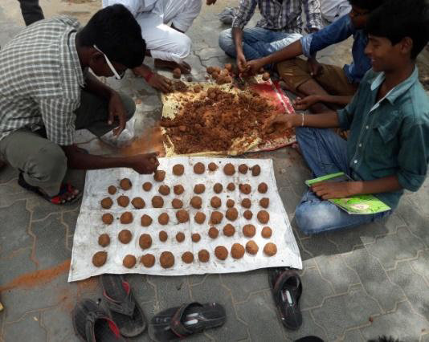
Seed ball is the process by which the clay soil will be mixed thoroughly with cow dung or manure by adding little bit of water in 1:1 ratio and made into dough like form by which the seed balls will be prepared by adding seeds on the clay balls . Until the time of germination; the seeds will be protected from insects and birds. Seeds balls will be distributed for dropping at the identified area when it is completely dried. This technique is used to increase the green cover drastically in areas such as near highways and other barren lands and can regulate extreme temperatures with improvement of native trees.
This concept was first introduced by the Japanese agriculture scientist Masanobu Fukuoka on his book one straw revolution. Experts say the success rate of saplings born out of seed balls tends to be high and it is based on the survival of the fittest concept. The concept is very popular among the nature conservation groups and it will attract to do this concept by all sections of the
community.

WALL OF LOVE
As part of Sri Sathya Sai Vidya Jyothi Project our Sai brothers and sister have been visiting our schools regularly and doing impactful service activities which will benefit the school children, parents and teachers. As we move deeply into the project , it is our responsibility to make our school children self sustainable .
As a mark of Swami’s 92nd birthday celebrations, we have planned to involve our children with a unique activity to foster the act of doing seva and to share love and offer to Swami as a birthday gift . This activity requires little effort from our side, but could create great impact in our children. With blessings of our Swami the below activity is a good start for them to do more responsible service in the future. As swami says "From the most impressionable years the children should be taught to cultivate love for all. Love leads to unity. Unity promotes purity. Purity leads to Divinity". — Sri Sathya Sai Baba

WALL OF LOVE (ACTIVITY)
1. Tie a piece of white cloth along with children friendly paint besides in a bowl, inside the school premises
2. Share *stories* related to sub values of *Love* (such as caring, compassion, empathy, forgiveness, helping, patience, sharing, etc) with the children.
3. Ask children to practice love, service for the entire November and imprint his/her hand for every act of love practiced, at the end of the week.
4. Request for a teacher in-charge, if possible, or one of our teammate can take in-charge of the activity monitoring.
5. The in-charge will hear stories from the children (sharing of their love with friends, family, elderly person, differently abled, etc) , to check if genuine and writes children's name in the handprint
6. At the end of November, count the imprints under each name; gift the children with maximum imprints and token gift for all children with at least one imprint
7. Offer it to Swami on behalf of our children Till now the wall of love has been successfully implemented at the following schools of Tamilnadu-
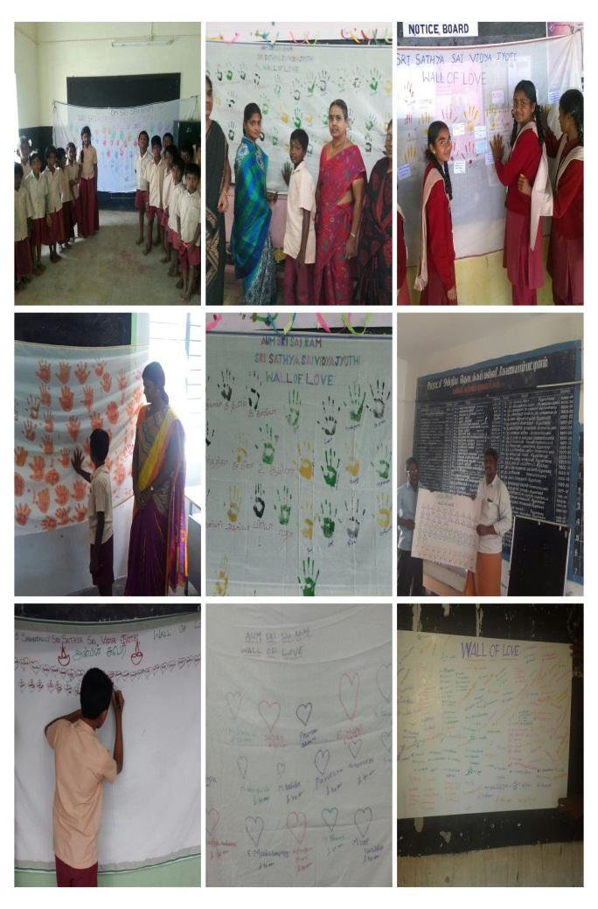
1. Government middle school – Shoolavandan
2. Government high school Ootiyampakkam
3. Avvai kalvinilayam – Namakkal
4. Punchayat middle School Embaavi
5. Punchayat middle school Konayampatti
6. Governemnt High School – Thirunagari
7. Punchayat middle school – Periyanemmeli
8. Panchayat union primary school - Asaramam
9. Punchayat middle -Sarakarapalli
10.Siruthavoore panchayat middle school
11.Varapalayam panchayat middle school
12.Panchayat union middle school – Soolai
13.Panchayat union middle school – Bikshandar kovil
14. Hindu middle school – Thirukurungudi
15.Corporation middle school Narasimha nagar
16.Siragu Montessori school
17.Shanmuga middle school – Srirangam
18.Malayappanagar middle schhol – Trichy
19.Kamaraj government primary school – Neyveli, Cuddalore
20.Pudur high school- Chennai west
21.TKR Middle school – Thanjavore
22.Yedakkadu governmet Hr. Sec school
23. Belagondapalli Panchayat primary school – Dharmapuri district
24.Panchayat union middle school – Karumakoundanpalayam
25.Baba Matriculation school – Nallattur

The children participated enthusiastically and compete with each other to involve in activities related to compassion. The teachers are very much impressed by this novel idea . They involve by bringing old dhotis to make screens to continue the activity till the end of November . Swami’s divine Prasatham and gifts to children were distributed during the Swami’s birthday celebrations.

4.1 SRI SATHYA SAI BAL VIKAS HALF-YEARLY REPORT
STATE: TAMIL NADU |  | FROM - JANUARY TO JUNE 2018
1. STATISTICAL DATA |  | Group - I | Group - II | Group - III | TOTAL
CENTRES | School | 343 | 145 | 50 | 538
 | Rural/Village | 181 | 77 | 24 | 282
 | Urban | 814 | 520 | 317 | 1651
 | Slum | 20 | 12 | 5 | 37
 | SSSVIP | 23 | 10 | 5 | 38
 | Special* | 6 | 1 | 0 | 7
TOTAL No. of CENTRES in STATE |  | 1387 | 765 | 401 | 2553
GURUS - MALE | Master Trainers |  |  | 10 | 10
 | Resource Persons |  |  | 7 | 7
 | Gurus | 147 | 62 | 64 | 273
 | TOTAL | 147 | 62 | 81 | 290
GURUS - FEMALE | Master Trainers |  |  | 44 | 44
 | Resource Persons |  |  | 14 | 14
 | Gurus | 677 | 320 | 318 | 1315
 | TOTAL | 677 | 320 | 376 | 1373
TOTAL No. of GURUS in STATE |  | 824 | 382 | 457 | 1663
STUDENTS - BOYS | School | 11309 | 3423 | 1235 | 15967
 | Rural/Village | 1600 | 658 | 186 | 2444
 | Urban | 3923 | 2098 | 879 | 6900
 | Slum | 148 | 127 | 46 | 321
 | SSSVIP | 353 | 66 | 38 | 457
 | Special* | 110 | 0 | 0 | 110
 | TOTAL | 17443 | 6372 | 2384 | 26199
STUDENTS - GIRLS | School | 11241 | 2907 | 1352 | 15500
 | Rural/Village | 1855 | 760 | 229 | 2844
 | Urban | 4618 | 2141 | 1049 | 7808
 | Slum | 178 | 187 | 59 | 424
 | SSSVIP | 354 | 45 | 24 | 423
 | Special* | 80 | 0 | 0 | 80
 | TOTAL | 18326 | 6040 | 2713 | 27079
TOTAL No. of STUDENTS in STATE |  | 35769 | 12412 | 5097 | 53278

2. TRAINING PROGRAMMES | Group-I | Group-II | Group-III | TOTAL
No. of Master Trainer Training Programmes Conducted at State Level |  | - | - | -
No.of Gurus Trained in Master Trainers Training Programmes at State Level |  | - | - | -
No. of Master Trainer Training Programmes Conducted at District Level | 7 | 2 | 1 | 10
No.of Gurus Trained in Master Trainers Training Programmes at District Level | 133 | 3 | 2 | 138
No. of Gurus Training Programmes Conducted at State Level | - | - | - | -
No. of Gurus Trained in Gurus Training Programmes Conducted at State Level | - | - | - | -
No. of Gurus Training Programmes Conducted at District Level | 37 | 7 | 5 | 49
No. of Gurus Trained in Gurus Training Programmes Conducted at District Level | 333 | 72 | 15 | 420

3. PARENTING PROGRAMMES | TOTAL
No.of Parenting Workshops / Training Programmes conducted at State Level
No.of Gurus and other Participants at State Level Workshops / Programmes
No.of Parenting Workshops / Training Programmes conducted at District Level | 9
No.of Gurus Trained in Parenting at District Level | 80
No.of Parents Meets Conducted | 55
No.of Parents participated during the Parents Meets | 1195

4. PAST STUDENTS ACTIVITIES | TOTAL
No.of Past Students Conventions conducted at State Level | -
No.of Past Students participated in State Level Conventions | Male: - | Female: -
No.of Past Students Conventions conducted at District Level | 3
No.of Past Students participated in District Level Conventions | Male: 74 | Female: 102
TOTAL No.of Gr-III passed / Past Students in SSSSO | Male: 1145 | Female: 1264
TOTAL No. of Gr-III Convocation Graduates (Cumulatively) | Male: 1156 | Female: 1489
5.2 Qualitative Report of Balvikas- Tamilnadu
TAMIL NEW YEAR PROGRAMME
86 Balvikas children of Chennai Metro South participated in the programme at Prashanthi Nilayam. The theme of the dance ballet was ‘Festivals of Tamil Nadu’, which covered the major festivals celebrated in TamilNadu according to the Tamil calendar starting with Chittirai and ending with Panguni. There were 18 dances in total. In spite of the busy schedule of examinations in March, children came for the rehearsals held in various places in full attendance. Gurus and parents from all samithis gave a helping hand in training the children in various dances. It was a great learning experience for all involved in the programme.
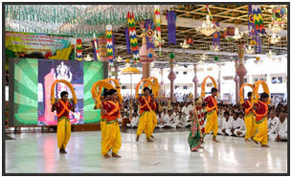
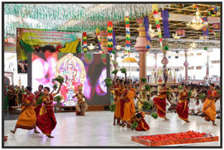
SYMPOSIUM ON 9 POINT CODE OF CONDUCT
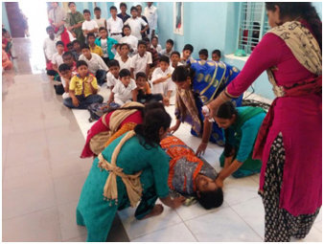
The Symposium was conducted at Senthilnagar, Thiruvallur Dist. on April 16th 2017 with the help of Power Point Presentations by Group III Balvikas students. In total around 55 students, 11 gurus, parents and members participated in the programme.
Disasater Management for Group III
The Sri Sathya Sai Disaster Management Task Force of Tamilnadu, in consultation with the State Education Wing of SSSSO, has customized a special half day module for the Group III Balvikas students and has been successfully conducting such workshops over the past few years, covering both the theoretical aspects and demonstration sessions.
In Chennai Metro North District, Disaster Management Programme was conducted at Sri Sathya Sai Nivas, Perambur, by the youth girls for the group II & group III Balvikas students on April 16, 2017. A total of 60 students participated in the programme. The workshop included an overview of various types of natural disasters, followed by a practical demonstration of Emergency methods of rescue as well as a session on various types of knots.
Disaster management training was conducted on 29th January at Prasanthi Gurukulam School, Asoor, by Kanchipuram South District.
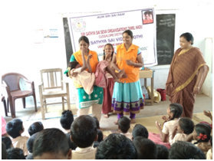
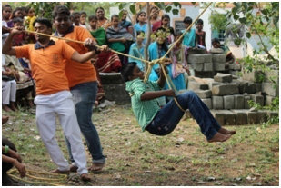
Kanchi South Neyveli
Aaradhana Mahotsavam
Around 265 Carnatic singers from Tamilnadu, Andhra, Telengana, Kerala, Karnataka and Maharashtra were blessed to render Sai Panchrathna Kritis at Sai Kulwant Hall. The Kritis have been composed by Dr. Vashant lakshmi and set to music by noted musician Sri Rajkumar Bharathi great grandson of Subramanya Bharathiyar). Balvikas children from Chennai Metro South, West and Kanchi North also participated in the same.
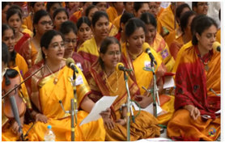
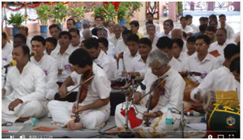
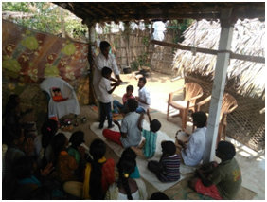
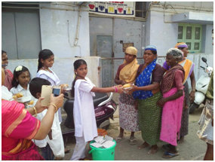
The day began with Aumkaram, Suprabhatam, Nagar Sankeethan in almost all the districts. This year’ s Maha Narayan Seva like the previous years saw huge participation of Balvikas children, ex-balvikas students, Gurus and parents. In Erode District, Aaradhana Mahotsavam was celebrated with a special Bhajan at JJ Nagar rural Balvikas centre and Narayan Seva at SSSVIP village, Sathya nagar.

- Balvikas children of Perambur Samithi (Chennai Metro North) chanted Sai Gayatri for an hour in the morning at Sri Sathya Sai Nivas, Perambur.
- As part of Aradhana Day celebrations, the Balvikas children of Agaram Samithi (Chennai Metro North) visited the Siragu Montessori School (where free education and food is provided to around 150 students). The Balvikas children entertained the inmates by performing dances, conducting value games and also performed Narayana Seva.
- A mega Narayana Seva was conducted in all Samithis of Kanchi North.
- Aradhana Mahotsavam was also celebrated at Sai Gurukulam, Tirunelveli Dist with Rudrabhishekam, Bhajans, Speech and Vastradaanam.
- As part of Maha Aradhana Mahotsavam, Thiruvallur district organized Ekadasa Rudra Parayanam, Sai Gayathri Homam, Varuna Japam, Vasthra Dhaanam, Sahasranama Japam and Distribution of Wheelchairs.

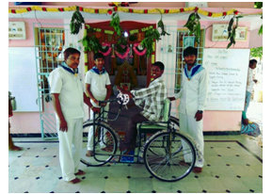
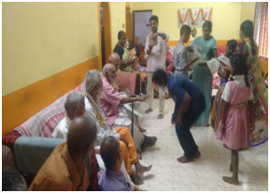

Vasthra Dhaanam at Old Age Home Wheelchair Distribution

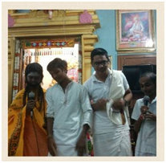
As part of Maha Aradhana Mahotsavam, Cuddalore district, organized a Power-Point presentation cum Harikatha by Balvikas children titled ‘Nandanar Mahimai’ at Neyveli on April 23rd and at Vilupuram on April 27th.
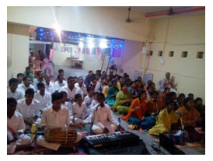
Harikatha at Neyveli Cultural prog-Guduvancherry, Kanchi South

57 Balvikas children and 20 mahilas of Kanchi North Dist performed the Sai Panchratna Kritis at Sundaram on the occasion of Aradhana Day. They were ably supported by Balvikas children in flute, mrudangam and violin.
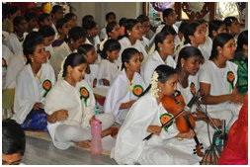
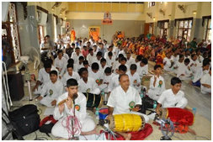
Kanchi North
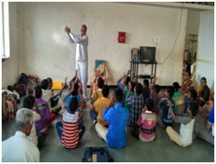
Sports events
Sports meet for Balvikas children was conducted in Porur, Thiruvallur dist. With events such as picking a toy, lemon and spoon, filling the bottle, balancing the ball, skipping, sack race, shuttle running, sticking bindi, and cricket.94 boys and 85 girls participated.

Trichy Dist organized rural sports at Thirunedungalam on 7th April, in which 33 students took part.

Value Games events were organized by Erode Dist at Koduvai Gurukulam Orphanage.

Summer Course on Indian Culture and Spirituality
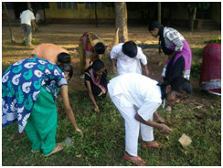
Summer course on Indian Culture and Spirituality was conducted in almost all districts in the month of April, May. In Chennai North Summer Course was conducted for school children in the age group 10 to 16 years at Sri Sathya Sai Nivas, Perambur from April 21-23, 2017 and was attended by 130 students from various schools. Speakers delivered speeches on various topics such as ‘Ramayana for everyone’, ‘Anger management’, ‘The Royal Road to God’; activities such as Role Play and Chart Making were conducted along with a session on Yoga each day.All the students were awarded certificates.
In Thiruvallur District, Summer Course was held on 25th and 26th April, 2017. The programme covered various topics such as Life and mission of Sathya Sai, lessons from Ramayana, duty and devotion, Adisankara, Navavidabhakthi, Importance of Aumkaram and Jyothi Meditation. In addition,value games and quiz competition were organized. Matrupooja and parenting programme was conducted on second day. In Cuddalore Dist, Summer Camp was organized at Tholcopier School, attended by 48 students.
In Trichy District, Balvikas Summer Camp was organized on 16th April at Raja High School, Uttamarkovil, which was attended by 76 boys and 95 girls.
In Kanchi South, Summer Camp was organized for students of 9th and 10th standards of Sothupakkam Govt. Higher Secondary School on 5th April on topics such as Revere your parents, 5Ds, etc.
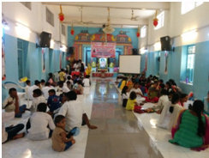
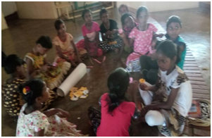
Chennai Metro North- group activities Paper crafts- Tambaram Samithi

Easwaramma Day Programme
Throughout the State, Easwaramma day was celebrated for a week. Various activities were undertaken by the balvikas students with the assistance of gurus, parents and samithi members. Service activities like Butter milk distribution, Narayana Seva, Vasthra dhaanam, Distribution of Jabla and baby kit to new born babies, visit to old age home, Pallaki seva, and distribution of notebooks and boxes to the needy were mostly undertaken in all samithies. Mathru Pooja was also performed as per the divine dictum “Matru Devo bhava, Pitru devo bhava”. On the final day CulturalProgramme was organised which showcased the multi-faceted talents of the children. Some of the samithis conducted Balvikas Rally Zonewise as a part of Easwaramma day celebrations.
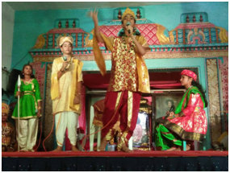
A Cultural Programme was organised by Chennai Metro North Dist on 30th April, 2017 in which 120 Balvikas students displayed their multi-faceted talents with a medley of programmes such as Veda, Shlokas, Dance and Drama. Ex-Balvikas students helped the Gurus to train the participants and also helped to maintain discipline during the programme.
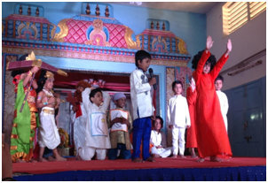
Cultural Programmes – Chennai Metro North
VP Colony Samithi of Chennai Metro North organized the Maatru Devatha Navarathri Programme from 9th to 17th May, 2017, with various programmes designed to pay homage to the 5 Mothers namely Desha Matha, Veda Matha, Go Matha, Deha Matha and Bhoo Matha. The programmes included devotional songs concert, speech, Veda chanting, feeding of cows, rendering of patriotic songs, etc.
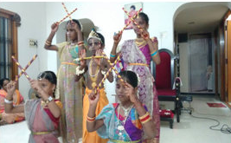
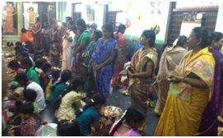

Gandhi Nagar Samithi, Erode Maatru Puja, Tambaram Samithi

Tamil Nadu Balvikas WEBSITE INITIATIVES
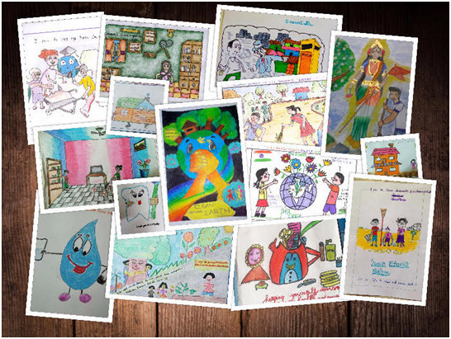
A number of initiatives have been taken through the TN Balvikas website (www.sssbalvikastn.org) to generate interest in Balvikas activities and to encourage participation by Balvikas children and their parents. One such step was the Online Drawing Competition on the theme ‘Swacchatha Se Divyata Tak’. The competition attracted participation by many students. Some of the entries are reproduced below:
‘The winners of the Swacchatha online drawing competition were felicitated during the prize distribution ceremony of the State level Talent Search competitions on 24th December 2016.

As part of Pongal celebrations, an online Rangoli completion was held for parents of Balvikas children titled ‘Rang Birangi Rangoli’. The winners were given the opportunity to offer their Rangoli at Prashanthi Nilayam during the Tamil New Year.
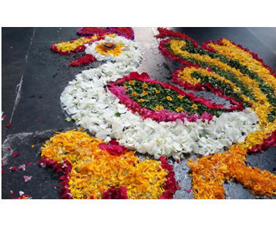
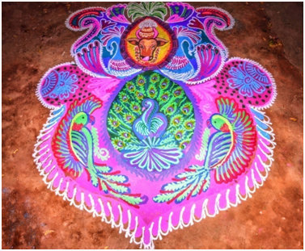

Poo Kolam by prize winners in front of Swami’s dais at Sai Kulwant Hall
Other EVENTS
- ​Special lecture by a Balvikas guru is conducted every month (first Sunday) in Chakkarai Amman temple, Tiruvanmiyur for the last 4 yrs.
- Balvikas children of Sainagar,​ Mylapore Samithi, Chennai Metro South Dist, pack the Amrutha Kalasam to be distributed to Magrel village every month.
- Balvikas children from Sivakasi Town Samithi,Virudhanagar District, participate every month in service activities in Free Mental Health Camp and Homeo Camp.
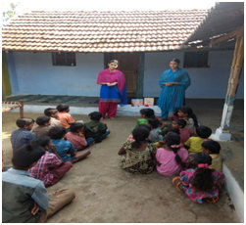
- Past Balvikas students play an active role in Erode District, by helping to conduct rural Balvikas classes to Thamburetty Tribal settlement children at Bargur hills.
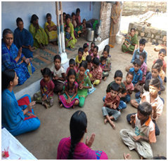
Tribal settlement, Bargur Hills Teacher’s Conference, Nilgiris District
Nilgiris district organized a District Teacher’s Conference on ‘Education in Human Values’ on 14th May, 2017 at Sai Kailas. The programme commenced with a welcome address by the District President. The teachers were enthralled by the speech of Shri Vinay Kumar, Former State Youth Co-ordinator. This was followed by interactive sessions on Sri Sathya Sai Balvikas , Sri Sathya Sai Vidya Vahini programme and Vidya Jyothi Programme. The response to the programme was encouraging with all the teachers giving positive feedback.
DISASTER MANAGEMENT AWARENESS TRAINING PROGRAMME:
The Disaster Management awareness programme for Balvikas group III students was conducted at Sri Sathya Sai Seva Samithi, Porur in Thiruvallur district on June 4th 2017, in which 45 students participated.
After giving them an introduction about different types of natural disasters, the students were taught the following:
- Basic First Aid
- General Awareness
- Necessity of maintaining the first Aid box
- Basic Fire Fighting techniques
- Explanation of fire triangle, classes of fire
- Types of fire extinguishers.
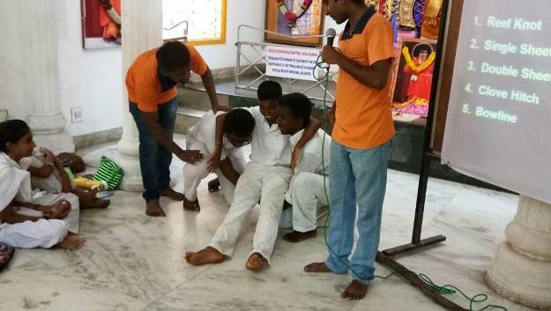
This was followed by practical sessions.
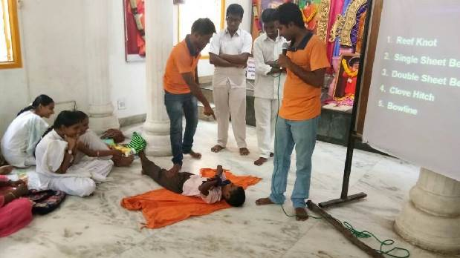
GURU POORNIMA CELEBRATIONS:
The glorious occasion of Guru Poornima was celebrated in Sri Sathya Sai Nivas, Perambur, Chennai Metro North with a palki seva on 9th July 2017 in which Balvikas students and alumni of Perambur Samithi participated. The Balvikas children of V.P.Colony Samithi performed worship to the feet of the Guru on this occasion.
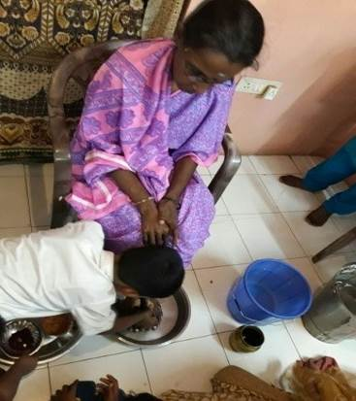
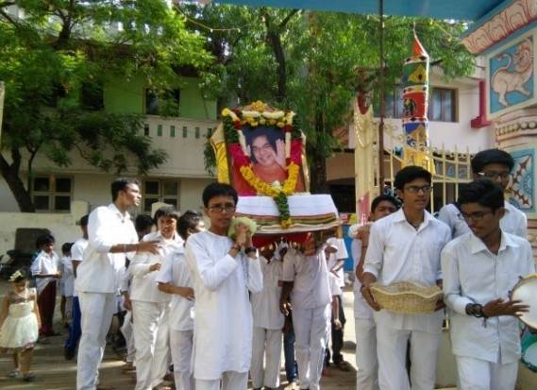

Chennai Metro North

78 Balvikas children and alumni took part in the Guru Poornima celebrations at Thiruvallur district.
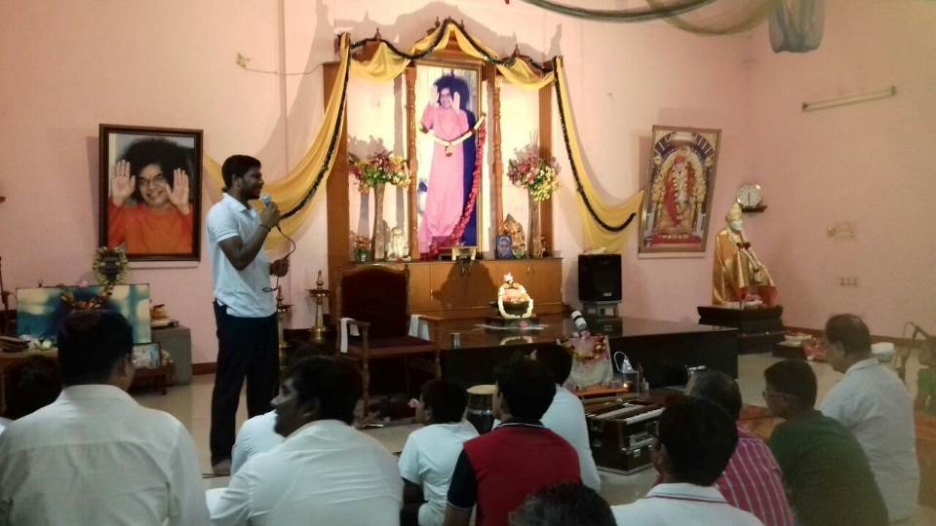
Thiruvallur district

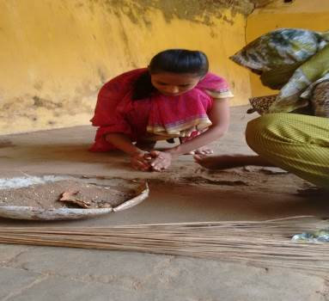
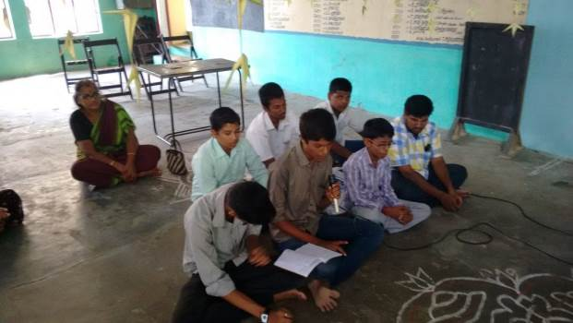

Veda Parayanam for Guru Poornima, Thanjavur Uzhavarapani at Kalahastheswarar temple

Guru Poornima was celebrated in the schools where Balvikas classes are held with distribution of sweets to the children. The school children were taught the importance of the Guru and asked to pay homage to the feet of the Guru.

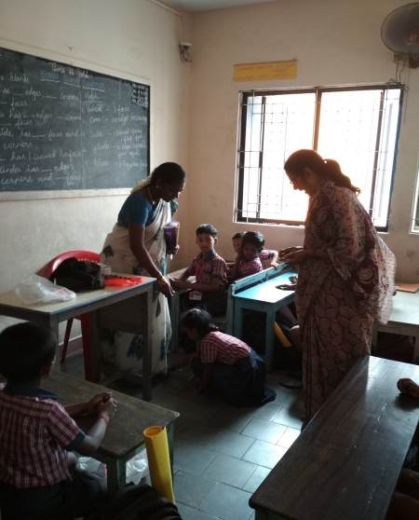

Guru Poornima celebration at School Balvikas, Chennai Metro North

Orientation programme for teachers:

An orientation programme was organised for the teachers of Siragu Montessori School, Palavedu (Chennai Metro North), where Balvikas classes are held.
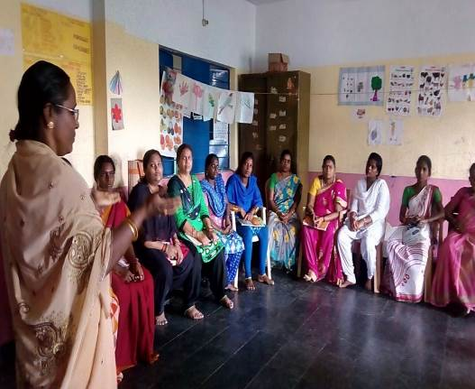
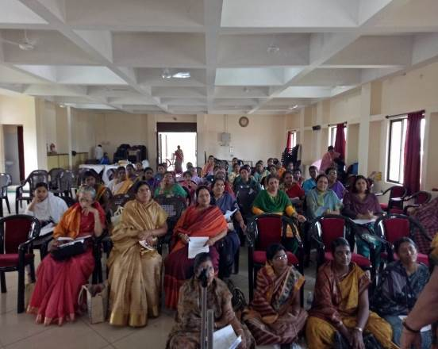
Teacher’s Orientation Programme Gurus training @ Pondicherry

BALVIKAS EXAMINATIONS
With the Divine blessings of our Beloved Bhagawan, a total of 1018 students appeared for Group II assessment and 499 students appeared for Group III examinations of Balvikas throughout Tamil Nadu on August 27, 2017.

KRISHNA JAYANTHI AND VINAYAKA CHATURTHI CELEBRATIONS
Balvikas boys and girls participated in the Aumkaram, Suprabhatam and Nagar Sankirtan and special Bhajans at their respective Samithis on August 15th for Krishna Janmashtami and on August 25th for Vinayaka Chaturthi.

On the occasion of Krishna Jayanthi and Independence Day, the members of Chennai Metro North including Balvikas children and alumni participated in the programme of feeding the cows at Pinjrapole, where around 1500 cows are housed.
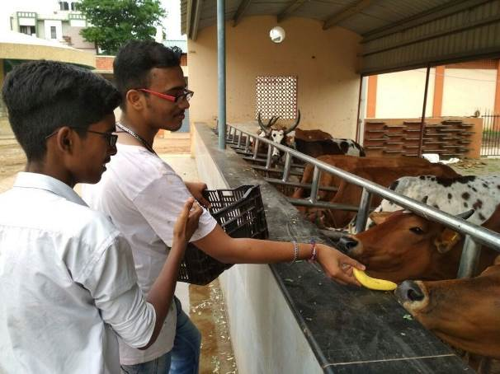
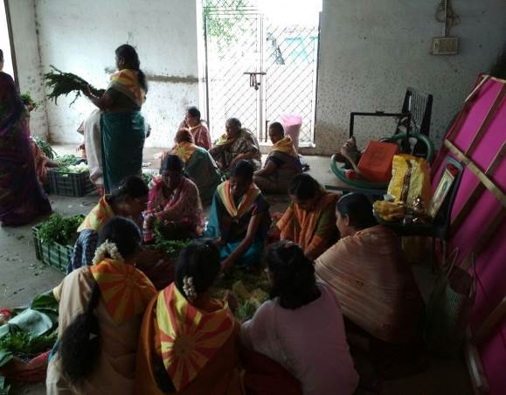
Cow-feeding Chennai Metro North
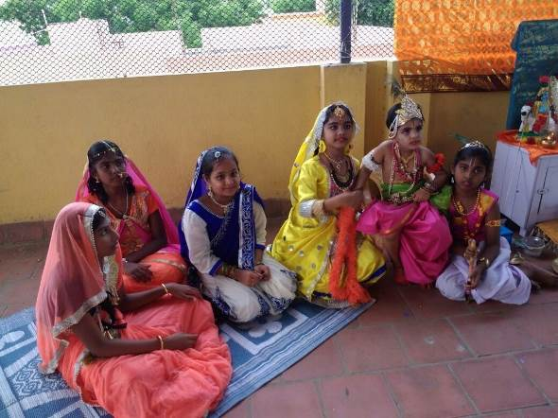

Cultural programme @ Thiruvallur dist

RANGOLI COMPETITION
A Rangoli competition was organised for the parents of Balvikas children on August 20th 2017 at Sri Sathya Sai Nivas, Perambur. All the parents participated enthusiastically in the competition.
From August 27th a weekly Rangoli class has been started for Balvikas children at Sai Nivas.
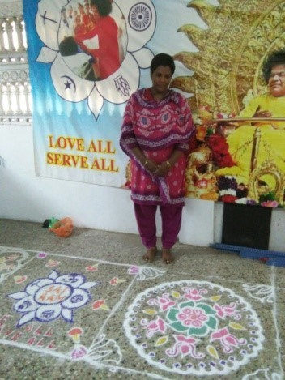
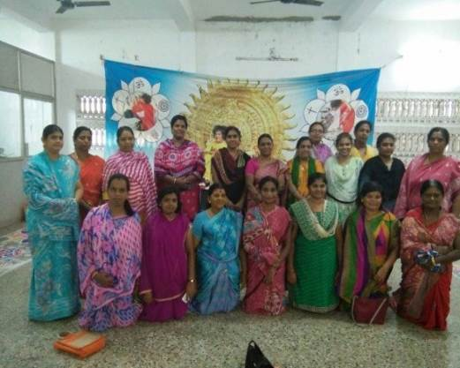

Rangoli competition for parents – Chennai Metro North

VALEDICTORY FUNCTION FOR BHAJAN VIKAS:
The Bhajan Vikas programme for the fifth batch of boys and sixth batch of girls of Chennai Metro North, West and South was inaugurated in June 2017. On September 16th, the Valedictory function was celebrated at Sundaram. The National Vice President officiated as the chief guest. All the students received the certificates and medals for successful completion of Bhajan Vikas programme.
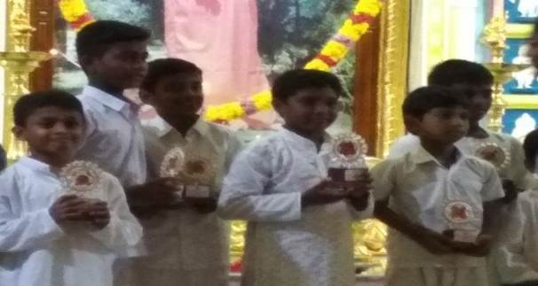
The Bhajan Vikas valedictory function was held at Chrompet Samithi, Kanchi North district on October 8, 2017.
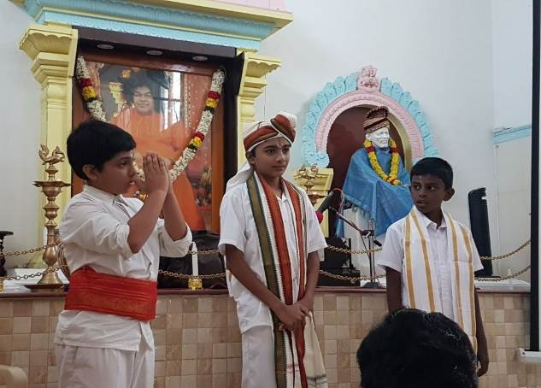
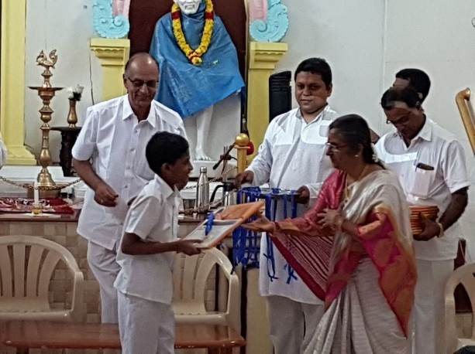
NAVARATRI CELEBRATIONS
On the auspicious occasion of Navaratri, chanting of Durga, Lakshmi and Saraswathi Ashtotrams was done and Archana performed on all the nine days in Sri Sathya Sai Nivas. A few ex-Balvikas girls also participated in the event.

Vilakku pooja was performed by the Balvikas children and parents in many Samithis as part of Navaratri celebrations. The Balvikas children and alumni also kept a golu and an exhibition relating to life and mission of Swami.
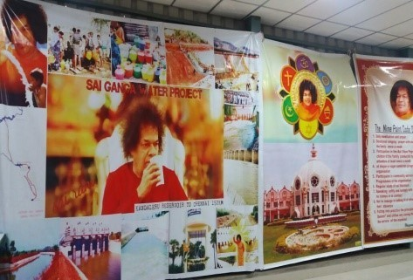
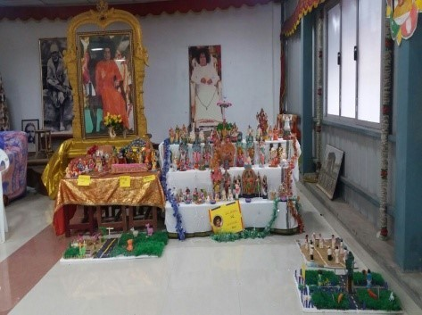
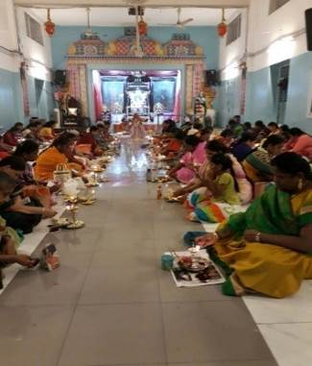

Navratri celebration Chennai Metro North
With the divine blessings of Bhagawan, Veda Purusha Sapthaaha Jnana Yagnam was conducted from September 24th to 30th at Sai Nivas. This was followed by Kalashaabishekam to Bhagavan Sri Shirdi Sai Baba and Swami’s Padukas on 30th September.
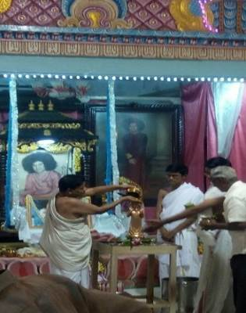
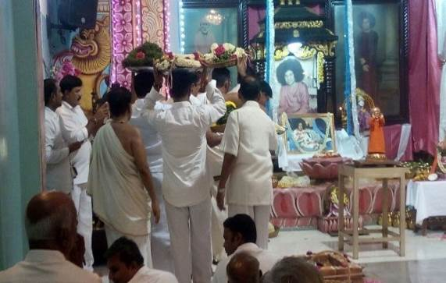

Balvikas children of Kanchi North district put up cultural programmes to showcase their talent on all the nine days of Navratri.
AVATAR DAY CELEBRATIONS
A district level rally was organised on October 8th, 2017 by Chennai Metro North District to celebrate the Avatar Day. More than 120 children participated in the rally which started from Sri Sathya Sai Nivas, Perambur. They held placards with sayings of Bhagawan Baba. Bhajans were also led by Balvikas students. The children also performed various dances such as kavadi dance, karagattam and peacock dance, gopika dance, dance paying homage to Lord Ganesha and Lord Muruga. They were accompanied by floats with children dressed in costumes and broadcasting the message of our Swami. The programme was given brief coverage by Sankara TV channel.
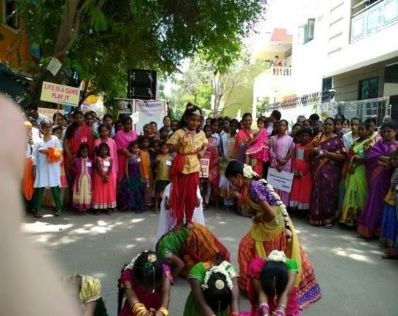
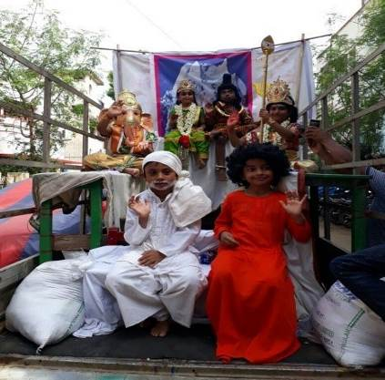

DEEPAVALI FESTIVAL CELEBRATIONS:
The Balvikas children of Kanyakumari district celebrated Deepavali with the children on Anbu Illam.
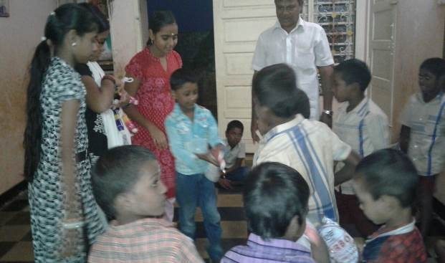
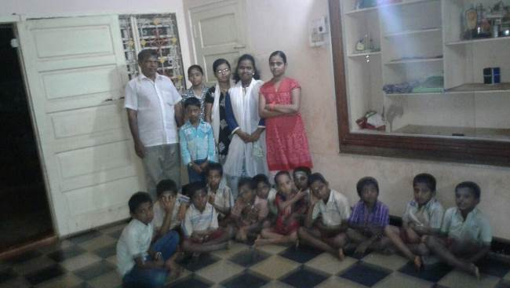

Deepavali celebrations - Kanyakumari dist
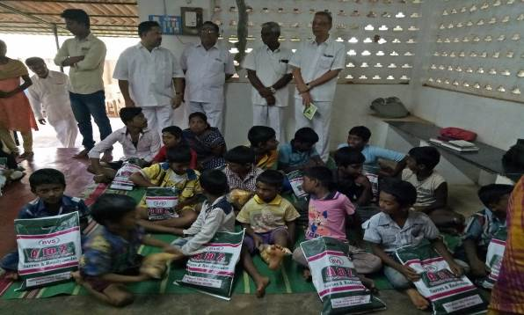
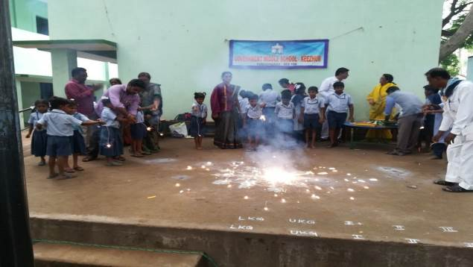
Deepavali was celebrated at Pondicherry with distribution of sweets to Balvikas children in all centres. They also distributed clothes to the village Balvikas children of Navarkulam Village for Deepavali.
Distribution of clothes for Deepavali - Pondicherry district

GLOBAL AKHANDA BHAJAN

Balvikas children and alumni of all the districts participated enthusiastically in the Global Akhanda bhajan on 11th and 12th November, 2017.
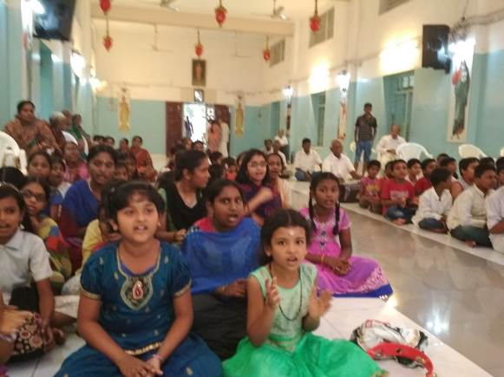

Chennai Metro North

SWACHATA SE DIVYATA TAK - FROM CLEANLINESS TO GODLINESS

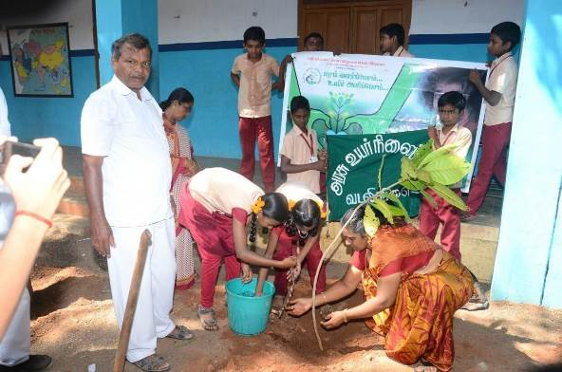
As part of the programme of ‘Swacchata se Divyata tak’, the Balvikas children of Kanyakumari district undertook tree planting activity.
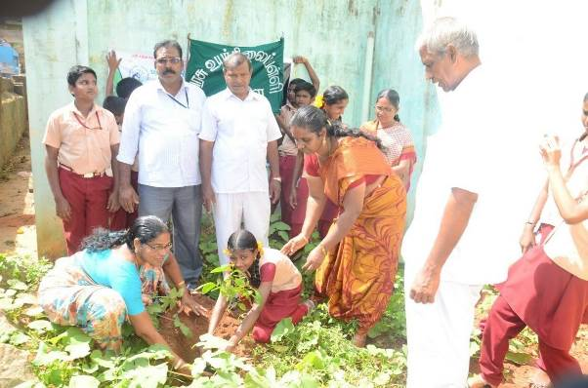
Kanyakumari dist

As part of the Swacchhata Se Divyata Tak Programme, 85 Balvikas children and alumni of Thiruvallur district participated in tree plantation and seed ball making.
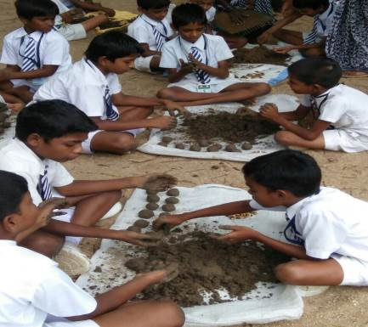
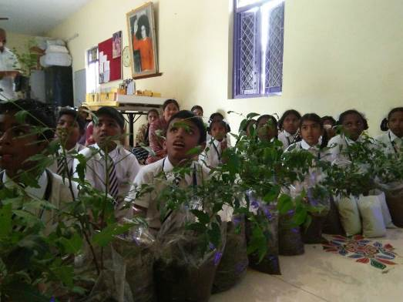
Thiruvallur dist
Tamil Nadu Balvikas WEBSITE INITIATIVES
A number of initiatives have been taken through the TN Balvikas website (www.sssbalvikastn.org) to generate interest in Balvikas activities and to encourage participation by Balvikas children and their parents. One such step was the Online Quiz Competition for Balvikas Gurus on the theme ‘Summer Roses in the Blue Mountains’. The competition attracted wide participation. The winners were awarded at the State Conference in Chennai. A presentation about Balvikas activities in Tamil Nadu
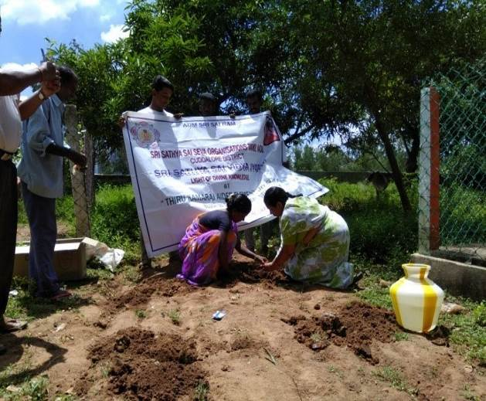
was also made to the National Co-ordinators during the Conference.
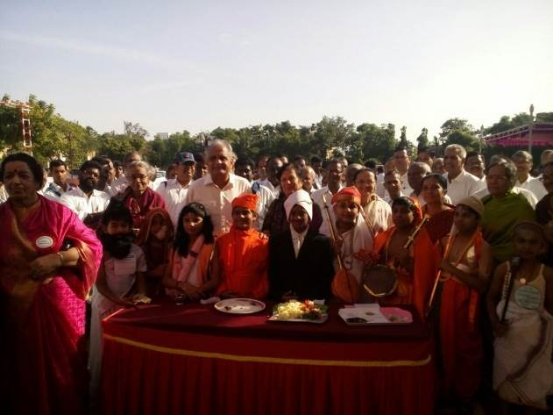
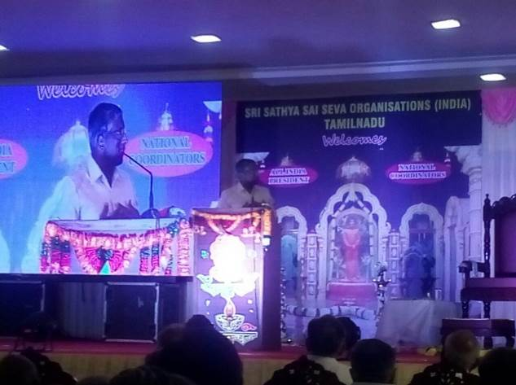

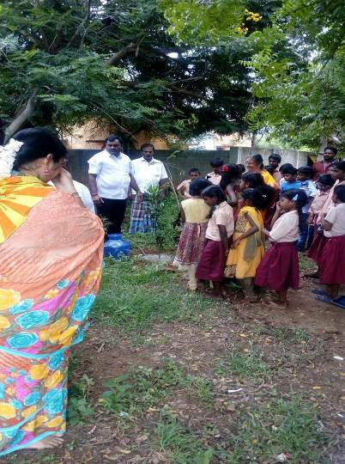
OTHER ACTIVITIES:
The Balvikas children of Vidya Jyothi school of Kanchipuram North participated in sapling planting.

An exam-orientation programme was organised by Thiruvallur District at Sri Sathya Sai Vidyalaya Matriculation School Thiruvottiyur on July 2, 2017, for the benefit of students appearing in the Group-II & III examinations of Balvikas, in which around 120 students participated.
The anniversary of Agaram Samithi (Chennai Metro North) was celebrated in a grand manner in August with a series of cultural programmes.

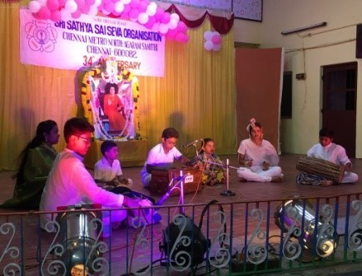
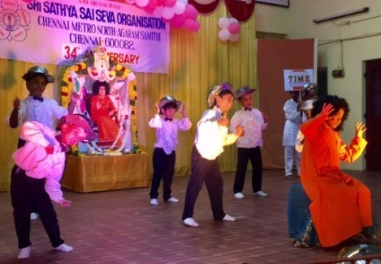

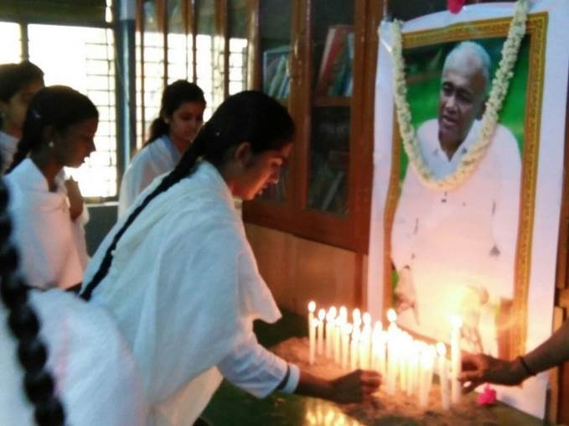
The District Level Talent Search events were conducted by all the districts on different dates. The ex-Balvikas students also helped in conducting the events. In Thiruvallur, the Talent Search commenced with the children paying homage to former AIP Mr. V.Srinivasan.
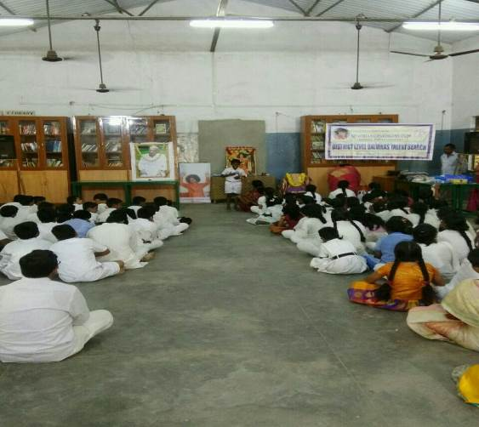
District Level Talent Search- Tiruvallur
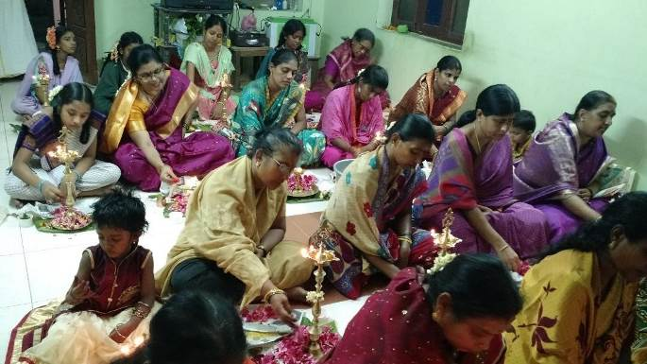
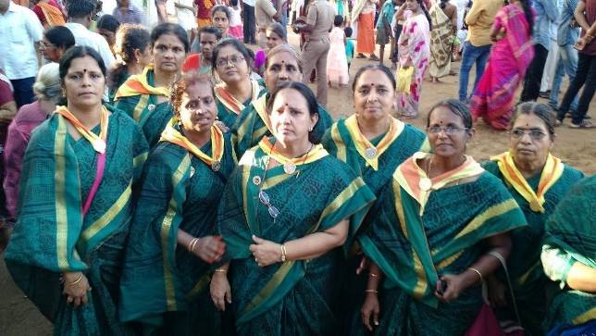

Thanjavur district – Vilakku Pooja Aadi Velli
The Balvikas Gurus of Thanjavur district also participated in the service activities during the Kaveri Maha Pushkaram.
The paper evaluation of the Balvikas examinations conducted in all the districts of Tamil Nadu was done at Kumbakonam, Thanjavur District.
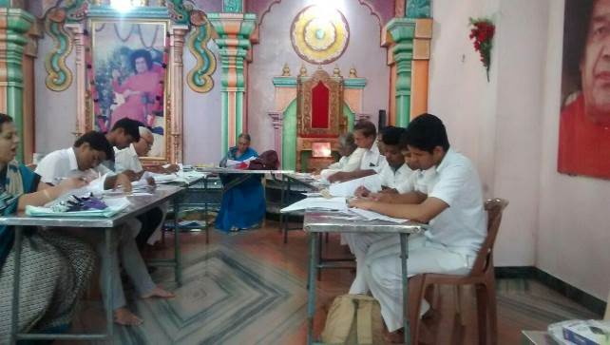
The District level Balvikas Alumni Meet was organised for the eleventh successive year by Erode District on July 29th and 30th, 2017.
Erode District has started a programme of conducting 1008 Sri Rudram Parayanam at the houses of devotees as well as non-devotees. The parayanam has been completed in 23 houses so far, in which Balvikas students and alumni also participate.
Kanchi North district organised various programmes such as Medical Camp for Balvikas children, a spriritual tour to Injambakkam Shirdi Baba Temple and ISKON temple, Annual Sports Meet and Pallaki Seva to create awareness about Swami’s message and to increase the Balvikas strength. The Balvikas children participated with great enthusiasm in all the events.
To increase health awareness among the children, Yoga Day was celebrated with the students of SSSVIJ Kamaraj School, where a Mahila Guru taught easy Yoga exercises to the children.
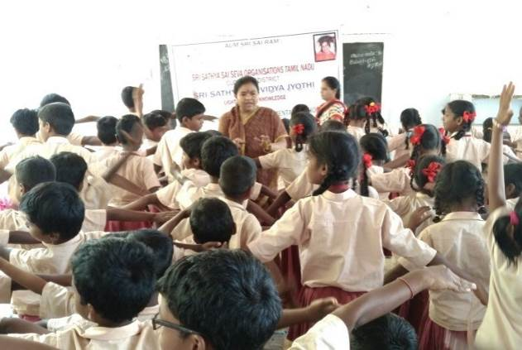
Celebration of Yoga Day at Vidya Jyothi school (Cuddalore dist)
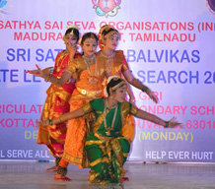
To create awareness about dengue, the medical co-ordinator explained Dos and Don’ts to the children of SSSVJ school, Cuddalore dist. and Nilavembu Kashayam was distributed to all.

State level Balvikas Talent Search 2017
For more than three decades, Balvikas children, Gurus and Parents from all over TamilNadu, celebrate the oneness of Humanity by gathering to participate in the State Level Balvikas Talent Search Programme. Karaikudi was the chosen venue for the event in 2017. The event was held at Sri VidyaGiri Educational Institutions, Puduvayal, Karaikudi. The two-day event featured cultural programmes by Balvikas children on December 24, 2017 and the Talent Search event was held on December 25th. The details of participation are as follows -
Category | Number of Participants
Balvikas students | 368
Parents & Gurus | 435
Judges | 21
State Level Office Bearers | 6
Total | 830
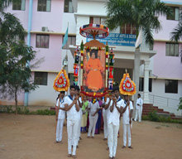

NEW YEAR , PONGAL AND REPUBLIC DAY CELEBRATIONS
New Year was celebrated in various Samithis with a variety of programmes such as Pallakuseva, Sahasranamaarchana by BV students and parents, Special bhajans and Narayana seva.
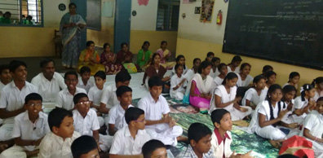
New Year Bhajans – Sankara Vidyalaya School Balvikas –Thanjavur dist Thiruvallurdist
As a part of Pongal celebrations, kolam and thiruppavai competitions were conducted for the balvikas children of Kanchi North district.The children who participated in these competitions displayed not only their talents but also their will to compete and their affection towards Tamil Literature.

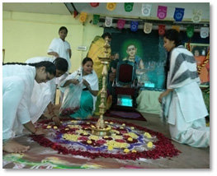
Republic Day was celebrated in many Samithis such as Mylapore and Valmiki Nagar in Chennai Metro South by recounting stories of Freedom fighters.
KanchiNorth

Balvikas Alumni meet at PrashantHiNilayam – 6th, 7thJanuary
Diploma in Sathya Sai Educationwas conferred upon hundreds of Balvikas students on the 7thmorning. The session commenced with a Band procession that was followed by a procession of Balvikas gurus, students and office bearers escorting the symbolic ‘Wand Of Transformation’, entering the Sai Kulwant Hall. A song of adoration to Mother Gayathri, “SarvarogaNivarini Gayathri…” accompanied the procession, sung by the students, alumni and gurus in united voice.Balvikas alumni from Tamil Nadu got the opportunity to render Veda Chanting on the 6th at Sai Kulwant Hall.Therewas a scintillating music performance by the Balvikasstudents of TamilNadu on the 7th morning after the award ceremony.The details of participation by Balvikas students of Tamil Nadu are given below.

Category | Male | Female | Total
Convocation students | 69 | 110 | 179
Present Group-lll& II | 23 | 26 | 49
BV-Alumni | 107 | 111 | 218
BV Gurus | 24 | 100 | 124
Total | 223 | 347 | 570
This year Chennai Metro West district had the distinction of preparing and printing the All India Balavikas convocation certificates which was placed at the Sannidhanam for the blessings of our Beloved Lord. Gurus and past balavikas alumni carried out this immense responsibility and executed this task with finesse by taking into consideration even minute details.
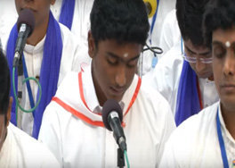
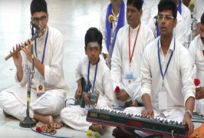

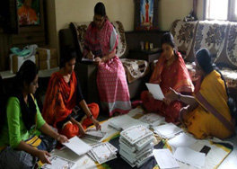
Convocation in Districts
It is a known fact that only the chosen ones enroll into the Balvikasprogramme and only the most blessed ones continue their journey through the entire nine years to complete the course. As is always the practice, the group III children received their diploma certificates in a grand function in their respective districts amidst Vedas, Bhajans and Oath taking ceremony. Chennai Metro North celebrated this joyous occasion on the 26thJanuary,Chennai Metro South on 29thJanuary and Cuddaloredist on 28th January.

Winners of Talent Search events at the State Level and the District Leveland Balvikasboys and girls who successfully completed their group II were also honoured with certificates, gifts and mementos.
A District Balvikas Alumni meet was organised by Thiruvallur District at Sri Sathya Sai VidyaVihar School, Thiruvottiyur,where in 124 students participated. Certificates were also presented to the students who completed Group 3 in 2017.
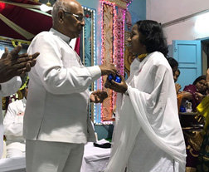
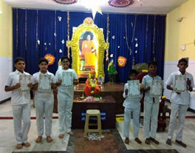

Thiruvallur dist. Chennai Metro North
Balvikas Alumni Meet was organized at VannarpetSamithi, Tirunelveli Dist. on 16th January which was attended by 10 boys and 7 girls and by Vellore District on 28th January which was attended by 10 boys and 20 girls.
A Balvikas Alumni and youth meet was organized by Kanchi South Dist on 25th February 2018 which was attended by 66 students from 17 Samithis. 17 Group 3 students also received Diplomas during the function, which was presided over by Shri Varadan, State President.
A function to honour the Group 3 Convocation students and the state level and district level talent search winners was organised in Chennai Metro West on 4th February 2018 at Sai Pushpanjali. The State President Shri G.Varadhan and Smt. Uma Maheswari Coordinator of StreeSevaMandir, Saligramam were the chief guests for the occasion.
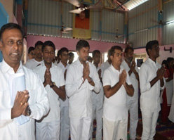
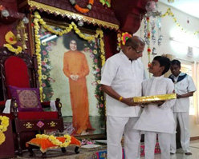
. Kanchi South Chennai Metro West

Details of Group 3 passed out Students in 2017 – district-wise
District | Boys | Girls | Total
Chennai North | 3 | 18 | 21
Chennai Metro South | 17 | 28 | 45
Chennai Metro West | 19 | 32 | 51
Coimbatore | 6 | 5 | 11
Cuddalore | 2 | 6 | 8
Dharmapuri | 2 | 4 | 6
Dindikul | 2 | 2 | 4
Erode | 64 | 60 | 124
Kanchi North | 24 | 19 | 43
Kanchi South | 6 | 11 | 17
Kanyakumari | 0 | 12 | 12
Madurai | 21 | 10 | 31
Nilgiris | 1 | 14 | 15
Pondycherry | 0 | 5 | 5
Salem | 2 | 8 | 10
Thanjavur | 5 | 6 | 11
Thirunelveli | 4 | 6 | 10
Thiruvallur | 25 | 20 | 45
Tirupur | 0 | 3 | 3
Trichy | 4 | 4 | 8
Tuticorin | 1 | 5 | 6
Vellore | 1 | 5 | 6
Virudhunagar | 1 | 5 | 6
Total | 210 | 288 | 498

Shivarathri
Shivarathri was celebrated with great fervour in almost all the districts of TamilNadu on February13, 2018. The day began with Suprabhatam and Nagar Sankirtan. Balvikas students and alumni got the chance to lead the Bhajans in the evening. The night long Bhajans during Maha Shivaratri has been an important event in the Annual Calendar of almost all districts. Balvikas children also participated in the night-long Bhajans.

ShivarathriBhajan- Thanjavurdist
Balvikas Bhajans
Bhajans were conducted in manySamithis in this half year in the houses of Balvikas children to create the awareness and interest among parents. Both parents and students showed an overwhelming response.
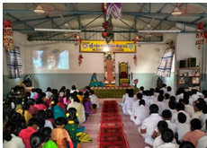
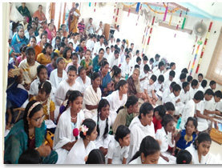
To welcome and prepare for the joyous occasion of swami’s 93rd birthday the balvikas children of Kanchi Northoffered a string of 93 pearls in the form of 93 bhajans. These bhajans were organized on the 1st of February at three different places.
93 BhajansKanchi North
NEW GURUS ORIENTATION
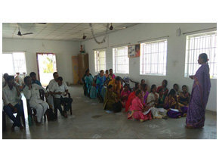
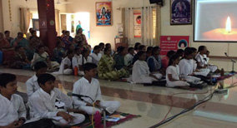
As per the State Education directive for conducting Balvikas Gurus Group I training, Chennai Metro South organized the Gurus Training Programmeon four Sundays starting on 18 February 2018, where 22 Gurus underwent training for Group I. In Chennai Metro West, Group 1 Gurus Training for Group 3 students and others was held on 26th & 28th Jan 2018 at Sai Pushpanjali. There were 58 participants in all. This was only an introduction to the group 1 syllabus and all the participants were told to be assistant gurus in their respective samithis and after a year of assisting in taking classes, they can become full-fledged gurus. School Balvikas Training Programme is organized by ThanjavurDist on the 19th of every month at Maxwell Matriculation School, in which around 40 teachers are receiving training.
Balvikas Gurus Refresher course – Erode Chennai Metro West
A motivation session for Balvikas Gurus was organised at Chinmaya Nagar Samithi(Chennai Metro West) on 23rd of April 2018. The speaker was the former District President of DindigulShri Narayanan Sairam. Around 35 Gurus and 10 samithi members attended this programme. In the afternoon, there was a similar session at JaigopalGarodia School, Annanagar, where the district Gurus are taking School Balvikas classes.All the teachers were very happy with the thought provoking session conducted by Shri Narayanan Sairam.
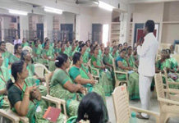

Gurus Motivation Session - Chennai Metro West
PARENTS’ MEET
Parents are to be educated, engaged and inspired to send their children to Balvikas. With this end in view the Balvikas Gurus of Thiruvallur district conducted a Parents Meet on February 2, 2018 at Villivakkam.

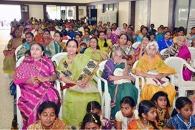
In Chennai Metro North, a workshop on parenting was conducted at Almighty Academy, Nammalwarpet in Ayanavaram on February 3, 2018, where a new Balvikas centre was also inaugurated. Gurus and office bearers spoke on the importance of Balvikas in character development. Around 70 parents attended the programme.
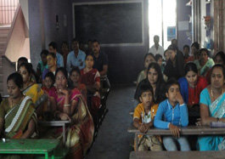
Chennai Metro North Coimbatore District
PROGRAM TO MOTIVATE STUDENTS APPEARING FOR BOARD EXAMS
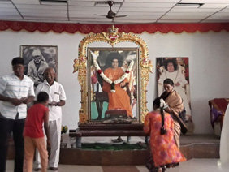
Kanchi South District organized a program on 6st March, 2018, where hall tickets were issued to students appearing for the 10th standard exams, along with a pen, pencil, ruler, Geometry Box and Swami’s photo at Sogandi Village, SSSVIP, Govt. High School.
A Blessings Day was organised on February 18, 2018 at Sri Sathya Sai Nivas, Perambur, when the children appearing for Board exams were invited to take blessings of Bhagawan on the eve of the exams. Exam tips and guidelines were shared with them and special prayers were held for them. Arrangements were also made for special tutors who were ready and willing to clarify any doubts of the students.

RamaNavami Celebrations
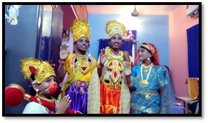
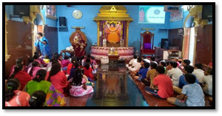
In Kanchi North district, Ram Navami was celebrated in all the samithis across the district spanning 10 days.The samithis conducted different activities which included Rama Katha RasavahiniParayana, talks on ideal students/ mother/ son/ friend/guru etc, nine point code of conduct. All these activities involved the active participation of parents thus forming a good rapport with them.
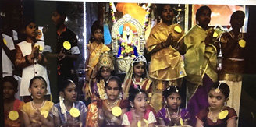
Ram Navami Celebrations- Kanchi North
A Ramayana Story Telling event was organized for Balvikas students of Kanchi South and around 10 children also sang the Naama Ramayana.

SYMPOSIUM ON 9 POINT CODE OF CONDUCT
A symposium was conducted on 9 Point Code of Conduct in many Districts, in which most of the Gurus participated. In Kanchi North, there were speeches given by Balvikas Parents and quiz conducted by Balvikas Group 3 children on Nine Point Code of Conduct.
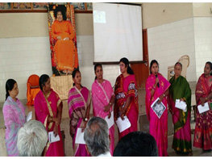
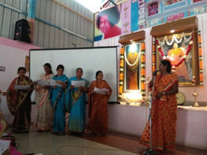
Kanchi South Erode
Chennai Metro West District organised a sadhana camp on 18th March 2018, where the balvikas children put up a skit on on Nine Point Code of Conduct, which was very much appreciated by the National Vice President Shri N Ramani. He also suggested that this be sent to the All India President with English subtitles. The same has been done. Our State Educational Coordinator also wanted the Tamil script of the 9 skits to be uploaded on the Balvikas website, so that all the other districts may use it.
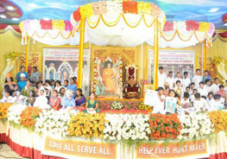
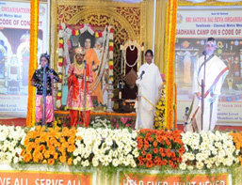
Chennai MetroWest

Disasater Management for Group III
The Sri Sathya Sai Disaster Management Task Force of Tamilnadu, in consultation with the State Education Wing of SSSSO, has customized a special half day module for the Group III Balvikas students and has been successfully conducting such workshops over the past few years, covering both the theoretical aspects and demonstration sessions.
About 74 Balvikas students of Chennai Metro West participated in this training from our district which was conducted by the State Disaster Management Team on 21st January 2018. Shri Anand Velu and Shri Kalai conducted this day long workshop for the students in a very lively and enjoyable manner. Various skill sets were imparted for emergency preparedness including first-aid, procedure for the movement of injured to hospital, how to build makeshift stretchers, band aids and other equipment needed for disaster management. The workshop also taught the students on fire emergencies and importantly the measures to be taken to extinguish the fire.
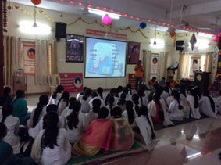
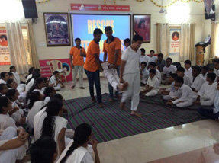
Chennai Metro-West

In Chennai Metro North District, Disaster Management Programmewas conducted at Lakshmi Narayana Matriculation School on April 8th for boys and at Sri Sathya Sai Nivas, Perambur on April 15th for girls. The programme was attended by group II & group III Balvikas students as well as Balvikas alumni. In Thiruvallur district, the training was organized at Thiruvottiyur on April 1, 1918.
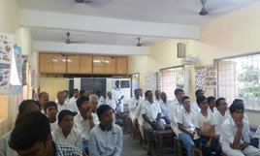
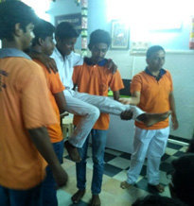
Chennai Metro North Thiruvallurdist

Aaradhana Mahotsavam
A host of Carnatic singers from Tamilnadu, Andhra, Telengana, Kerala, Karnataka and Maharashtra were blessed to render Sai PanchrathnaKritis at Sai Kulwant Hall. The Kritis have been composed by Dr. VasanthaLakshmi and set to music by noted musician Sri Rajkumar Bharathi, great grandson of SubramanyaBharathiyar.Balvikas children from Chennai also participated in the same.
The day began with Aumkaram, Suprabhatam, NagarSankeethan in almost all the districts. This year’s Maha Narayan Seva like the previous years saw huge participation of Balvikas children, ex-Balvikas students, Gurus and parents.
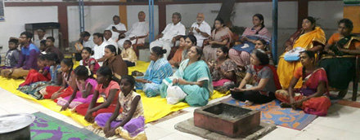
AradhanaMahotsavam with Rural Balvikas children- Chennai East Coast Dist
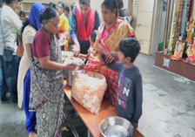
As part of Aradhana Day celebrations, the Balvikas children of Agaram Samithi(Chennai Metro North) visited the Siragu Montessori School (where free education and food is provided to around 150 students) and offered NarayanaSeva. On Aaradhana Day, Gurus with Balvikas Children, in Udumalpet, Tirupur district, visited an orphanage and assisted them in cleaning the surroundings followed by Sai Bhajan and served food to the orphanage residents.

Balvikas children of Chennai Metro South performed a dance Ballet on Swamy’s life ‘Sri Sathya Sai Sat Charithra’ followed by Bhajans on the 18th of April in the prestigious RR Sabha on the occasion of the anniversary of Smt. VidyaSrinivasan Aunty. It was very well appreciated by one and all.
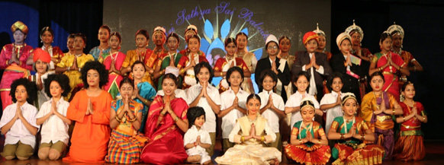
Chennai Metro South
Sports events
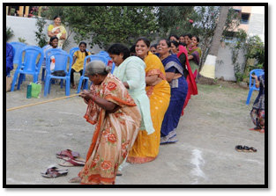
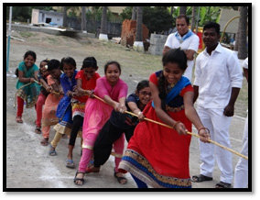
Multiple sports activities were conducted for balvikas as well as rural children of KanchiNorth.The children displayed their sportsmanship along with their ability to work as a team and achieve the pinnacle of success.

Kanchi North
Ruralsports was also organised by Vellore District on 13th January in which 27 Balvikas students and 7 Alumni participated.
Balvikas games were conducted on May 1st at Tirupurdist and prizes awarded. 97 children participated in the games.
Summer Course on Indian Culture and Spirituality
Summer course on Indian Culture and Spirituality was conducted in almost all districts in the month of April, May. In Chennai Metro North, Summer Course was conducted for school children in the age group 10 to 16 years at Sri Sathya Sai Nivas, Peramburand at Almighty Academy, Nammalwarpet, from April 21-22, 2018 and was attended by 130 students from various schools. Speakers delivered speeches on various topics such as ‘Effective Living, ‘Waste Management’, ‘The Nine Point Code of Conduct as exemplified by characters in Ramayana; activities such as Role Play through Mime and Drawing were conducted.

- Summer Course in Indian Culture and Spirituality was organized by Chennai Metro South from 15th to 23rd March for students of 6th to 9thStandard in VidyaRatna School, Shastri Nagar.
- A Winter Course was organized by 3 Samithis in Coimbatore District in which 98 boys and 114 girls participated.
- A Course on Spoken English was conducted for Balvikas children of R.A.PuramSamithi from 15th to 28th April.
- A 2 day Summer Course was conducted in Govt Higher Sec School,Pudur for the students of class 6th, 7th and 8th standard by Chennai Metro West.
- Summer camp was organised on the topic ‘Healthy education and traditional games’ in Hosur – Dharmapuri district.
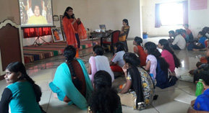
- Summer camp was organised in Puducherry from May 1-4, 2018.

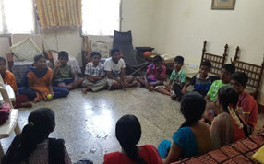
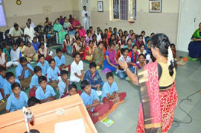
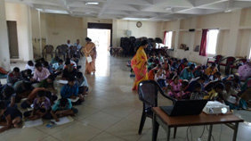
Puducherry District-Summer campChennai South – Spoken English classes
Coimbatore district – Winter course

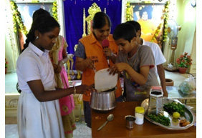
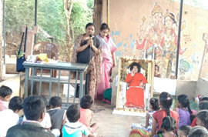
Summer camp-Neyveli SSSVIP Thidirkuppam Dharmapuri District

Easwaramma Day Programme
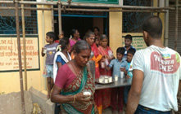
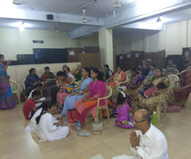
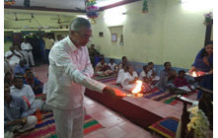
Throughout the State, Easwaramma day was celebrated for a week. Various activities were undertaken by the balvikas students with the assistance of gurus, parents and samithi members. Service activities like Butter milk distribution, Narayana Seva, Vasthradhaanam, Distribution of Jabla and baby kit to new born babies, visit to old age home, Pallakseva, and distribution of notebooks and boxes to the needy were mostly undertaken in all samithies. Mathru Pooja was also performed as per the divine dictum “Matru Devo bhava, Pitru devo bhava”. On the final day CulturalProgramme was organised which showcased the multi-faceted talents of the children.Valmiki Nagar Samithi (Chennai Metro South)started a Summer Course for rural Balvikas children in Thiruveedhi Amman Temple on the theme ‘All power is within you; Arise and Awake’ for 15 days.
Buttermilk seva-Chidambaram Paduka Puja- Koothapakkam, Cuddalore
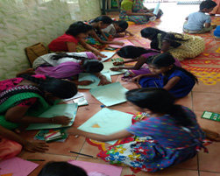
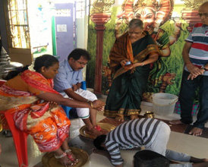

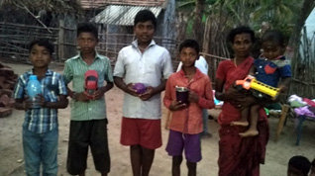
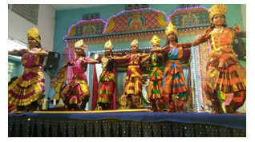
Matru Pooja – Chennai Metro South
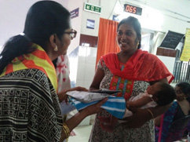
Erode – Competitions conducted and Prize distribution

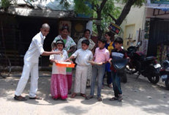
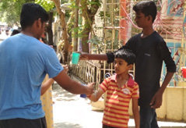
Chennai Metro North:Cultural Programmes , Baby kits distribution at hospital
Buttermilk distribution – Tuticorin Chennai Metro North
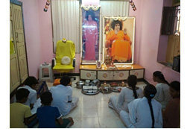
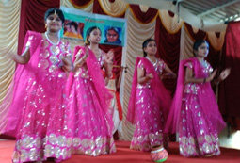
Cultural Prog- Sai Kailas, Ooty Veda Chanting & Narayan Seva- Dindigul

Tamil Nadu Balvikas WEBSITE INITIATIVES
A number of initiatives have been taken through the TN Balvikas website (www.sssbalvikastn.org) to generate interest in Balvikas activities and to encourage participation by Balvikas children and their parents.

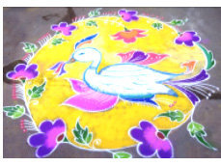
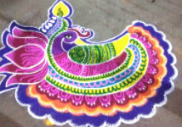
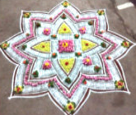
As part of Pongal celebrations, an online Rangoli completion was held for parents of Balvikas children titled ‘Rang BirangiRangoli’. The winners were given the opportunity to offer their Rangoli at PrashanthiNilayam during the Tamil New Year.
Kolam by prize winners in PrashantiNilayam
Apart from the above, during e very festival, activities and games for Balvikas children are uploaded on the website, which can be used by the Gurus. The significance of each festival and related stories are also uploaded, which prove to be an useful resource for the Gurus. There is also a Cookery Corner, where healthy recipes are added, for parents and children to benefit.
On the occasion of theAradhana Day, Tamil Nadu Balvikasoffered a song ‘Sai PaadameyThunai’ at the Lotus Feet of Bhagawan. The song was rendered by a Balvikas alumnus, the instrumentals were also by BalvikasAlumni.. The video was uploaded on the website on theAaradhanadayand can be accessed by clicking on the following link:
https://www.youtube.com/watch?v=84H9iH2xpBk

5.1 Activities @ SUNDARAM for the period 1st January 2016 – 30th June 2016
Regular Activities
Activity | Periodicity / Duration
Abishekam to Shirdi/ Sai Sundareswarar | Daily morning
Evening Rudram to Sai Sundareswarar | Daily evening
Playing Radio Sai program relayed from Prasanthi Nilayam | Morning : 7 am to 12 noon  Evening : 3 pm to 5.00 pm  Night : 7 pm to 8:00pm
Veda Teaching Class | All Thursdays & Sundays
Vibuthi packing by 10 Mahilas | All Mondays
Garland making by 30 Mahilas | All Thursdays, Sundays and Festival days in the forenoon
Shramdhan by Men Sevadals | All Sundays
Cleaning of Sundaram premises and puja articles by Samithi Mahila members on rotation | All Days
Duty for Men Sevadals on rotation from Chennai Metro (South, North, West)  Day time duty – 3 numbers  Night time duty – 2 numbers | All Days
Multimedia Reading Room | All Days – 9 am to 1 pm and 3 to 5:30pm
Book Stall | All Days 9:00 am – 8:00 pm
Blood Bank (volunteers on rotation) | All Days 06:00 am – 10:00 pm
Recording of RadioSai programs in Tamil for broadcasting on Saturdays 7:30-8:30 pm | Every day

Regular Features at Sundaram:
Activity Days | Activity
All 1st Sundays | 05:00 am: Omkaram, Subrabatham and Nagarasankeerthan 06:30-07:30 am: Puja to Shirdi Sai and Sai Sundereswar
Mahila Day  19th of every month | Early morning Omkaram, Subrabatham and Nagarasankeerthan and later followed by Sai Sahasranama Archana.  Bhajans by Mahaila group was done in the evenings.
All Sundays &Thursdays | 5:00 pm : Video Show on Bhagawan.  5:30 pm : Veda Parayaam.  6:00pm – 7:00 pm : Bhajan by Sundaram Bhajan group
All week days other than Thursdays | Bhajans conducted by three metro districts, Kanchi-North and Tiruvallur district samithis from 6pm to 7pm in rotation.
All Pradosam day evenings | Rudram chanting with Abishekam to Sai Sundareswar conducted by the Veda Group
All Thiruvadirai star days (Swami’s birth star) | Ekadasa Rudram chanting with Abishekam from 6 am to 9 am. This is usually attended by hundreds of devotees.

Special Festivals/ Events
Festivals | Date | Activity
Sri Rama Navami | 05.04.2017 | 03:30 pm : Video Show on Bhagawan  04:30 pm : Veda Parayanam.  05.00 pm : Devotional Music by Sri. Soundarrajan and  Party  06.00 pm: Bhajans by Sundaram Bhajan Group  07.00 pm: Maha Mangala Aarthi
Tamil New Years Day | 14.04.2017 | 05:00 am: Omkaram, Subrabatham and  Nagarasankeerthan  06.15am: Abhishekam to Shirdi Sai and  Sai Sundereswar  10.30am: Sahasranama Archana  12 noon : Narayanaseva  3:30 pm : Video Show on Bhagawan  4:30 pm : Veda Parayanam.  5.00 pm : Devotional Music by Karthik Narayanan and  Party  6.00 pm: Bhajans by Sundaram Bhajan Group  7.00 pm: Maha Mangala Aarthi
Vidya Vahini Meeting | 15.04.2017 &16.04.2017 | State Level Meeting and Exhibition of Vidya Vahini was Conducted
Aradhana Mahotswam | 23rd and 24th April 2017 | 04.00pm: Chandi Aavarana Pooja  06.00 am: Chandi Homam  09.30 am: Rendering of Sai Pancharatna Kritis by  leading Musicians with Disciples and Children  of Sai Schools followed by honouring the  Musicians  11.30 am: Narayana Seva  05:00 pm : Video Show on Bhagawan  05:30 pm : Veda Parayanam.  06.00 pm: Bhajans by Sundaram Bhajan Group  07.00 pm: Maha Mangala Aarthi
Solar Power Panel Installation | 04.05.2017 | 30 Kv Solar Power Panel was Installed (The Electric Bill has come down to 1/10th in comparision to earlier Bills)
Eswaramma Day | 06th May 2016 | Vastra Dhanam for Pregnant Ladies and Ladies with New born Children.  04.30 pm to 06.00 pm: Bal Vikas Cultural Programme  06.00 pm to 07.00 pm: Bhajans by Bal Vikas Chilren
Summer Course | 02nd June 2017 – 04th June 2017 | 08.00am to 04.00 pm: Summer Course for Group 2 and  Group 3 Bal Vikas
Guru Poornima Celebrations | 08th July 2017 | 05:00 pm : Video Show on Bhagawan  05:30 pm : Veda Parayanam.  06.00 pm: Bhajans by Sundaram Bhajan Group  07.00 pm: Maha Mangala Aarthi
AIP’s Chennai Visit | 23rd July 2017 | AIP’s Meeting with Chennai Elite and with Alumni from SSS University
Satsang | 13th August 2017 | Talk by Sri. Arvind Balasubramiam of Radiosai, Prashanthi Nilayam
Vinayaka Chaturthi | 25th August 2017 | 05:00 pm : Video Show on Bhagawan  05:30 pm : Veda Parayanam.  06.00 pm: Bhajans by Sundaram Bhajan Group  07.00 pm: Maha Mangala Aarthi
Sai Sundareswarar Prathista Day | 02nd September 2017 | 06.15am: Special Abhishekam to Shirdi Sai and  Sai Sundereswar  3:30 pm : Video Show on Bhagawan  4:30 pm : Veda Parayanam.  5.00 pm : Devotional Music by Karthik Narayanan and  Party  6.00 pm: Bhajans by Sundaram Bhajan Group  7.00 pm: Maha Mangala Aarthi
Bhajan Vikas Function | 16th September 2017 | Bhajan Vikas Function was conducted
Navarathiri Celebrations | 21st September 2017 to 30th September 2017 | Navarathiri was observed with Daily Kumkum Archana between 10.30 am to 11.30 am followed by Prasadham, distribution  Evening Special Devotional Program, Bhajans was rendered to Bhagawan
Avatar Day | 20th October 2017 | Avatar day was Celebrated
Bal Vikas Akanda Bhajans | 22nd October 2017 | Bal Vikas Akanda Bhajan from 5.30 am to 03.00 pm
Bhagawans Birthday celebrations | 11th November 2017 to 23rd November 2017 | Birthday Celebrations was conducted for 9 days. Commencing with akanda Bhajan at 11th 6 pm to 12th 6 pm with every day morning sahasranam archana and evening special programme on 16th Thursday Nov. Flute recital by Smt Sikkil Mala Chandrasekar and on 17th evening Satsangh was conducted by Dr.T.Venugopal and on 18th Evening Instrumental music (Mandolin) by Master Sai Govind. On 19th Sunday there was Balavikas Rally from 7 am to 9 am at 12 noon distribution of Food packets at Door steps in Sundaram salai. In the afternoon a Musical Programme with Vedio presentation by Alumni of Anantapur Campus followed by Deveotional by Smt Bushany Kalyanaraman & Party. On 21st November evening devotional music presented by Kum Lakshmi and Party.on 23rd November Bhagawans Birthday Nagar sankirtan with Rathotsavam taken place. Aavahanti Homam and Abhishekam followed Rudram recitation by Sai youth wing followed by Sahasranama archanai followed by vasthra dhanam for 100 Gents and 100 Mahilas selected from poorer section followed by Narayana seva for more than 2000 person and evening Alumni from Prasanthi Nialyam and Brindavan Campus presented there inspiring experiences with swamy. Musical presentation by Sundaram Bhajan group with Swami’s Jhoola Vaibhavam attended by more than 5000 devotees. Entire sundaram building was colourful light decoration. At 10 pm Sai youth went around entire Chennai Metro and adjoin district distributing Blankets (350 nos) for homeless poor pavements dwellers.
New Year Celebration | 01.01.2018 | 05:00 am: Omkaram, Subrabatham and  Nagarasankeerthan  07:00 am: Abhishekam and Puja to Shirdi Sai and Sai  Sundereswar. New Year Calender and Laddu  Prasadham were distributed to devotees
04:30 pm: Video Show on Bhagawan.
05:00 pm: Veda Parayaam.
05:30 pm: SpecialBhajan by Sundaram Bhajan Group
06.30 pm: Maha Mangala Aarthi
SUNDRAM  36th Anniversary Celebrations. | 19.01.2018 | 05:00 am:Omkaram, Subrabatham and  Nagarasankeerthan  06.00am: Mangala Vadhyam and Flag Hoisting  06.15am: Abhishekam to Shirdi Sai  06.30 am:10.00 a.m.: Mrithunjaya Homam to Sai  Sundereswar  10.30am: Sahasranama Archana  12 noon : Vastra Dhanam and Narayanaseva  03:30 pm: Video Show on Bhagawans  Visit to SUNDARAM on Various Occasions  04:00 pm: Veda Parayaam.  04.30 pm: Special Musical presentation by SUNDARAM  MAHILA BHAJAN  05.30 pm: Devotional Music by CHONG CHIU SEN  AND PARTY  06.30 pm: Bhajans by Sundaram Bhajan Group  07.15 pm: Maha Mangala Aarthi followed by Prasadham  Distribution and Narayana Seva
 | 20.01.2018 | 04.00 pm: Aungnai, Ganapathy Pooja, Punyavachanam,  Ankurarpanam, Raksha Bandhanam, Srinivasa  Kalyana Mahotsavam  07.00 pm: Maha Mangala Aarthi followed by Prasadham  Distribution and Narayana Seva
 | 21.01.2018 | 05.00 am: Gho Pooja  05.30 am: Ganapathy Pooja, Sankalpa, Kalasa Prathista,  Mahanyasa Japa,  08.00 am: Ekadasa Rudra Parayanam along with  Abhishekam to Sai Sundareswarar  10.30 am: Rudra Japa Yagnam, Poornahuthi, Vasordhara 11.30 am: Kalasa Abhishekam to Sai Sundareshwarar  with Bhajans, Alankara Deeparadhana,  Swasthiprarthana,  12.00noon Maha Mangala Aarthi followed by Prasadham  Distribution and Narayana Seva
Commencement of Sai Pancharathna Keerthana Practice | 26.01.2018 | 10.00 am to 12 Noon Commencement of Sai Pancharathna Keerthana Practice
Vidya Vahini Symposium | 26.01.2018 | 03.00 to 04.00 pm Vidhya Vahini Symposium by Tamil Nadu Vidhya Vahini Unit along with Prashanthi Nilayam Representatives
Disaster Management Training Programme | 11.02.2018 | Disaster Management Training Programme was held at Sundaram by State Faculty Participated about 75 Trainees Participated.
Maha Sivarathri | 13.02.2018  14.02.2018 | 6.00 pm to 6.00 am: Akhanda Bhajan commenced with  Lighting of Lamp of Love  8.00 p.m. to 2.00 a.m.: Special Abhishekam and  Poojas with Ekadasa Rudhram  Chantings to Sri Sai  Sundareshwarar .  06.00 am Maha Mangala Aarthi followed by Maha  Prasadham  Prasadham was distributed throughout Night.
Ugadi Day | 18.03.2018 | 05:00 am: Omkaram, Subrabatham and  Nagarasankeerthan  06.00am: Mangala Vadhyam and Flag Hoisting  06.15am: Abhishekam to Shirdi Sai and  Sai Sundereswar  10.30am: Sahasranama Archana  12 noon : Narayanaseva  03:30 pm : Video Show on Bhagawan  04:30 pm : Veda Parayanam.  05.00 pm : Devotional Music by Smt. Lavanya  Vaidyanathan and Party  06.00 pm: Bhajans by Sundaram Bhajan Group  07.00 pm: Maha Mangala Aarthi and Prasadham  distribution
Sri Rama Navami | 25.03.2018 | 06.15am: Abhishekam to Shirdi Sai and  Sai Sundereswar  04:00 pm : Video Show on Bhagawan  04:30 pm : Veda Parayanam.  05.00 pm : Devotional Music by Dr. Narayanan and  Party  06.00 pm: Bhajans by Sundaram Bhajan Group  07.00 pm: Maha Mangala Aarthi and Prasadham  distribution

21st Sep to 29th Sep 2017 Navaratri celebrations Sundaram
Navarathri was celebrated with spiritual fervor at Bhagawan’s abode in Chennai, Sundaram from September 21 to 29, 2017. On all the nine days and including Vijayadasami day on 30th September, kumkumarchana was conducted to please the triune Mother deities along with bhajans by mahilas. In the evenings Veda parayanam and devotional songs rendering were held. This was followed by bhajanss and the daily program concluded with maha mangala arathi and prasadam distribution. Devotees in large number participated and graced the celebrations.

20-10-2017 Avatar day celebrations Sundaram
Avatarhood declaration day was celebrated at Sundaram on October 20, 2017 in a very memorable manner. In the morning abishekam was performed to Sri Shirdi Sai along with Veda parayanam. In the evening the program commenced with video show, Veda parayanam and a violin concert by Parur Anantha Lakshmi followed a vocal recital. This was followed by Sai bhajan and the day long celebrations concluded with maha mangala arathi to Bhagawn and distribution of Vibhuti and prasadam to the gathered devotees.

Following course of the Avatarhood celebrations Akhanda Bhajan by bal vikas children of Chennai metro south district was held on October 22, 2017 from 05:30 am to 03:30 pm. At 04:00 pm video show on Bhagawan was held followed by Veda parayanam, vocal recital by Sri. Sriram Parthasarathy, Sai bhajan by Sundaram bhajan group and concluded with maha mangala arathi to Bhagawan.

Bhagawan’s 92nd birthday celebrations

Bhagawan’s 92nd birthday was celebrated at His holy abode in Chennai, Sundaram as an eight-day festival from 16th to 23rd November 2017 woven as a garland of activities offered at His Divine Lotus Feet. The daily day long program commenced at 06:00 am with mangalavadyam, hoisting of Prasanthi flag, abishekam and pooja to Sri Shirdi Sai and Sai Sundarareswarar, Sahasranamarchana at 10:30 am and Narayana Seva at 12:00 noon. The evening program commenced at 04:00 pm with video show on Bhagawan followed by Veda Parayanam. At 05:00 pm special programs were held of which the soul stirring performances include Satsangam and devotional renderings which included Satsangam by Dr. T. Venugopal, mandolin by master. Sai Govind, vocal recital by Smt. Bhooshani Kalyanaraman and party, musical rendering by Sundaram gents bhajan group and flute recital by Smt. Sikkal Mala Chandrasekar. At 06:00 pm Sai bhajans by bhajans groups from various districts - Kanchipuram south, Kanchipuram north, Sundaram bhajan group, Chennai south and east districts, Chennai west district, Chennai north and Tiruvallur districts were held.

On the auspicious occasion of Global mahila day on 19th November at 05:00 am Omkaram, suprabhatham and nagara sankeertan with active participation by mahilas from Chennai metros was hel;d. This was followed by Sri Gayathri homam from 06:00 am to 09:00 am.

On that day a memorable rally by bal vikas children marching from four directions congregated at Sundaram much to the delight of the people witnessing the event. The evening program commenced with video show at 03:30 pm by alumni of SSSIHL (mahilas) Anantapur campus.

On the much awaited Bhagawan’s birthday on 23rd November the day long programs began with Omkaram and Suprabhtham. This was followed by nagara sankeertan attended by a swarm of devotees during which a flower decked decorated chariot carrying the holy portrait of our beloved Bhagawn was taken along the streets which was a feast to the eye. From 06:00 am to 08:00 am Avahanti homam and abishekam were performed. From 06:00 am to 08:00 am Sai youth rendered Rudra parayanam and bhajan. At mid noon Narayana seva and vastra danam were held. At 04:00 pm programs by alumni of Prasanthi Nilayam and Brindavan campus was held. At 06;00 pm Sai bhajans were held and the day long celebrations concluded with jhoola seva and maha mangala arathi. On all the days after maha mangala arathi prasdam was distributed to the gathered devotees.

On the very day to mark the glory of Sai seva sevadals of respective districts undertook the noble seva activity of distribution of blankets to the destitutes crouching on the roadsides from 10:00 pm to 01:00 am. In this manner a garland of activities marked the memorable eight day long 92nd birthday celebrations of our beloved Bhagawan which filled the hearts of the devotees with bliss and earned the bountiful blessings of our beloved Bhagawan.

37th Anniversary celebrations
The 37th anniversary celebrations of Sundaram, Bhagawan’s divine abode in Chennai were celebrated on 19th, 20th and 21st January 2018 with aesthetic and spiritual fervor. On 19th January the celebrations commenced with Omkaram, suprabhtham and nagara sankeertan. At 06:00 am amidst the rendering of auspicious mangalavadyam the Prasanthi flag was hoisted. Sri Sudarshana homam was performed at Sri Sai Sundareswarar Sannidhi followed by abishekam. Following this abishekam was performed to Sri Shirdi Sai. At 10:30 am Sai Sahasranamarchana was performed at the main bhajan hall. This was followed by vastradanam and Narayana seva to the gathered devotees. The evening programme commenced at 03:30 pm with a video show on the glory and grandeur of Sundaram. This was followed by Veda parayanam and musical rendering by Sundaram mahil bhajan group. A devotional rendering by Smt. Lavanya (grand daughter of Smt. D. K. Pattamal) was held. This was followed by bhajan and the day long programme concluded with maha mangala arathi to Bhagawan.

On 20th January the second day proceedings commenced at 04:00 pm with Sri Maha Ganapathi pooja, raksha bandhanam and followed by Sri Srinivasa Kalyana Mahotsavam and the second day program concluded at 07:00 pm with maha mangala arathi to Bhagawan.

On 21st January the third day celebrations commenced at 05:00 am with Go pooja. At 08:00 am Sri Rudra Parayanam along with abishekam was performed followed by Sri Rudra japa yagnam and concluded with maha poornahuthi. Amidst rendering of bhajans, abishekam was performed to Sri Sai Sundareswarar with the sanctified kalasha teertham. This was followed by alanakram and the Rudra yagna concluded with maha deeparadhana. In the evening bhajans by Sundarm bhajan group was held.

In this three-day anniversary celebrations, a swarm of devotees participated and made the event even more memorable. The State President, district presidents of all districts, trust members, National Vice President presided in these celebrations. The celebrations left evergreen memories especially the aesthetically decorated Sundram building with hanging festoons were a feast to the eye. On all the three day at the end of the day long celebrations prasadam was distributed to the gathered devotees.

Sri Rama Navami Celebrations
Sri Rama Navami was celebrated at Sundaram temple on March 25, 2018 in a very grand manner. At 07:00 am abishekam was performed to Sri Shirdi Sai and Sai Sundareswarar. The evening programme commenced at 04:00 pm with Video show and Veda parayanam. At 05:00 pm a devotional rendering was performed by Dr. Narayanan and party. At 06:00 pm bhjan by Sundram bhajan group was held and the celebrations concluded with at 07:00 pm with maha mngala arathi to our beloved Bhagawan.

Maha Shivarathri
Maha Shivarathri was celebrated at Sundaram temple on March 13, 2018 with spiritual fervor. The programme commenced t 04:00 pm with Pradosha kala abishekam to Sri Sai Sundareswarar. At 05:00 pm video show and Veda parayanam were held. At 06:00 pm Akhanda Bhajan commenced amidst the lighting of kuthu vilakku. At 10:00 pm along with Ekadasha Rudra paraynam abishekam was performed to Sri Sai Sundareswarar. The whole night Sai brothers and sisters from samithis as per their roster participated in the Akhanda Bhajan. Devotees in large numbers thronged to the aesthetically and colourfully illumined Sundaram temple the whole night and participated in the bhajans and had the darshan of Bhagawan. The 12 hour long Akhanda Bhajan concluded at 06:00 am on 14th with maha mangala arathi to Bhagawan.

5.2 Activities across the Districts
08-04-2017 Seetha Kalyanam Madurai
The SS colony Samithi of Madurai district had organised a Seetha Rama Kalyanam at Bharamana Mahal on 8th April 2017. Sri.Prakas and his team conducted the ritual in the traditional manner with rendering of devotional songs. A rally was also organised to mark the event from Samithi to the venue which was attended by 140 devotees.

24-04-2017 Aaradhana Mahotsavam Tamilnadu
Special Omkarm, Nagarsankitan, Bhajans and Narayanseva was held in almost all the samithis in Tamilnadu. Devotees and active workers of the respective samithis participated in large numbers to mark the event.

06-05-2017 Eswarammma Day Celebrations Kodaikannal
The devotees from the districts of Chennai Metro West, Tirpur, Salem, Madurai and Dindugal organised cultural program, Nrayan seva and Vastra Dhanam at Sai Shruthi- the divine abode of our Beloved Bhagwan. More than 2000 beneficiaries attended the program on 6th morning who were given Prasadam, blankets for gents and sarees for mahilas.

10-05-2017 Vastradhanam Chennai Metro West
With the Divine Blessings of Bhagawan Sri Sathya Sai Baba Varu, Sri Sathya Sai Seva Organisation, India, Tamil Nadu, Chennai Metro West, West Mambalam Samithi organised Vasthradhanam to 200 patients of Government Mental Hospital, Kilpauk, Chennai on 10/05/2017.
Dr. Shanthi, Medical director of the hospital & an ardent devotee of Swami appreciated & welcomed our service and advised us to do more services to mentally challenged persons. Dr. Shanthi is a regular attendee for Sundaram bhajans and travels to Prasanthi Nilayam once in a year to attend medical camps/conferences.
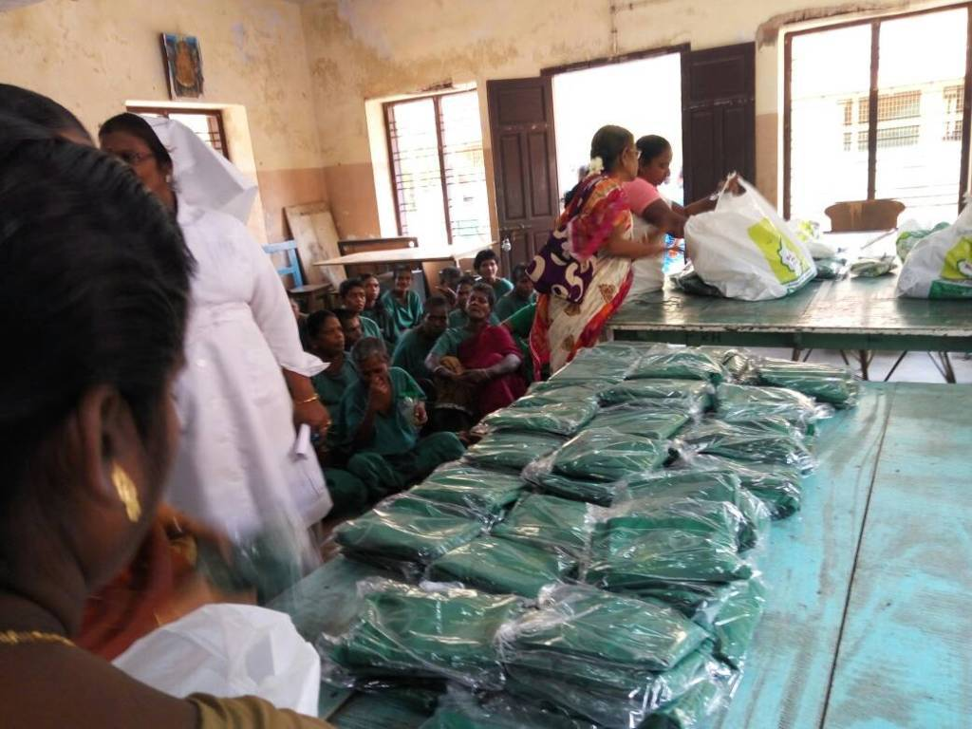
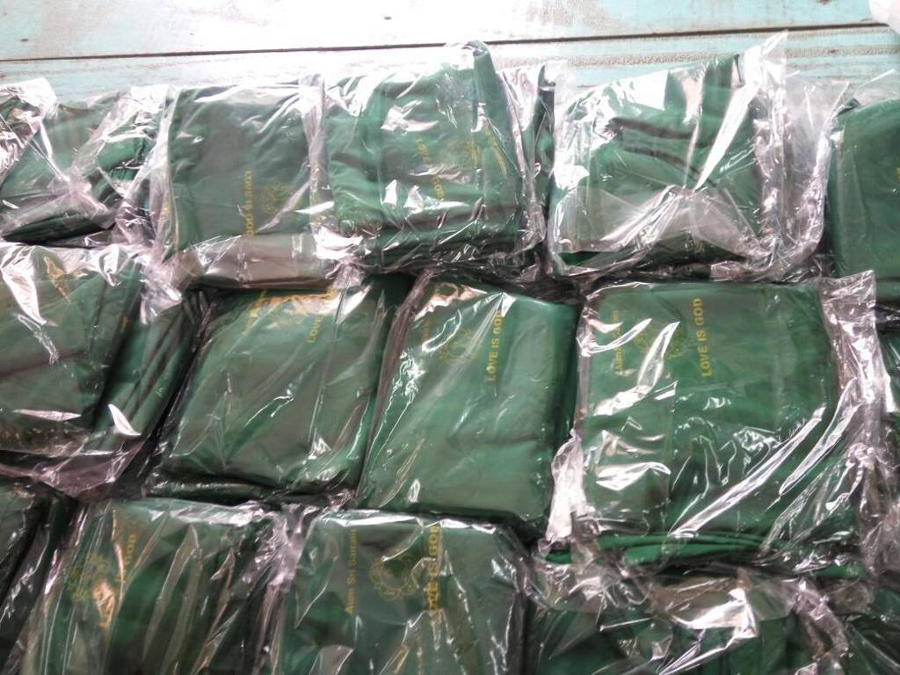
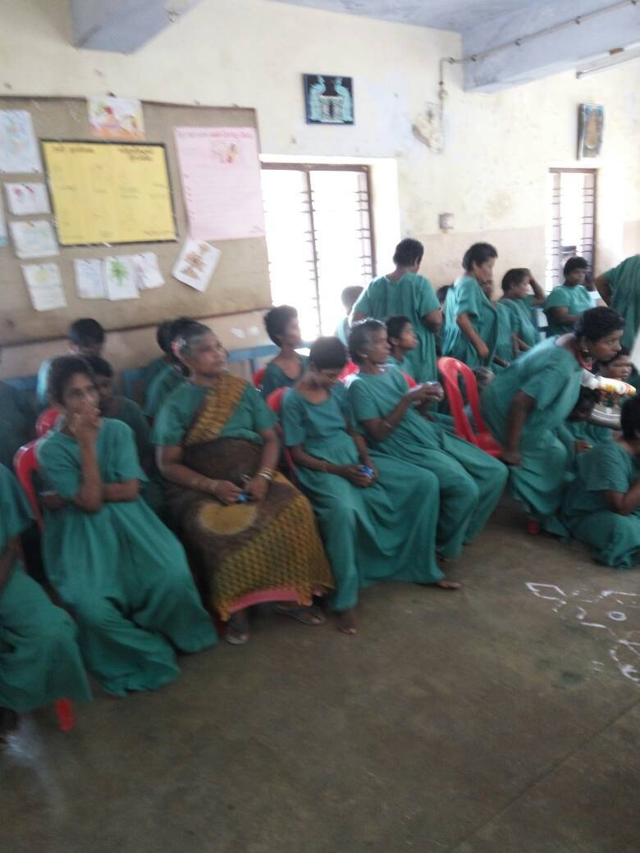

22-04-2017 Anandha Nilayam Inaguration day Madurai
19th Anniversary day was celebrated by the devotees of Madurai district to mark the inauguration of Anandha Nilyam by the Divine hands of Bhagwan Sri Sathya Sai Baba. A special Pallaki seva and Nagar Sankitan was carried out in the evening carrying Bhagwan’s chariot across the main lanes of the town. A special video show was arranged recollecting the cherished moments of Divine Visit to Anandha Nilayam and its inauguration.

23-04-2017 Thiruvillaku Pooja at SSSVIP Village Madurai
As part of the Maha Aaradhana Celebrations of our Beloved Bhagwan, the Madurai district SSSSO had organised a Thiruvillaku Pooja at Angappan Kottam Village on 23rd April 2017. More than 35 mahilas of the village participated in this event. A special Nagar sankirtan was also organised at this venue.
23-04-2017 Anandha Vaibhavam Madurai
As part of the Anandha Vaibhavam event Sri Srinivasan fromMumbai addressed the gathering which was well attended by the deovtees and members of the organisation. On 24th April 2017 Selvi.Dhanalakshmi from Karaikudi rendered a musical consert at Anandha Nilyam.

xx-xx-xxxx Nithya Narayan Seva Chennai Metro West
The Chennai Metro District is doing National Narayana Seva to group of 75 people who are mainly destitute for the last 5 years on a continuously for the past six years . All the samithis of our district, would deliver food for a minimum of 75 persons on each day, as per the roaster prepared. The coordinator or one of his team members, will be present on all days at the appointed hour for handing over the food prasadam to the recipients. The food served is sufficient for 2 times including night. During summer, we provide butter milk also and on function days, sweet is also provided.

08-06-2017 INAUGURATION & INSTALLATION OF R.O WATER PLANT Thiruvallore
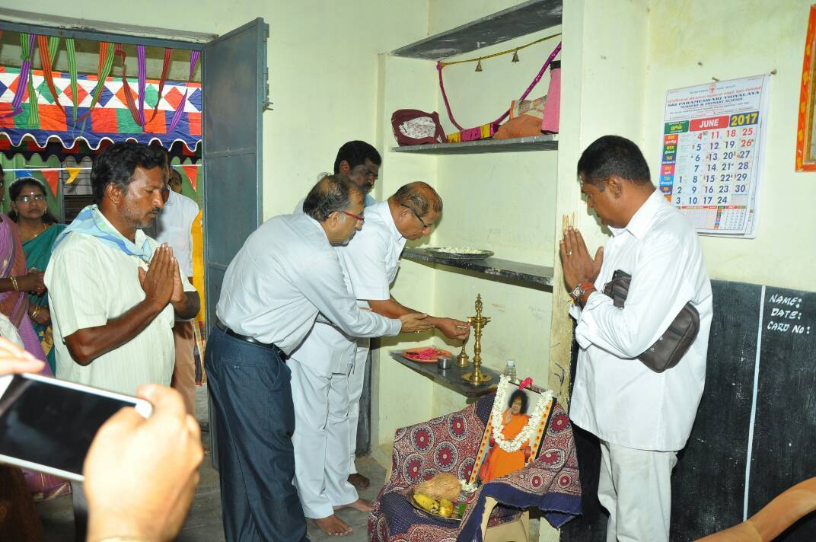
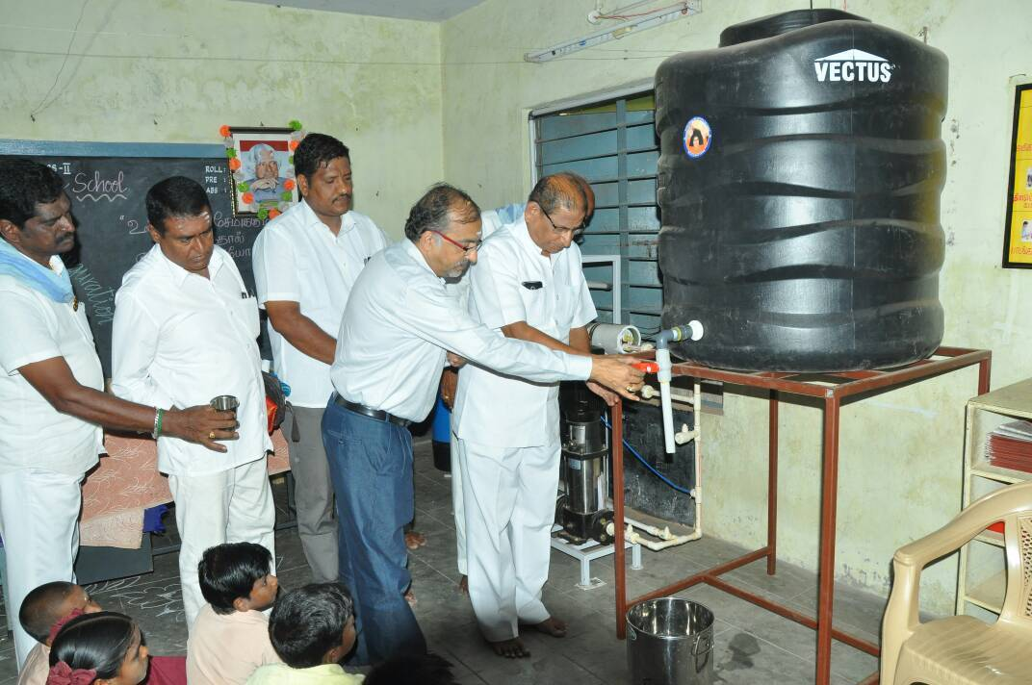
On 08th June 2017, Thursday, the R.O Plant has been installed for the benefit of Panchayath Union school children and staff. The R.O Plant has been contributed by P.A Footwear India Pvt. Ltd. Shri. Venkat Jayaraman, who is a senior sai devotee, alumni of Sri Sathya Sai Institute of higer learning and also the general manager of P.A Footwear helped to coordinated with the management of P.A Footwear and Kavarapettai Samithi. Sri. G. Varadhan, State president, SSSSO(I), TN, Shri. Venkat Jayaraman, general manager of P.A Footwear, Shri. SathyaNarayanan, District president, tiruvallur district and other office bearers participated in the event. Around 212 children along with other staffs are benefited by this R.O Plant.

18-07-2017 “Go seva” Chennai metro north district
On behalf of the district “Go Narayana Seva” was performed at “The Madras Pinjrapole Goshala”, Otteri was held on June 18, 2017. The program commenced with offering milk in feeding bottles to 16 young motherless calves. 800 chappatis and 500kgs of cut vegetables were offered to the 2500 cows, bullocks and buffaloes inhabited in the goshala. Moreover, cleaning work was undertaken in the goshala. Around 125 sevadals including gents and mahilas participated in this noble seva. It is to be noted that this seva is being undertaken every year for the past six years.

    - Global Gayathri Japa yagnam Chennai metro west district
On May 28, 2017 Gayathri japam, Varuna Japam and abishekam to the idol of Sri Gayathri Matha was performed at Sri Maakaali Amman Koil, Nagar by members of the samithis under Sathya Zone of Chennai metro west district in a grand manner. It was a memorable event since that day marked the conclusion of the Koti Gayathri Maha Mantra Japam which commenced with the divine blessings of Swami on November 27, 2016. Manu number of devotees participated in this yagna.

    - Seva rendered during the holy month of Ramzan Coimbatore district
The holy festival of Ramzan was celebrated along with Muslim brothers and sisters on behalf of Pothanur samithi at Sri Sathya Sai Mandir located at Sathya Sai Nagar, Pothanur on June 11, 2017. The district president presided and addressed the gathering. The District Integrated Jama Ad ex – President Sri. Ammer Aldab and Government Ulma Welfare Beneficiaries Board State Principal Secretary Sri. Ashraf Ali enlightened the gathering regarding the significance of the month of Ramzan and fasting. Fruits and tiffin were distributed to the gathering after the traditional Namaaz. More than hundred gents and mahilas participated and enjoyed the celebration.

    - R O Plant inaugural function Tiruvallur district
Purified drinking water R O Plant was installed at Panchayat Union School, Kavarapettai by Kavarapettai Samithi and inaugurated on June 8, 2017. More than 200 children and authorities were benefitted by this installation. Sr. G. Varadan, State President, Sri. Sathya Narayanan, District President, Sri. Venkat Jayaraman, General Manager, P.A. Footwear India Pvt. Ltd., school authroties and samithi members presided over the inaugural function.

05-06-2017 Temple festival seva Madurai district
Sholavandan Samithi members participated in the seva activity in commemoration with Vaikasi Tiruvizha at Sri Janakai Mariamman Koil, Sholavandan from 5th to 7th June 2017. The seva activity included crowd control on the first day, butter milk distribution on the second day and assisting the first aid team monitoring the Pookuzhi function (walking on hot fire embers by devotees). The devotees who slipped and fell into the hot embers were moved on stretchers to the Government Hospital nearby for treatment.

“Sai Sandesam”- District Level Conference Sri Sathya Sai Seva Organisations, Tamil Nadu
One-and-a-half-day district level conferences entitled “Sai Sandesam” were held in the respective districts for the present day district and samithi level office bearers of Sri Sathya Sai Seva Organisations, Tamil Nadu in their respective districts. The ongoing spiritual, seva, educational and young wing activities were highlighted by the erudite speakers of the districts. Moreover, gearing up to undertake the future divine assignments in full swing with interaction session to welcome suggestions and exchange ideas were also held. More over Sri Sathya Sai Seva Organisations national and state level in charges and coordinators participated in these conferences and gave valuable suggestive measures.
The significant topics discussed in the conferences include bhajana mandalis, samithis,bal vikas centres, bhajan, grama seva, Sri Sathya Sai Rehabilitation Program, disaster awareness program, vocational training centres, Veda classes, medical camps, backing up schools, under Sri Sathya Sai Vidya Jyothi Program, IT wing, Sanathana Sarathi, Sai One App and Prasanthi seva.

10-06-2017 District level conference Chennai metro West district
District level conference for the office bearers of Chennai metro west district was held at district centre “Sai Pushpanjali”, T. Nagar on 10th and 11th June 2017 in a very grand manner. Around 170 office bearers of the district participated in this conference.

7th and 9th June 2018 Guru Poornima celebrations Chennai metro west district
- Members of Anna Nagar East samithi celebrated Guru Poornima in their samithi premises on July 7, 2017 in a very grand manner. In the evening devotional rendering by play back singer Smt. Amritha and party was held.
- Members of T. Nagar samithi celebrated Guru Poornima in the morning of July 9, 2017 in their samithi premises with spiritual fervor. Matru pooja was performed to 65 mothers of bal vikas children. Besides this cultural program by bal vikas children and special address by Sri. Ganesh were held.
- Special bhajan was held in commemoration with Guru Poornima at district spiritual centre “Sai Pushpanjali” in the evening of July 9, 2017. A video presentation of Swami’s Guru Poornima divine discourse was held. Sri. Marisami addressed the gathering which was attended by members of all samithis in large numbers.

17-07-2017 Vastra danam Chennai metro west district
In commemoration with Sports Day for the inmates of Institute of Mental Health, Kilpauk vastra danam (stitched dresses) was performed to 150 inmates by members of Zackaria Colony samithi on July 17, 2017.

02-07-2017 Balvikas Workshop Virudhunagar district
A bal vikas workshop was conducted on July 2, 2017 at the new Mandir of Srivilliputhur Samithi, for group 2 bal vikas parents, new gurus, group 3 bal vikas children and Ananda Vidyalaya School teachers on behalf of Virudhunagar district. The workshop commenced at 09:00 am and concluded at 03:00 pm. This was presided over by Sri. T. A, Matchavel, district president and Smt. S. Mahalakshmi, district educational coordinator. Sri. Narayanan, former district president, Dindugul in his key note address explained the importance and purpose of bal vikas classes and teaching techniques while the gurus spoke on various topics with a detailed explanation. About 138 people participated in this workshop.

Guru Poornima celebrations Dharmapuri district
The members of Hosur samithi conducted Pada pooja to the teachers of bal vikas children studying in respective schools at the samithi premises in a very memorable manner. A skit entitled “Acharya devo bhava” followed by rendering of Bhaja Govindam and Abhang bhajans by bal vikas children was held. Teachers, gurus, parents and samithi members around 100 in number graced the celebrations. Besides this Sri Sathya Sai Vratha pooja was held in which devotee couples participated.

Vilakku Pooja Dharmapuri district
The members of Chennasandiram samithi conducted Vilakku Pooja at Sri Shirdi Sai temple, Bandarayapalli village. More than 100 mahilas participated in this pooja.

Sri Sai Sathya Narayana Vratha Pooja Dharmapuri district
Dharmapuri samithi conducted Sri Sai Sathya Narayana Vratha Pooja in which 40 devotee couples participated.

Grama Seva Madurai district
Under the Cleaning Up Program two colored waste baskets one for decomposable and the other for non – decomposable wastes were offered to each household of Angappan Thottam village under SSSVIP. In the afternoon Narayana seva was performed to all the villagers at their doorstep.

11th August – 15th August 2017: 92 hours Akhanda bhajans Krishnagiri and Dharmapuri districts
92 hours akhanda bhajan was held at the premises of Hosur samithi at 02:00 pm on August 11, 2017 and concluded at 12:30 pm on August 15, 2017. This unique program has been underway for the past 15 years since Bhagawan’s 78th birthday. In this program Dharmapuri, Krishnagiri, Hosur samithis, Brindavan bhajan group, Bangalore, Coimbatore metro Vadavalli samithi, Kovilapatti samithi, Cuddalore district samithis, Chennai, Salem, Wallajabad and bhajan singers sfrom various other samithis participated in this bhajan yagna. On the first day the origran commenced with Ganapathi homam. On the concluding day August 15, 2017 alumni of Satya Sai University participated in the bhajan. The program concluded with maha mangala arathi to Bhagawn. The modalities for the program were well planned and organized under the stewardship of the District President.

16-07-2017 Medical camp Pondicherry district
On behalf of Sri Satya Sai Seva Organisations, Pondicherry district, a medical camp was conducted at panchayat town Thiruvennainallur village, Vilupuram district on July 16, 2017. A temple cleaning activity was also undertaken at the famous Chola period Lord Shiva temple. In this mega cleaning activity 160 sevadals involved whole heartedly. Following course medical camp was conducted by a medical team of 5 doctors and 20 paramedical staff in which medical tests under diabetes, blood pressure and physiotherapy and on diagnosis medicines were offered to these village patients.

In this camp around 300 villagers were benefited. Dr Sri. Bala Subramanian, Former Director, JIPMER Medical college addressed the gathering in which he elucidated Bhagawan’s teachings and shared his experiences.

19-07-2017 Temple festival seva Theni District
Periyakulam Mariamman Koil festival was conducted as a 8 day festival commencing on July 19, 2017. During this festival Sai sevadals involved in the noble seva of taking care of the footwear of the devotees and also conducted butter milk distribution to quench the thirst of the swarm of devotees. This seight day long eva was heartily welcomed by the devotees.

07-08-2017 Visit to Cancer patients home Chennai metro south district
In commemoration with the 18th foundation day of Sri Matha Trust rehabilitating about 250 cancer patients undergoing treatment was held on August 7, 2017 the members of Beasant Nagar samithi undertaking seva activities there participated in the celebrations and made it a memorable event for the patients. The program which commenced with Sai bhajan was followed by key note addresses by Smt. Sumithra Kalyanaraman, mahila wing in-charge and Sri. Krishnamurthy, Sri Matha Trust founder boosted the morale of the patients, necessary life style and highlighted the activities undertaken by the trust. Sri. Krishnamurthy lauded the seva activities undertaken by Beasant Nagar samithi. On behalf of our Organisation, Sri. Sarveswaran, district service coordinator addressed the gathering and distributed tokens of love to the beneficiaries as well as the staff serving the patients. At the end of the program on behalf of the samithi Narayana seva was performed to the whole gathering.

August 2018 Government General Hospital Seva Virudhunagar district
The members of disaster management team and members of samithi undertook a mega cleaning activity t the Government general hospital, Rajapalayam. In this cleaning activity 20 DM team members, 20 mahila sevadals and members participated.

25th to 27th Aug 2018 Sadhana camp Virudhunagar District
Rajapalayam samithi held sadhana camp on 25th, 26th and 27th August 2017 at Sai Sruthi, Kodaikanal. In this sadhana camp 42 disaster management team youth and 21 members participated.

03-09-2017 Sri Sathya Sai Vidya Jyothi Trichy district
Panchayat Union Middle School located near Pichandavar Koil South Street was adopted under Sri Sathya Sai Vidya Jyothi project and the inaugural function was held on September 3, 2017 in a very grand manner. Bal vikas classes for the school children were commenced on the same day. It is to be noted that this school is the fourth amongst the schools adopted under SSSVJ by Trichy district.

04-09-2017 New bal vikas centre Trichy district
Bal vikas classes were commenced for the benefit of students studying in Adi Dravidar Higher Secondary School, Telungapatti on September 4, 2017. As a part of the inaugural program note books and writing materials were provided to 215 students of that school.

15-08-2017 Sri Krishna Janmashtami celebrations Trichy District
Sri Krishna Janmashtami was celebrated at Sangiliyandapuram goshala on August 15, 2017 by performing “Go Narayana Seva” with offering of husk, oil cakes, green grass, bananas and jangree sweet to about 200 cows. 20 mahila sevadals and 10 gents sevadals participated in this noble seva.

24-08-2017 Borewell and R O water project Kanchipuram north district
Borewell and R O Water Project installation work was undertaken at Otiambakkam Government School to cater to the needs of the students under Sri Sathya Sai Vidya Jyothi Project on the auspicious occasion of Bhagawan’s Aradhana <Mahotsavam on April 24, 2017. The installation work was completed in four months course and on August 24, 2017 the inaugural function was held and was facilitated for usage. Sri. G. Varadhan, State President inaugurated the plant. Sri. Venugopal, District President, villge assistant village administrative officer, school head master, teachers, students and Sais samithi members in large numbers participated.

20-08-2017 92 bhajan songs program Kanchipuram north district
On behalf of the district 92 songs bhajan program was held at Sri Sankara Global Academy premises on August 20, 2017. 103 gents and mahila youths from 19 samithis of the district participated in this program. On invitation boys and girls and public from the surrounding areas attended the program in large numbers attended the program. Along with the bhajan session a video show of Bhagawan’s rare photographs and video clippings were held.

15-08-2017 Hridaya Sangamam Coimbatore district
A review medical camp for patients who underwent surgeries at Sri Sathya Sai Institute of Higher Medical Sciences, Prasanthigram and Whitefield Super Specialty Hospital under Sri Sathya Sai Rehabilitation Program (SSSRP) entitled “Hridaya Sangamam” was held on August 15, 2017. 40 beneficiaries attended the review medical camp. Dr. Sri. Ramani, cardiologist, Dr. Sri. Ravi Kumar, senior general physic, Dr. Sri. B. Radha Krishnan, eye specialist, Dr. Sri. Subbian, neurologist, Dr. Smt, Kanakavalli, rheumatoid specialist along with 5 paramedical staff screened the patients and provided medical advice. Sri. Raja Subramaniam, District President, Sri. Chandra Sekar, district SSSRP coordinator, Sri. Jayaraj, State SSSRPcoordinator presided over and addressed the gathering.

22-09-2017 Sri Sathya Sai Vidya Jyothi Villupuram district
Gandhi Kamala Nehru Primary and Higher Secondary School, Kutteripadu, Villupuram was adopted under Sri Sathya Sai Vidya Jyothi project on September 22, 2017. This school under the government of Tamil Nadu cherishes a historic significance. It is red lettered that Sri Mahatma Gandhi personally handed over the keys of the school to the daughter of renowned freedom fighter Sri. Jagadeesh Iyer. Our State President, national SSSVJ coordinator, state service coordinator and state SSSVJ coordinator attended the inaugural function. State President in his address highlighted on the significance of human values and the state service coordinator highlighted the importance of seva. 190 students were provided a kit comprising of note books and writing materials. 25 teachers, PTO members, students and Sai sevadals in large numbers participated in the inaugural function. Tree sapling plantation was also held as part of the program.

Sep 2017 Dengue fever awareness program Chennai metro west district
Dengue awareness program was conducted for 3500 students of Government girls higher secondary school, Ashok Nagar and nilavembu kashayam (decoction) was offered to the students. This was held under the stewardship of Sri. K. Suresh Chander, District President and active participation of mahilas and gents sevadals and cooperation of school head master and teachers and this commendable seva was undertaken as a part of Sri Sathya Sai Vidya Jyothi Program.

30th Aug to 3rd Sep 2017 Sri Sathya Sai Charitamrutham Madurai district
On behalf of Madurai east samithi a 5 day spiritual discourses program was held entitled “Sri Sathya Sai Charithamrutham” elucidating on Bhagawan’s Avatarhood, leelas and teachings at Siddharashramam near Madurai Teppakulam from 30th August to 3rd September in a very grand manner. Prof. Sri. Srinivasan, Tiruppur delivered the spiritual discourses. This program was attended by around 150 devotees on all the days.

02-10-2017 Akhanda Gayathri Japa Yagnam Madurai district
For the past 19 years Akhanda Gayathri Japa Yagnam is underway from 06:00 am to 06:00 pm on behalf of Madurai district on 2nd October (Gandhi Jayanthi) every year. This year the japa yagnam was held at “Sai Santoshi” located in Santhanam Nagar, Madurai in which around 200 devotees from all samithis of Madurai district participated.

Oct 2017 “Swatchatha se Divyatha Tak” Theni district
The members of Sri Sathya Sai Seva Samithi, Bodi undertook a mega cremation ground cleaning activity in which they were ably supported by students of Tirumalapuram Nadar Higher Secondary School, Theni Kammavar Polytechnic College NSS volunteers and Friends of Police group. The commendable and dedicated seva of the sevadals and volunteers included removal of thorny bushes and removal of debris to annul the fear of snakes and other poisonous creatures so that people without fear may participate in the ceremonial rites procedures. This seva was undertaken under the supervision of Sri. Bala Subramani, District President, Sri. Ramamoorthy, district service coordinator, Sri Pecchi Muthi, gas crematorium maintenance personnel, Sr. Raghunaganathan, Sri. Murugan, Sri. Selva Kumar NSS coordinators, Sri. Selva Kumar and Friends of Police coordinator.More than 50 tree saplings were planted in the premises.

Oct 2017 Tree Plantation Project Tiruvallur district
The 2000 students of Sri Sathya Sai School, Nallatoor, prepared seed balls and offered to the villagers besides offering 50 tree saplings as a mark of love, gratitude and a mission to save Mother earth and nature to be planted along their respective houses and foster them.

02-10-2018 Sadhana camp Tiruvallur district
The gents’ youth wing and sevadals of Tiruvallur district undertook a mega cleaning activity at Ambattur cremation ground on October 2, 2017.

17-10-2017 Awareness campaign Virudhunagar district
In commemoration with Deepavali celebrations the Sai youth of Rajapalayam samithi along with disaster management team members jointly undertook an awareness campaign on Octobber 17, 2017 along the main streets, cracker shops and amongst public for having a zero accident Deepavali by educating the public regarding the how of bursting crackers and distribution of pamphlets highlighting the basic first aid in case of cracker fire accidents.

13-10-2017 Tree Platation Project Pondicherry district
The gents and mahila sevadals along with youth undertook tree sapling plantation activity at SSSVIP adopted village, Keezhar village on October 13, 2017 under Clean India Project. Bal vikas children, their parents, teachers of Government Primary School took part eagerly and planted fruit bearing tree saplings in the school premises and besides their houses. In all 100 tree saplings were planted. Moreover, footwear was offered free to the school children. At the end of the program with an aesthetic fervor of celebrating Deepavali, crackers were burst and sweets were distributed to the gathered villagers.

20-10-2017 Avatar day celebrations Thanjavur district
Bhagawan’s Avatarhood declaration day was celebrated at Kumbakonam Samithi on October 20, 2017 with Omkaram, suprabhtham and nagara sankeertan in the early hours of the dawn. In the evening special Sai bhajan was held.

19-11-2017 92 bhajan songs program Chennai metro west district
In commemoration with Bhagawan’s 92nd birthday in Chennai metro west district 92 songs bhajan was held at district spiritual centre “Sai Pushpanjali” on November 19, 2017. The program began with Veda parayanam at 01:30 pm and concluded at 08:00 pm with cutting of birthday cake, maha mangala arathi and jhoola seva. A similar program was held on November 26, 2017 wherein bhajan singers representing all samithis in the district participated. On both the days a video presentation of Bhagawan delivering birthday message was held. More than 100 devotees participated in the program and were served Narayana seva.

23-11-2017 92nd birthday celebrations Chennai metro north district
Bhagawan’s 92nd birthday was celebrated at district headquarters Sri Sathya Sai Nivas on November 23, 2017 in a very grand manner. The morning program comprised of Omkara, suprabhatham and nagara sankeertan. The evening program commenced with Veda parayanam, devotional songs rendering, cultural program by bal vikas children and bhajan. Narayana seva was performed at mid noon. A swarm of devotees graced the occasion and received the blessings of our beloved Bhagawan.

23-11-2017 92nd birthday celebrations Kanchipuram South district
In commemoration with Bhagwan’s 92nd birthday celebrations at Parvathi Nagar samithi 3 bal vikas centres were inaugurated on November 18, 2017. Laddu prasadam was distributed to the students of Government Primary School and Government Higher Secondary School on the auspicious occasion of Bhagawan’s birthday on November 23, 2017.

29-10-2017 Tree plantation program Madurai district
On 29th October 108 tree plantation program was held by Madurai Central Samithi at the premises of Mahatma School near Azhagar Koil in which the school students and sevadals participated eagerly.

29-10-2017 Cleaning Program Madurai district
The youth of Sholavandan samithi undertook a cleaning program at Sholavandan railway station from morning to afternoon which was greatly appreciated by the passengers.

29-10-2017 Akhanda Sai Sahasaranamam Madurai district

The members of Madurai TVS Nagar samithi performed Akhanda Sai Saharanama parayanam and archana from 07:30 am to 11:30 am seated in three groups. The members from samithis of Madurai district too participated in this spiritual activity.

23-11-2017 Narayana seva Madurai District
In commemoration with Bhagawan’s 92nd birthday celebrations, bhajans were held at YMCA deaf school located in Madurai which was followed by Narayana seva to the students by members of Tiruppalai samithi.

12-11-2017 Medical Camp Virudhunagar district
The members of Srivilliputhur samithi conducted a diabetic camp at CSI Primary School, Paattangulam, Srivilliputhur on November 12, 2017 in which 125 patients were benefitted.

23-11-17 92nd birthday celebrations Theni district
Bhagawan’s 92nd birthday was celebrated at Theni district as a 6-day festival from November 18, 2017 to November 23, 2017 in a very grand manner. Abishekam was performed to Sri Shirdi Sai at Sri Raja Ganapathi temple, Bodinayakanur followed by bhajan and distribution of sweets by members of Gandhi Nagar bhajana mandali. On 19th November bhjana by mahila members was held at Sri Parvathi Paramasivan temple located in Keezh Raja Veedi. On 20th November there was a visit to the general hospital wherein besides enquiring the wellbeing of the patients, distribution of food packets and dresses to 5 new born children was held. On 21st plantation of 10 tree saplings at AHM Trust Old Age Home was held. On 22nd November a motivating talk was delivered by Sri. K. Narayanan former District President, Dindugul district to the 250 students and 10 mentally retarded students of Nirmala School, Dharmathupatti village. Narayana seva to around 700 in number was also held. On 23rd November nagara sankeertan in the morning and pallak seva along the main streets of Bodinayakanur was held and on reaching the samithi bhajan followed course and the program concluded memorably with maha mangala arathi to Bhagawan.

24-11-2017 Narayana seva at Omandurar Multi Specialty Hospital-Chennai metro south district
In commemoration with Bhagawan’s 92nd birthday celebrations Narayana seva was performed at Omandurar multispecialty hospital for about 1000 people comprising of patients, their attenders, security personnel and hospital staff on November 24, 2017. The program commenced with Sai bhajan followed by an address by Sri. Ananda Kumar, Nodal Officer, Omandurar multispecialty hospital in which he extolled the noble humanitarian service rendered through Sai seva. Sri. K. Suresh Chander, District President, Chennai metro west district highlighted the services seva rendered by our Sai organization. Sri. Sundararaj, hospital administrator delivered special address. Sri. Raghavendra Rao, sevdal coordinator for Omandurar hospital seva expressed gratitude to whole gathering. Many Sai sevadals participated in this seva rendered in a meticulous manner.

23-11-2017 Bhagawan’s 92nd birthday celebrations Coimbatore district
Bhagawan’s 92nd birthday was celebrated in all samithis of Coimbatore district with Omkaram, suprabhtham, nagara sankeertan, homas and various programs in a grand manner. The members of Vadavalli samithi conducted pallak seva at Sellappa Gounder Pudur village. Narayana seva to about 700 people, blanker distribution to 142 villagers and 70 dhotis to gents of the village were highlights of the celebrations. Members of Ramanathapuram samithi conducted bal vikas rally in which children of Chinnampathi and Pudupathi villages participated. Vasatra danam was offered to the children. Around 700 villagers participated in this program. Moreover, on behalf of Ramanathapuram samithi a cultural program entitled “Prema bhavam” enacted by the youth and bal vikas children was held at Dhanavantri Vaidyashala auditorium.

On behalf of R S Puram samithi 56 tree saplings were planted at Kuppanoor village. Vastra danam for 108 villagers and Narayana seva for 500 people were conducted. Baby kits were offered to 120 new born children. On behalf of Kovaipudur samithi Narayana seva was performed for 700 people and 25kgs rice, 100 diapers and 25 blankets were offered to the children of mentally challenged home. The members of Sai Baba Colony Samithi performed Narayana seva to the children of adopted Vidya Jyothi school, Varapalayam village. Members of Ondiputhur Samithi planted 92 fruit bearing tree saplings. On behalf of R S Puram Samithi writing materials were provided to the students. Narayana seva was performed by Guniyamuthur, Ravathur, Sami Chettipalayam, Sai Baba Colony and Pothur samithis as part of birthday celebrations.

On behalf of Coimbatore district Sai Baba Colony Samithi distributed 750 tree saplings to the students of SNS Academy School. On Bhagawan’s birthday a bag containing Sathyam Sivam Sundaram book, Swami’s photo, vibhuti and laddu prasadam were distributed to around 500 devotees at Sri Shirdi Sai Temple.

29-10-2017 Sri Rudra Parayanam Chennai metro west district
In commemoration with Bhagawan’s 92nd birthday 92,000 times Sri Rudra Parayanam praying for global welfare undertaken by West Mambalam samithi was held at samithis, devotee’s houses, public places, etc. This Rudra parayanam initiated on January 1, 2017 concluded on October 29, 2017. With the overwhelming involvement of devotees in large numbers the parayanam crossed 92,000 and was accounted 93,613 times in number. This program was meticulously planned and spearheaded by Sri. Krishnan, Veda coordinator, Chennai metro west district.

29th Nov – 4th Dec 2018 Sri Sathya Sai Vahineeyam Madurai district
In commemoration with Bhagawan’s 92nd birthday celebrations a unique sadhana of recapitulating the teachings of Bhagawan enshrined in Vahinis penned by Swami Himself under the title, “Sri Sathya Sai Vahineeyam” of which a few were chosen and a Sapthaham on these selected vahinis was held from November 29, 2017 to December 4, 2017 at Shiddhashramam near Neppakulam, Madurai as a string of discourses every evening of two hours duration.
The discourses which include Geeta Vahini and Dharma Vahini by Dr. P. Krishnamurthi on 29th November, Leela Kaivalya Vahini & Upanishad Vahini by Prof. N. P. Hariharan on 30th November, Dhyana Vahini by Sri. Narayanasamy, district president on 1st December, Vidya Vahini by Sri. K. R. Suresh, State Vice President on 3rd December and Sandeha Nivarini and Prasnottara Vahini by prof. N. P. hariharan on 4th December were presented in a lucid style amicable to the understanding of the gathering. In this attempt to take Bhagawan’s teachings to the reach of the common man devotees in large numbers participated with receptive minds.

16-12-2017 Public Toilets Tiruvallur district
For the benefit of the devotees thronging to the Perumal temple public toilets for both men and women constructed on behalf of Sri Sathya Sai Seva Organisation were handed over to the temple authorities on December 16, 2017.

16-12-2017 Go danam Tiruvallur district
Go danam, cow along with its calf was offered to a chosen family at the Perumal temple on December 16, 2017. Sri. G. Varadan, State President presided over and graced the occasion.

16-12-2017 RO Plant inaugural function Tiruvallur district
On the same day a R O Plant erected to supply purified drinking water for the benefit of the students of Arani Primary School was inaugurated. In all the programs State President, District President, district coordinators, convenors, samithi members and public participated.

08-12-2017 Health awareness program Salem district
In commemoration with Bhagawan’s 92nd birthday celebrations a unique seva was held at Salem (Fairlands) Azhagapuram area on December 8, 2017 for the benefit of corporation scavenging workers by distribution of masks for mouth, nail cutters and soaps on behalf of Salem Town Samithi. Besides this a demonstrative program of washing hands methodology and awareness and significance of health maintenance was conducted. The details of medical seva rendered at Salem Samithi was apprised to them and were requested to avail this opportunity for their health benefits. At the end of the program Narayana seva was rendered to the gathered workers.

01-01-2018 Sai Sahara samithi anniversary celebrations Chennai metro west district
The members of Sai Sahara Samithi celebrated their 10th anniversary as a four day celebrations from December 29, 2017 to January 1, 2018 in a very grand manner. On the first day Villupattu entitled “Sai Avatara Vaibhavam” was held. On 30th holy pilgrimage to the various temples in Kanchipuram was undertaken. Bhajan and Narayana seva were performed at NGO orphanage. On 31st Sri Maha Ganapathi homam, Sri Maha Rura homam, Navagraha homam concluding with maha poornahuthi was held at the samithi premises. On 1st January in the evening Vedam, bhjan and cultural programs were held. Sr. Narayanan, former DP, Dindugul delivered special address. Senior members were honoured during the occasion. Prizes were distributed to the bal vikas children.

02-09-2018 New bhajana mandalis Chennai metro south district
Sai Nagar bhajana mandali was inaugurated at the premises of Sai Kripa, near Sundaram temple by Smt. Soundarya Krishnamurthi, state spiritual coordinator on September 2, 2017.

On the same day Pallikaranai bhajana mandali was inaugurated at Appasami housing board complex by Sr. S. Ganapathi, State spiritual awareness programme coordinator. Sri. N. Ramani, National Vice President presided over both these inaugural functions and graced the occasion.

    - Pongal Celebrations with religious harmony Villupuram district
The members of Chenji and Elavansur Kottai samithis celebrated Samattuva Pongal Vizha (Pongal celebrations with religious harmony) at Chenji Avalapoondi Church, Villupuram on January 12, 2018. In this memorable celebrations students, boys and girls, 10 Muslim families and in addition Hindus and Christians of the village in large numbers participated. Sri. Narayanan, former District President, Dindugul addressed the gathering and delivered valuable advice. At the end of the program maha mangala arathi was offered to Lord Jesus Christ unitedly by a Hindu, Muslim and Christian sister which re-emphasized the glory of unity of religions. Prizes were distributed to the students and prasadam was distributed to the assembled gathering.

    - Hrudaya Sangamam Theni district
Under the Sri Sathya Sai Rehabilitation Program (SSSRP) a review medical camp entitled “Hrudaya Sangamam” for 30 cardiac patients operated in the twin Sri Sathya Sai Super Speciality Hospitals, Prasanthigram and Whitefield and 5 patients from in and around the district was held on December 24, 2017. Dr. Maitreyi (Prof. of Microbiology of Government Hospital, Theni), Dr. S. Venkat Prabhu (District medical coordinator, SSSSO), Dr. R. Aravazhi (Cardio specialist) and Sri. Jayaraj (SSSRP-TN State Coordinator) participated in this camp. Basic medical check-up comprising of BP< blood sugar and ECG was performed for more than 100 patients and suitable medical advice was offered.

29-12-2017 Vaikunta Ekadashi Seva Madurai District
The sevadals of Madurai district undertook the dedicated seva of controlling the crowd and distribution of Tulsi leaves offered to the Lord at Sri Koodal Azhagar koil on the auspicious occasion of Vaikunta Ekadashi on December 29, 2017.This noble seva has been underway for the past six years with the blessings of our beloved Bhagawan.

31-12-2017 Pallak seva Coimbatore District
Pallaki Seva was held by the members of Race Course Samithi on December 31, 2017. The grand procession colourful flower decked pallak with the portrait of our beloved Bhagawan commenced at 05:00 pm from the samithi and 3 km. marathon procession carrying the banners of our Sai Organisation was followed by Veda group carrying the Poorna Kumbham, bal vikas children, especially from the fishermen slums leading with Vedam chanting, district bhajan group along with the district youth rendering bhajan songs following course was a feast to the eye. All along the procession devotees and common public in large numbers who were blessed to have a glimpse of our beloved Bhagawan were offered a photo and Vibhuti prasadam besides an issue of Sananthana Sarathi. More the 300 devotees and bal vikas children participated in this grand procession.

11-02-2018 Virugambakkam samithi inaugural function Chennai metro west district
Virugumbakkam samithi blossomed as the 31st samithi of Chennai metro west district in the “Cee Bros Gardens” premises located at Sri Vembuli Amman Street on February 11, 2018. State President Sri. G. Varadhan inaugurated the samithi and delivered special address. District President Sri. K. Suresh Chander introduced the convenor and coordinators taking charge as office bearers of the samithi. The program also included bhajan and cultural programme by bal vikas children. Convgenor Sri. Ramesh Kumar delivered vote of thanks.

48th anniversary celebrations of T Nagar Samithi Chennai metro west district
The members of T. Nagar celebrated their 48th anniversary on January 28, 2018 at PSBB auditorium in Thirumalai Road in a very grand manner. The program commenced with Vedam, bhajan followed by abishekam to Sri Shirdi Sai Baba. This was followed by a mandolin convert by maestro V. Sai Govind. Sri. Prasanth, alumni of Sri Sathya Sai University delivered special address. A dance dramam entitled “Kshetrodbhavam” was meticulously enacted by the bal vikas children. District President Sri. K. Suresh Chander and State Gents Service Coordinator Sri. P. Suresh Kumar delivered felicitation address and presented tokens of love to the bal vikas children.

27 & 28-01-2018 Palani padayatris seva Madurai district
A noble seva is being undertaken by Sozhavandan samithi for the past 16 years for the benefit of padayatris to the holy Palani Hill. The seva includes medical camp and massaging the aching feet of the holy padayatris. This year this seva was rendered at Moolachathiram near Ottanchathiram along with Chinnalampatti Dharma Sastha Trust on 27th and 28th January 2018. In this laudable seva 20 bal vikas children, 25 gents and 25 mahil sevadals participated and served a mammoth 3500 padayatris.

17-02-2018 Hrudaya Sangamam Vellore, Tiruvannamalai districts
Under Sri Sathya Sai Rehabilitation Program (SSSRP) “Hrudaya Sangamam” a cardiac review screening camp was held for the patients of Vellore and Tiruvannamalai districts who underwent cardiac surgeries at the twin Sri Sathya Sai Super Specialty Hospitals at Prasanthigram and Whitefield at Sri Sathya Sai Seva Samithi, Ambur on February 17, 2018.

13-03-2018 Special seva at public health center Chennai metro west district
Our Sai sevadals have been rendering yeoman service at Public Health Centre since several years. For the benefit of the patients Sri Sathya Sai Seva Organisations, Tamil Nadu an oxygen generator machine was handed over by our State President Sri. G. Varadhan to the officer in-charge Sri. M. K. Srinivasan on March 13, 2018. Moreover he awarded certificates in honour of the trust membes and respective in-charges of the hospital. In this programme, District President, West Mambalam samithi convenor and sevadals presided.

04-03-2018 Grama seva and multi specialties medical camp Tiruvallur district
The members of Ambattur and Red Hills samithi conducted grama seva at Jnayiru village on March 4, 2018. In the morning pallak seva of Bhagawan’s portrait graced the main streets of the village. Following this a special medical camp comprising of general medicine, opthamology, dental, paediatrics, gyanecology specialties was conducted. More than 300 villagers were benefitted by this camp. At 11:00 am sports and games events were conducted for the children of the village.

    - Vilaku Pooja Kanchipuram north district
On behalf of the district Thiru vilakku pooja was celebrated in 19 samithis and 3 bhajana mandalis respectively on February 9, 2018. The pooja comprised of Veda parayanam followed by Sri Durga, Lakshmi, Saraswathi and Sai ashtothram satha nama pooja was held. In this pooja members, bal vikas parents and common public about 700 mahilas in number participated.

    - Medical camp Trichy district
Trichy K. K. Nagar samithi conducted a free general medical camp at Icchikamalaipatti on march 4, 2018. Villagers in large numbers attended and were benefitted by the camp.

01-03-2018 Narayana seva Trichy district
Under the Sri Sathya Sai Vidya Jyothi Project morning tiffin and afternoon lunch as Narayana Sev has been initiated for benefit of the students in the adopted schools in and around Sri Rangam since February 1st and March 1st respectively.

21-02-2018 Special pooja for students appearing for common board examinations Coimbatore
A special pooja praying for the students appearing for the common board examinations was held at Sungam Vignesh Mahal on February 21, 2018. Sri Lakshmi Hayagreeva pooja was performed with a fervent prayer to improve the educative, memory skills and ability to attempt questions by the students. Nearly 720 students participated in this pooja. Writing materials placed in the pooja were distributed to the students.

25-01-2018 93 houors Akhanda Bhajan Coimbatore District
In commemoration with 93rd birthday celebrations of our beloved Bhagawan 93 hours Akhanda Bhajan was conducted in Kuniamuthur Sri Sathya Sai Seva Samithi, a property of Sri Sathya Sai Central Trust. The Akhanda Bhajan commenced at 10:00 am on January 25, 2018 and continued for 93 hours. in this spiritual event more than 2500 devotees participated and enjoyed the bliss. Devotees from several districts participated in this glorious singing of the Names of the Lord. Not only from our state devotees from Karnataka, Kerala and Andhra Pradesh too participated in this Akhanda Bhajan and received the blessings of our beloved Bhagawan.

30-03-2018 Sri Sathya Sai Mitri Skills School 6th anniversary celebrations Chennai West district
The 6th year anniversary celebrations of skills school was held on March 30, 2018 at Chinnamani Valliammal Thirumana Mandapam, Choolaimedu. The chief guest of the occasion was villupattu Smt. Bharathi Thirumagan presided over and delivered special address. The experiences of the existing batch girls’ students and annual report was telecast as a video show. Poetess Smt. Ponmani too presided over offered a token of love to the chief guest, awarded certificates to the qualified 29 students and offered prizes to the bal vikas children who participated in the cultural programme as part of the celebrations.

6. Sri Sathya Sai Trust- Tamilnadu

Bhagwan Sri sri sri Sathya Sai Baba varu, Founder trustee- ssst-tn

Padmasri Dr.V.Mohan, Trustee, Convener – SSST-TN
Shri.N.Ramani, TRUSTEE- National Vice President- SSSSO(I)
prof. s.p. Thyagarajan, trustee
dr. m. vijaykumar, trustee
shri. R. rajagopal, trustee
shri. k. raman, trustee
shri. m. bhoopalan, trustee
shri. L.Adimoolam, trustee
shri. l. raj mohan, trustee

shri. g.varadhan, state president- sssso-tn
shri. k.r.suresh, state vice president- sssso-tn
The SSST-TN has been engaged in supporting and sustaining the Socio welfare projects of the SSSSO-TN. Some of the prominent areas supported by the State Trust can be broadly classified into:
- Education
- Health care
- Relief to the poor
- Objects of general public utility
Educational Assistance-
- SSST-TN supports the deserving students by awarding scholarships, Paying whole or part of the educational costs of the deserving students.
- Paying to needy students, school fees, college fees, books, instruments and tools etc.
- To provide all kinds of relief to the poor, including distribution of books, note books, clothes, uniforms or meals for the poor students and Indigents.
- It supports the organisation to conduct various EHV seminars at various educational institutions in the state.
Medical Assistance-
- The running of “Sai Kripa” dispensary next to Sundaram, Chennai catering to the neglected section of the society. Conducting rural camps and providing health education to all the patients has been the hall mark of this dispensary. The loving care by the medical fraternity and the miraculous cure by Bhagwan’s grace have made the patients grow in number and seek remedy.
- Organising regular medical camps across the state, conducting regular diabetic screening camps at Sai Shruthi-The hill abode of our Bhagwan and at Sai Kailash- Sai mandir at Nilgris wherein more that 500 people in every camp is been screened for diabetics.
- To hold, host, conduct medical camps, spreading necessary medical information and publishing literature or pamphlets for general improvement of health conditions.
- Extending medi-care to the adopted SSSVIP villages and the constant follow up of the needy patients were done with the active support of the State Trust.
- The Trust also widely supports Narayanseva during major festival days, SSSVIP programs and also while conducting mega medical camps.
Relief to the Poor-
- To strive hard to improve the living conditions of people in the surrounding villages by providing material amenities and spiritual inspiration.
- To rescue and assist in the rehabilitation of people affected in the natural calamities such as floods, earthquakes and landslides.
- To provide free food and/ or groceries to the deprived sections of the society and improve their living conditions to have a healthy and hygienic life.
Objects of general public utility-
- Working for the cause of the world peace and prosperity by joining hand with million’s of Baba’s devotees spread all over the world.
Financials-
Sri Sathya Sai Trust (Tamil Nadu)
"Sundaram", No. 7, Sundaram Salai, Raja Annamalaipuram, CHENNAI - 600 028
 | Income & Expenditure Account for the period 01-04-2017 to 31-03-2018
 | EXPENDITURE |  |  |  | INCOMES
 |  | (in lakhs) |  |  |  |  |  |  | (in lakhs)
 | Expenses on Education Activities | 12.41
 | Medical Relief Expenses | 48.90 |  |  | Voluntary Contributions |  |  |  | 112.05
 | Relief to Poor & Needy | 51.89 |  |  | Interest Income |  |  |  | 35.49
 | General Public Utility Projects Expenses | 31.91
 | (Including Maintenance & Depreciation on Assets)
 | Administrative Expenses | 0.27
 | Surplus - Excess of Income over Expenditure | 2.16
 |  | 147.54 |  |  |  |  |  |  | 147.54

Balance Sheet as at 31st March 2017
LIABILITIES |  |  | ASSETS
 | (In Lakhs) |  |  | (In Lakhs)
Capital Fund | 469.62 |  | Fixed Assets | 257.01
General Fund | 54.24 |  | Capital work in Progress | 110.08
Ear Marked Funds | 238.03 |  | Investments | 383.73
 |  |  | Current Assets | 11.07
 | 761.89 |  |  | 761.89

For The Board of Trustees For Vaidhyanathan Narayanan & Co.
chartered Accountants Dr.V.Mohan V.Naranayan
Convener- Board of Trustees, SSST-TN. partner

7. Conclusion:

The saga of the Kaliyuga Avatar continues…..in its own subtle way as per Will of our Lord. The attempt to documenting the multifarious activities of this Divine Organization and appreciating its enormity is a matter of great thrill and joy, a source of profound wisdom and message and a matter of immense fulfilment and satisfaction. Needless to say, what has been covered is just a drop in the ocean, for there is so much that the silent sevaks across the length and breadth of the State have rendered without the desire of being recognised. But what has been reported and documented truly reflects the unfolding of the Divine mission as envisaged by our Beloved Bhagwan.

