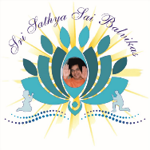 Om Sri Sairam

Sri Sathya Sai Seva Organizations
Delhi-NCR

Our most humble Pranams at the Lotus Feet of Bhagawan Baba.
By immense grace of Swami Easwaramma Day celebrations were celebrated in all Districts from May 1st –May 6th of Delhi-NCR with great devotion and love .
Various activities were performed by Balvikas children during this week long celebrations.
All social distancing norms were followed with utmost care.
Active involvement of parents, teachers Balvikas gurus ,Sevadal made the events go on smoothly.
Following districts activities are captured in the report.
- Central
- South East
- South West
- West
- North
- East
- Ghaziabad
- Faridabad
- Noida
- Gurugram

Following are the briefs from various districts:
- Central District :
Mother Easwaramma Day on 06 May 2020 through online meeting app and displayed a splendid show wherein the following activities were performed:-
- Veda chanting
- Offered Pushpanjali to God Ganesha, Goddess Saraswathi and our divine Satguru through dance performance. Prayed for the Mangal (well being of entire universe.
- Offered prayers through Ashtotram to Bhagawan Satya Sai Baba.
- Gave a inspirational talk on life of mother Easwaramma and the qualities of five different mothers.
- Performed Matru Pooja.
- Recited beautiful poems written by the children themselves.
- Rendition of beautiful Bhajans.
- Children shared a story on the efficacy of Namasmarana by narrating the incident from the life of Bhagawan Baba wherein the power and sanctity of Namasmarana has been depicted. Offered Namasmarana at the divine lotus feet with the prayer to continue the Nama Sadhana which the Balvikas Children and gurus have undertaken on themselves on daily basis. Thus making it a habit.
- Rendition of instrumental music.
- Programme concluded with Aarti .

The Balvikas children along with the gurus, parents and the office bearers of Central District attended the programme through the app , appreciated and blessed the children for conducting the event successfully.

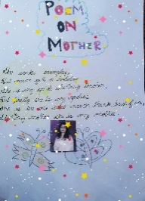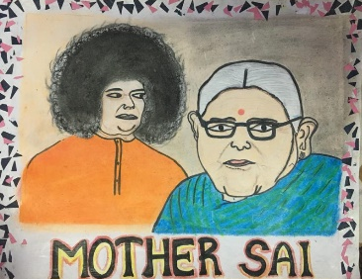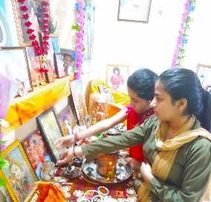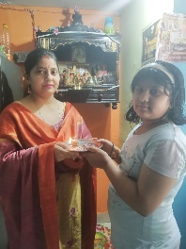

- South West District :
On the eve of Eshwaramma Day, children from rural Balvikas of South West District have offered a bouquet of activities at the lotus feet of our beloved Swami. These were - Matru Pooja, Fancy Dress competition, Essay Competition & Drawing competition. Given the pandemic situation, we could not do a group activity, but with the grace of Swami, we distributed prasad to 130 rural Balvikas children in various Samithis.
We also had a Zoom session with gurus &Balvikas alumni, who shared their divine experiences with Swami and everyone had a good close to the divine day.
Sharing few pictures of the activities conducted on May 6th.
Matri Puja
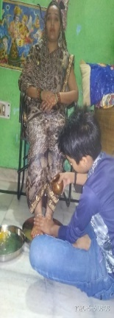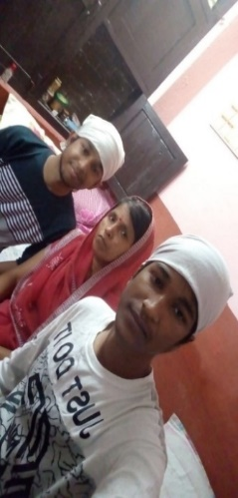
Fancy Dress Competition
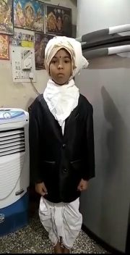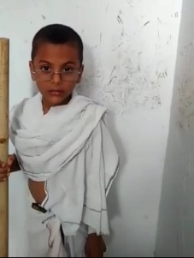
Drawing Competition
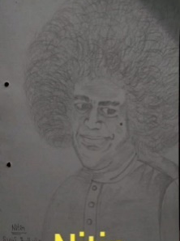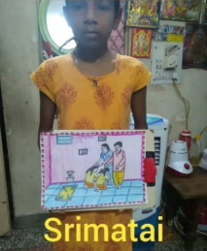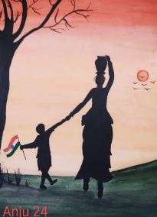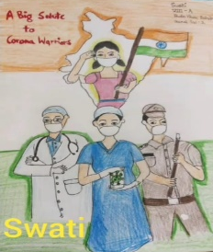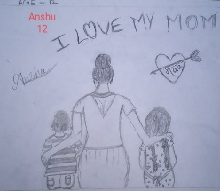
Essay Writing
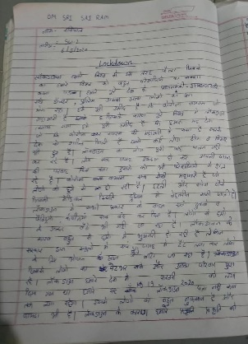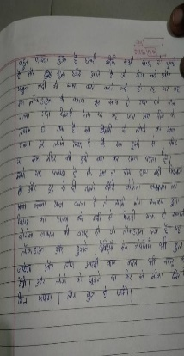
Prasad Distribution
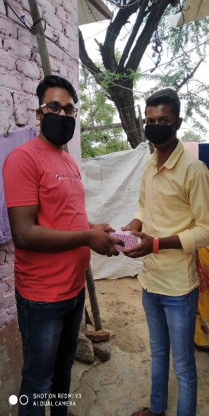
Zoom Meeting
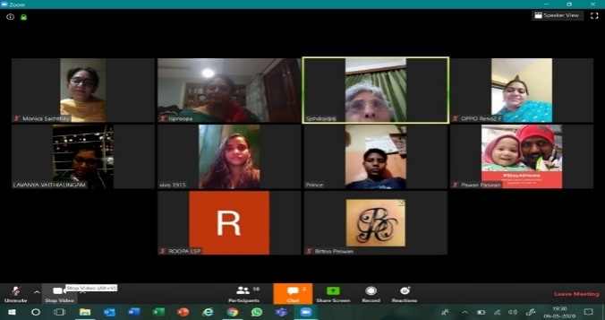

- Ghaziabad
Easwaramma Diwas 6th May 2020 on Distt level
Balvikas students of Ghaziabad district have put up a very beautiful presentation, of which, are the following details:
- Drama: Title Matru Deva Bhava
- Poem Recital: Gratitude towards God
- Bhajans
- Beautiful dance on Sarvadharma prayer.
- Collage making
- Matru Pujan
- Make best out of waste (a student made portable water cooler using cardboard and some motors for his mother)
Due to current pandemic and lockdown induced by it the recordings were done at their respective homes and the final video was compiled together. We thank Swami, for giving us such opportunities and strength to be a part of HIS mission to conduct such a beautiful program at the district level.

4.South East:

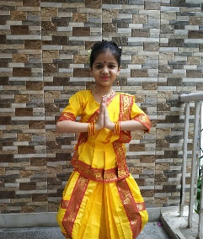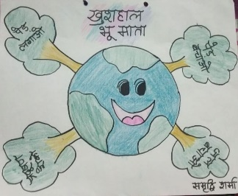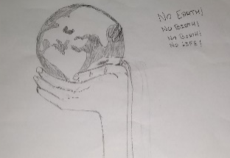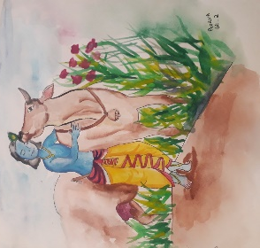
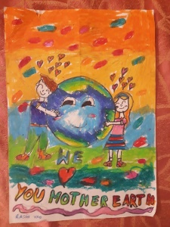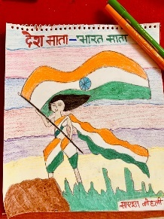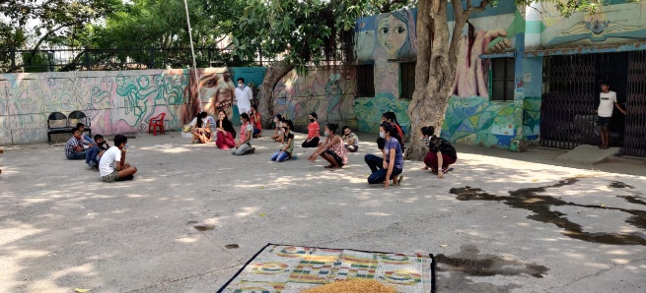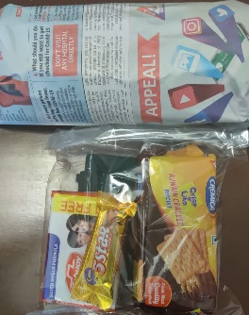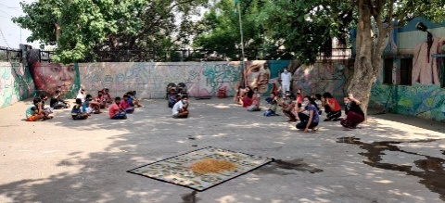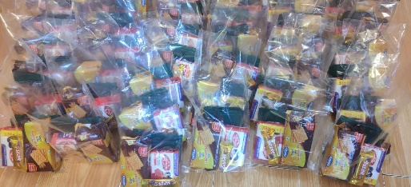
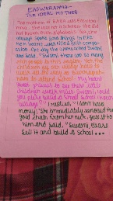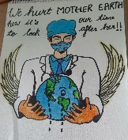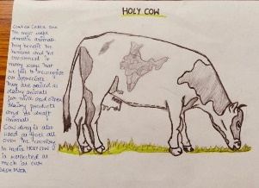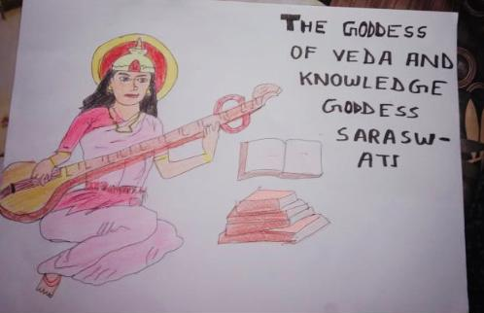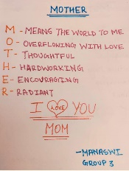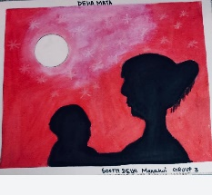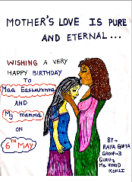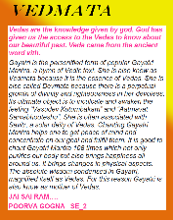
5.Faridabad
Aum Sri Sairam. With the ever loving guidance of Bhaghwan our Balvikas children and Balvikas Alumni enthusiastically participated in the Eswaramma Day 2020 celebrations. The Topic of this year celebration was Gratitude and Love.
During the Lockdown situation children offered their love by various means of communication. The day started with realizing and counting of our blessings through Letter to God and many children happily shared their feeling to their Loving God who is a Friend, Philosopher and everything.
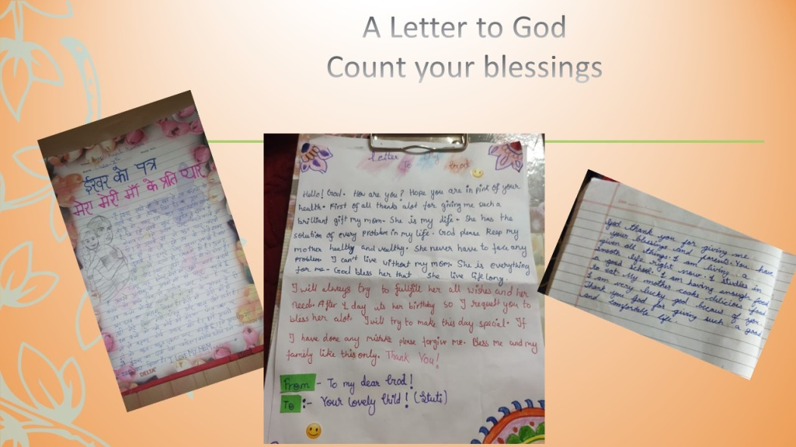

Creating and offering something to the Creator Himself is a great feeling. Children enjoyed doing this simple activity with very easily available items at home and expressed their pure love to their mothers during Matru-Pitru pooja. Some of the glimpses are displayed here.
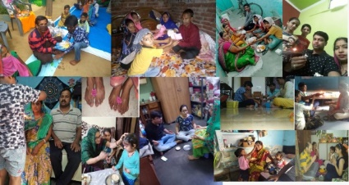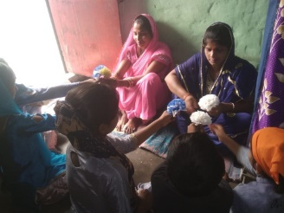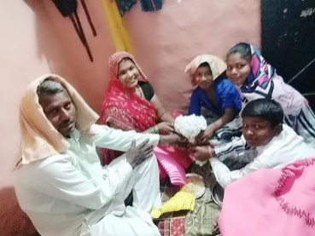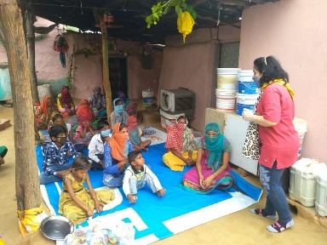
Balvikas children offered their Love through Singing Bhajans and making a drawing on the topic how I am helping my family during this period. This period made everyone realize their potential and has given a chance to enhance their skills
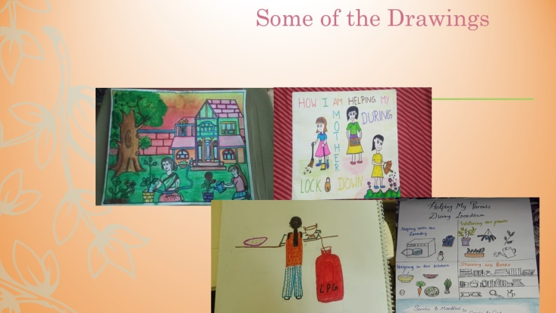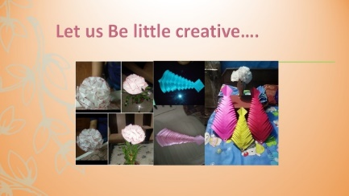
Many of the children participated in family chores and helping their family. We feel Swami has given this time to realize our own self and groom ourselves spiritually.
.
Bhajan offering by Balvikas children Alumni Team of Faridabad- Cherishing their Moments As Swami rightly said Technology is Tricknology but our Alumni Children used this Trick ology to offer love by opening their heart and cherishing the moments spent in Balvikas. Their implicit expressions surely touched everyone’s hearts.

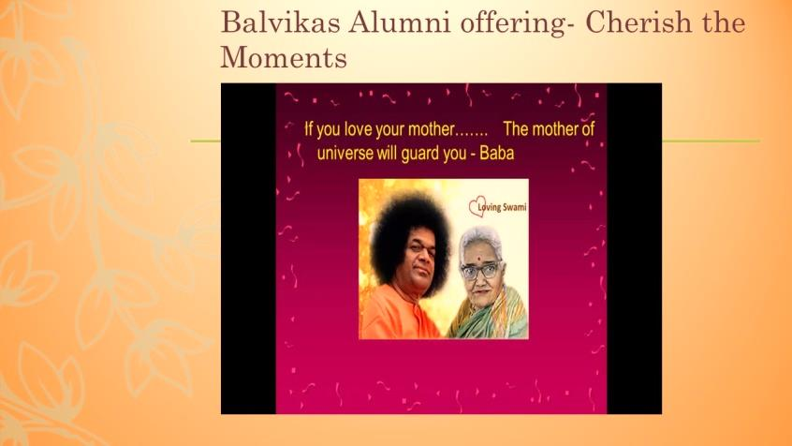

We surrender to Bhagwan for his constant Presense through every activities and his guidance in every programme.
7.North District:
Children, gurus and parents of District North participated with great enthusiasm to celebrate Maa Easwaramma Day on 6th May 2020. They expressed their love and gratitude in various forms.... Veda chanting, shloka recitation, making of greeting cards, poetry and singing of songs dedicated to mothers, making of surprise dish for mothers (cooking without fire), bhajans, display of art and craft. Matru Pooja. Presenting the bouquet of flowers at the lotus feet

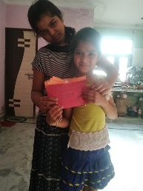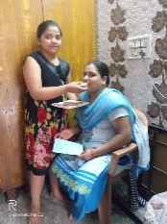
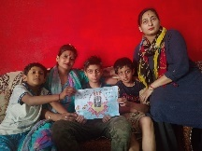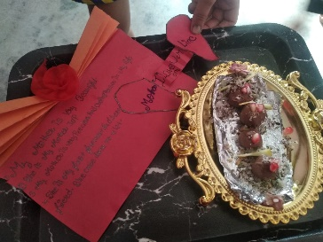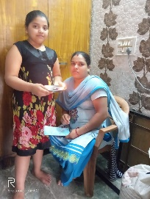

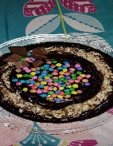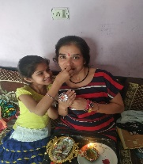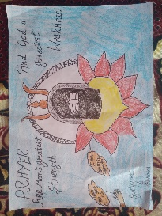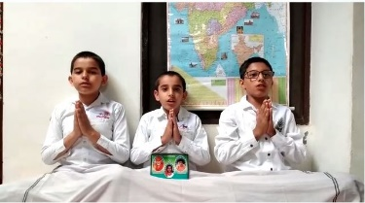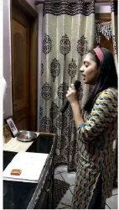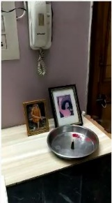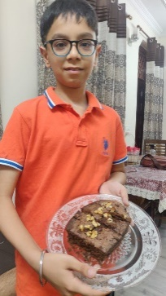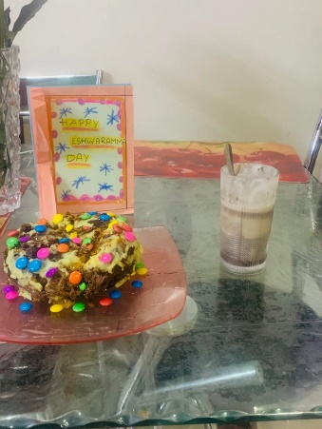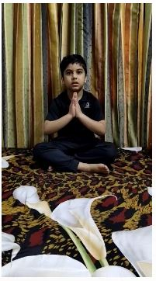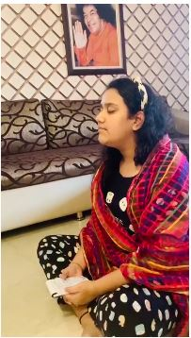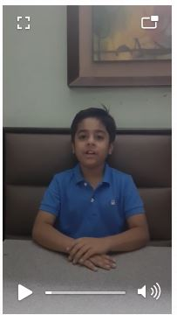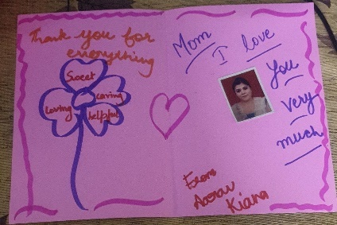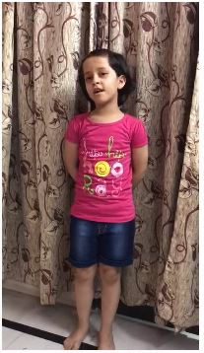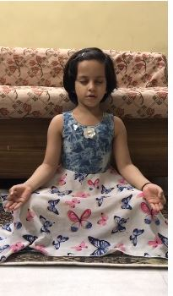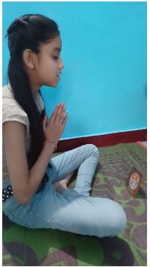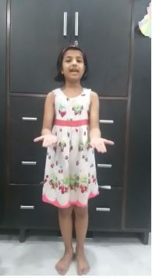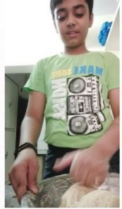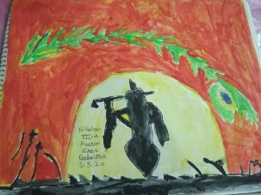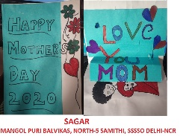
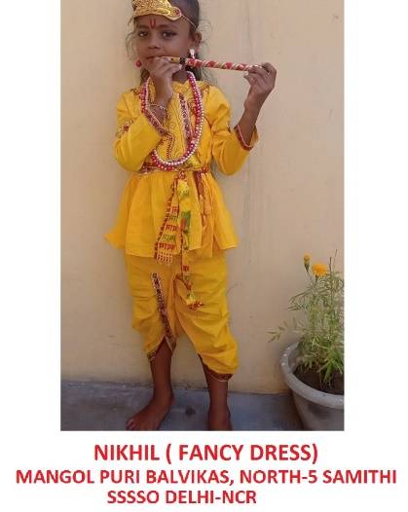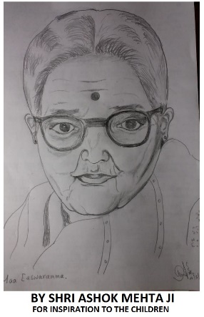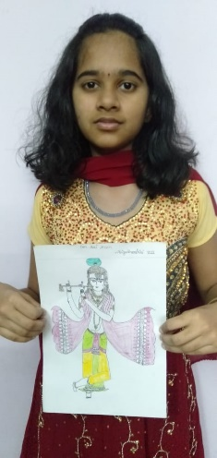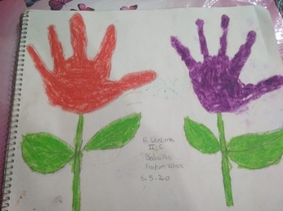

- East District:
Children, gurus and parents of East District participated with great enthusiasm to celebrate Maa Easwaramma Day on 6th May 2020. They expressed their love and gratitude in various forms.... Veda chanting, shloka recitation, making of greeting cards, poetry and singing of songs dedicated to mothers, making of surprise dish for mothers (cooking without fire), and bhajans, display of art and craft and Matru Pooja. Presenting the bouquet of flowers at the lotus feet🙏
- 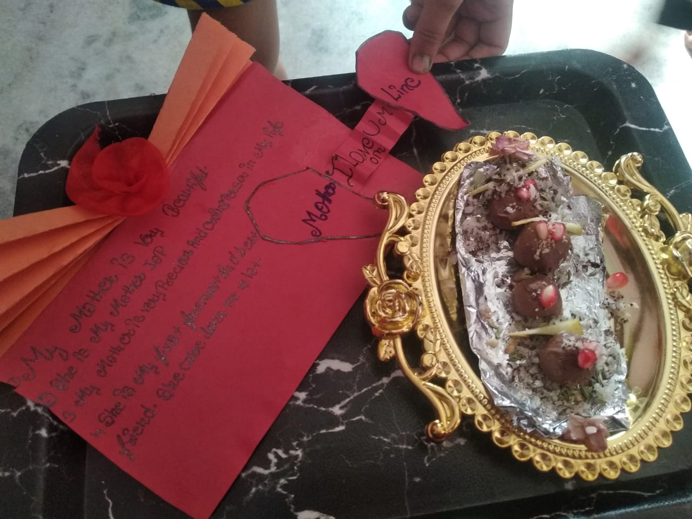
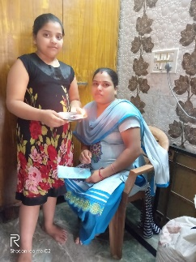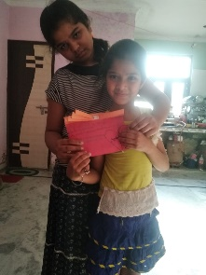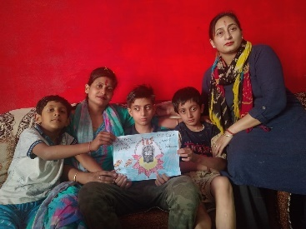

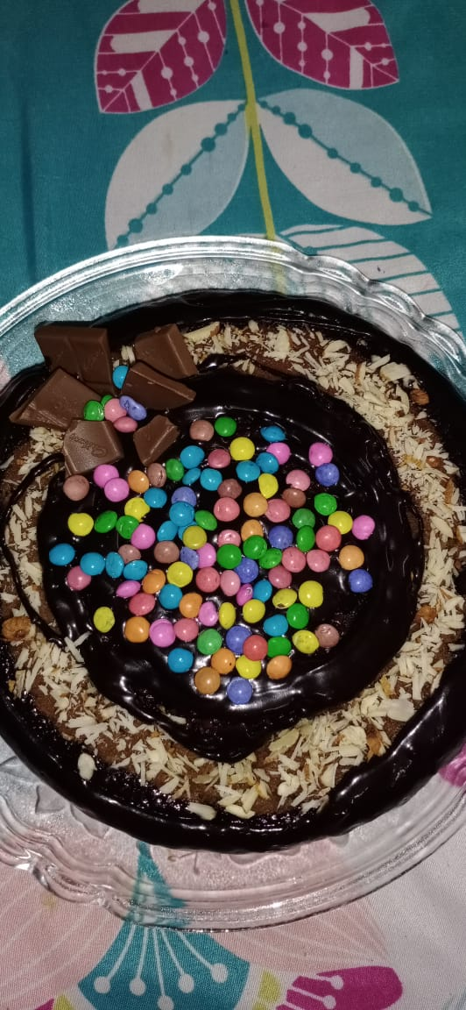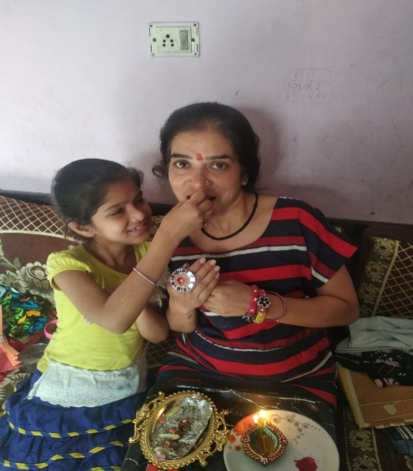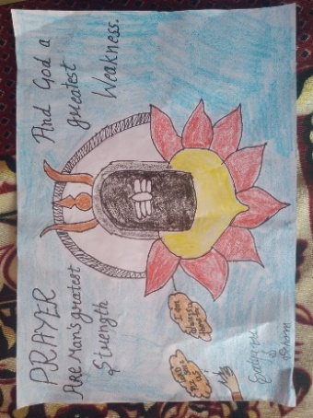

8.West Distrct :
With the immense grace of Bhagawan, West District celebrated the Easwaramma Day during 1-6 May 2020. Various events like:
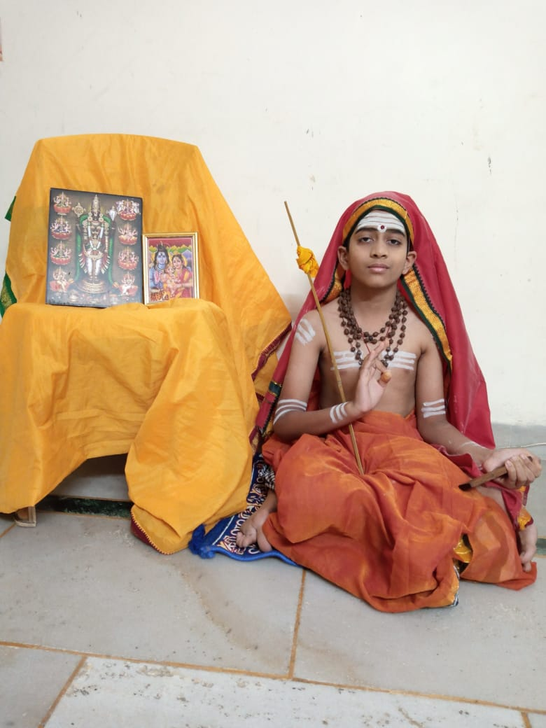
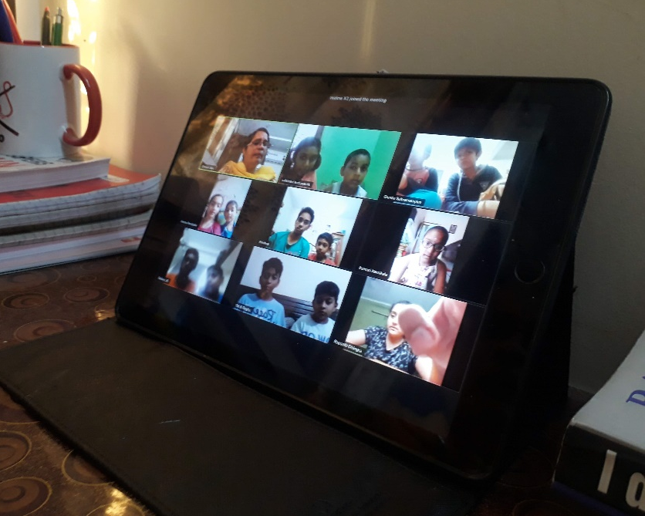
- Bhajan Singing
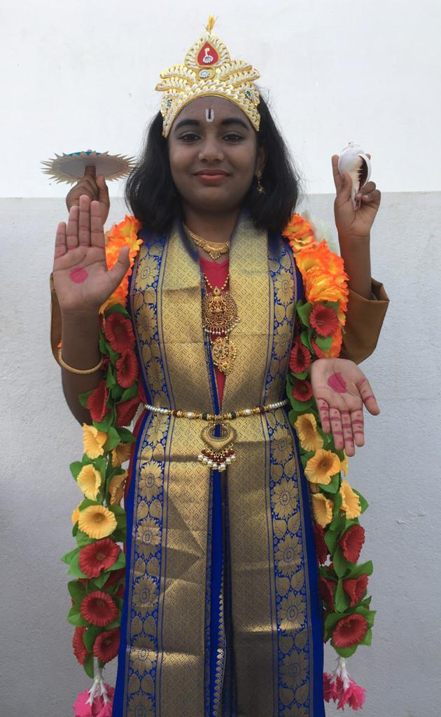
- Fancy Dress

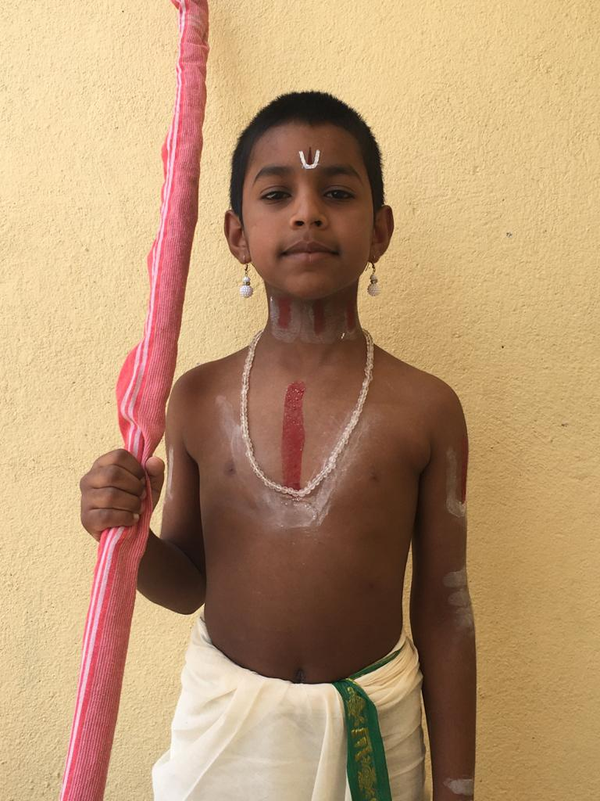

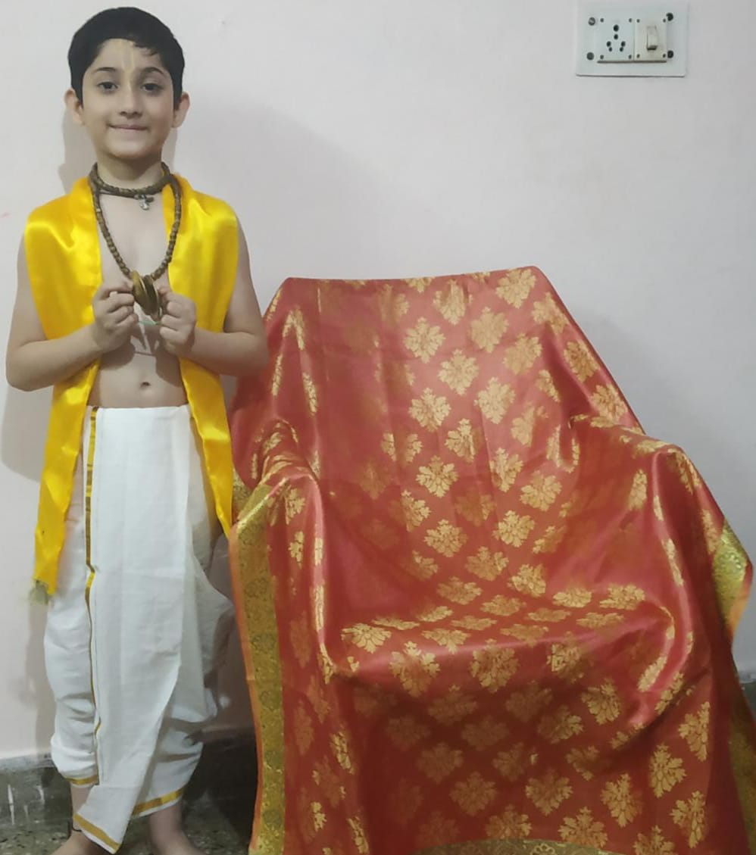
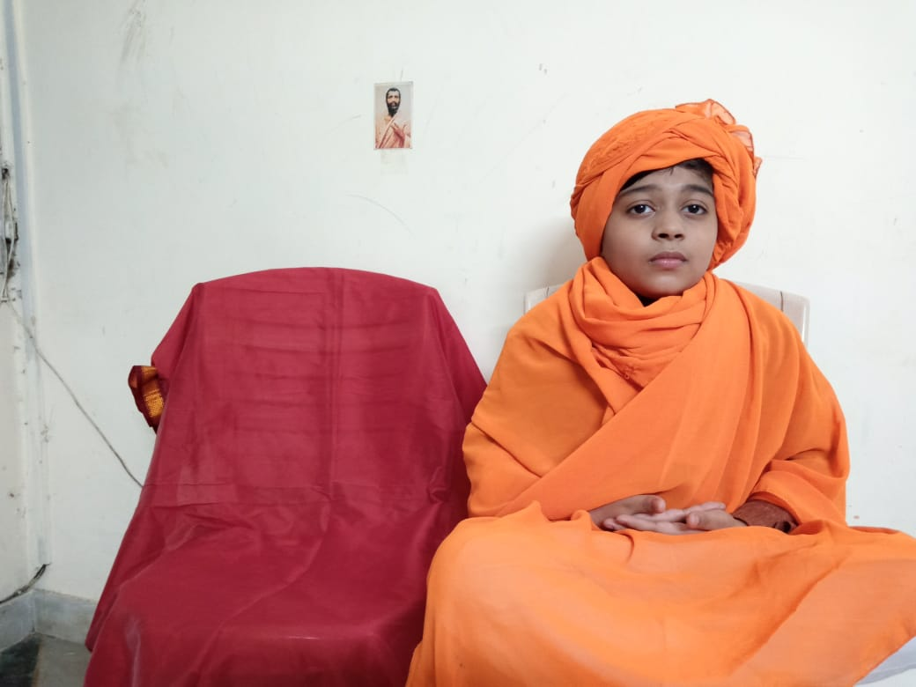

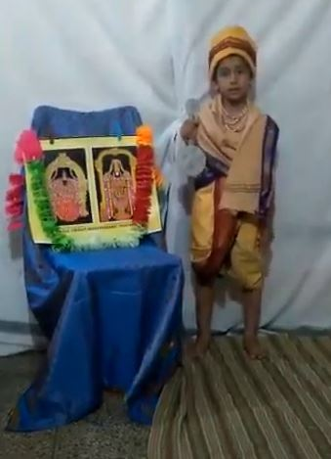
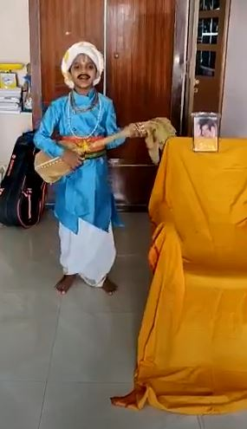

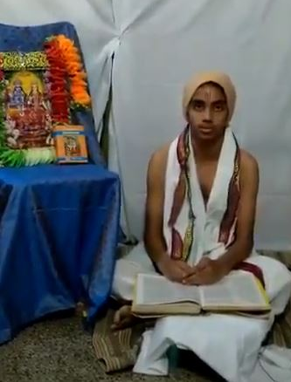

- Cultural Programme - https://drive.google.com/file/d/15z5autG-v2wAu4LtxpSSIt8JqMCdS_Fa/view?usp=sharing

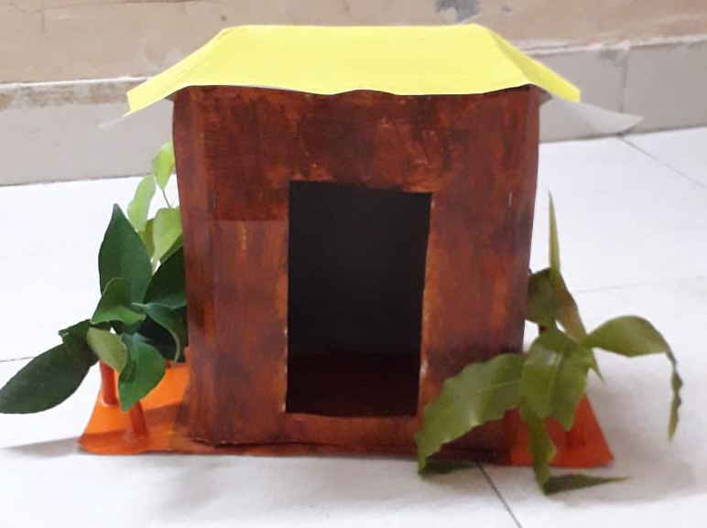
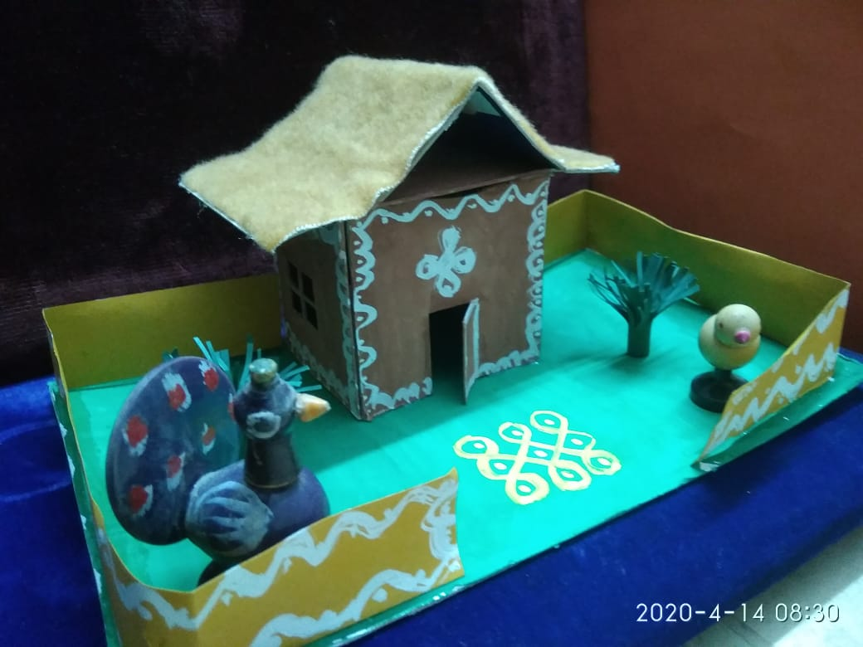
- Art and Craft -

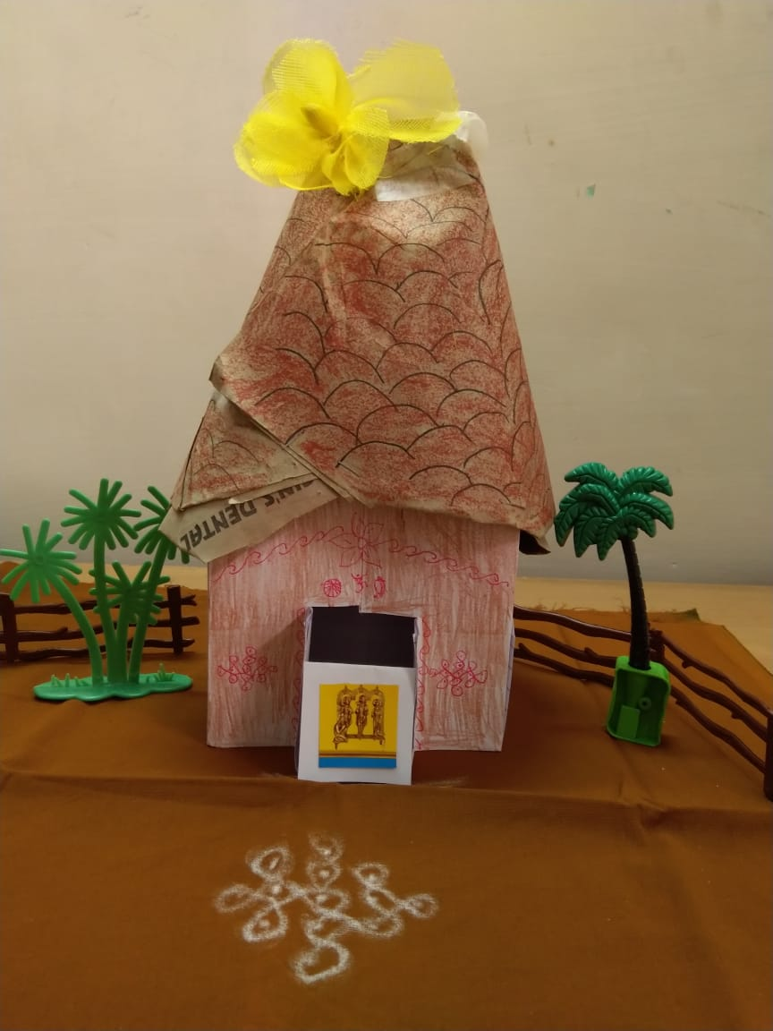
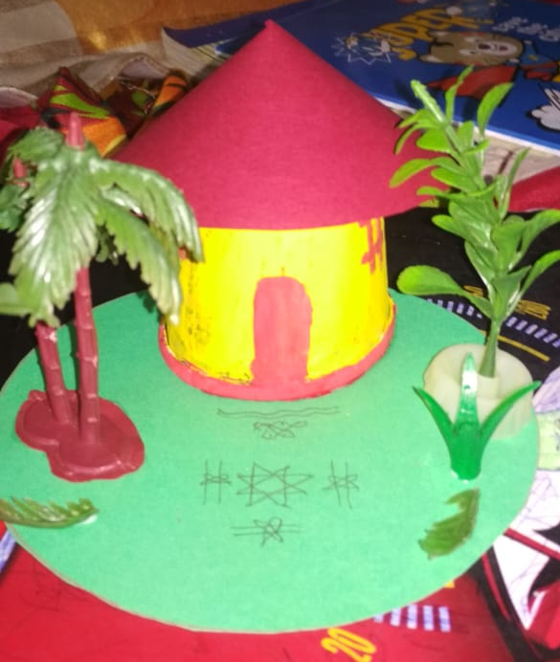

NOTE: Regarding the distribution of fruits, the DP did not receive any information from the Centre.

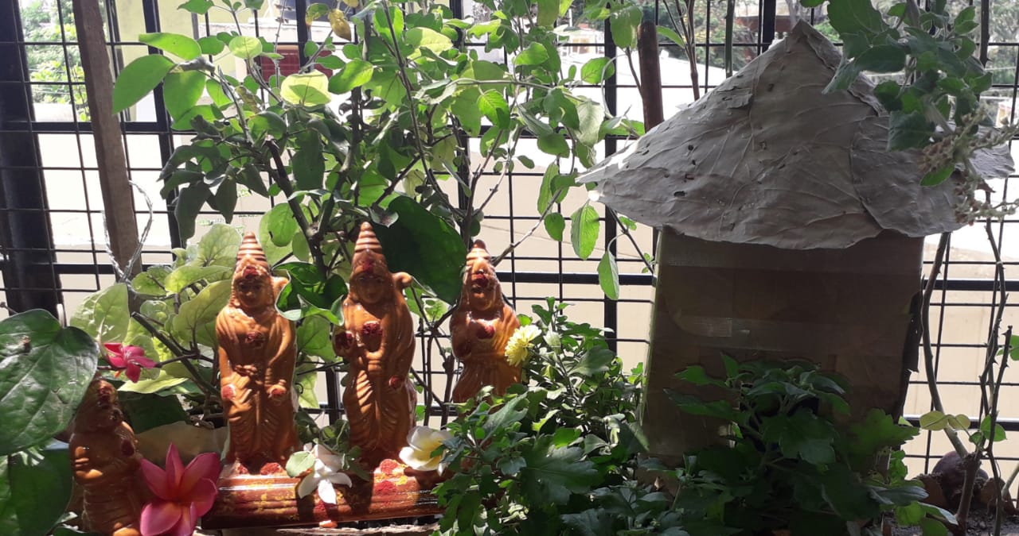

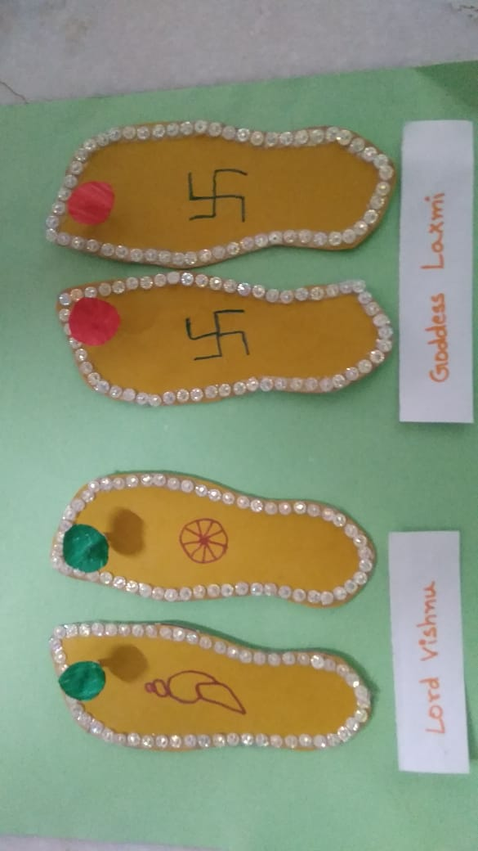

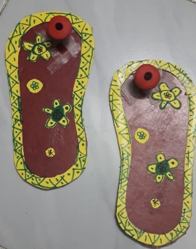

- 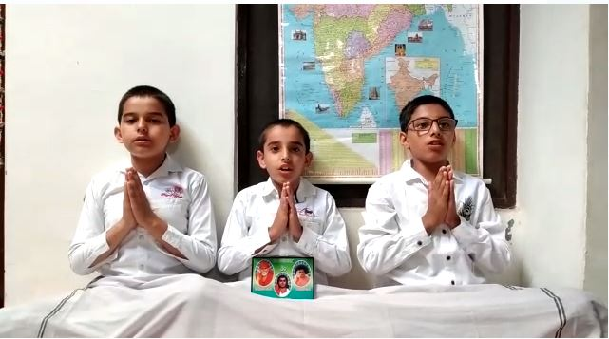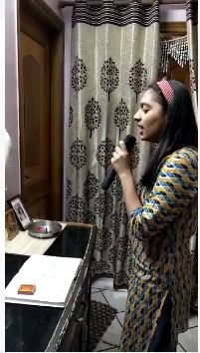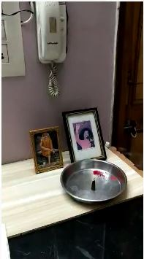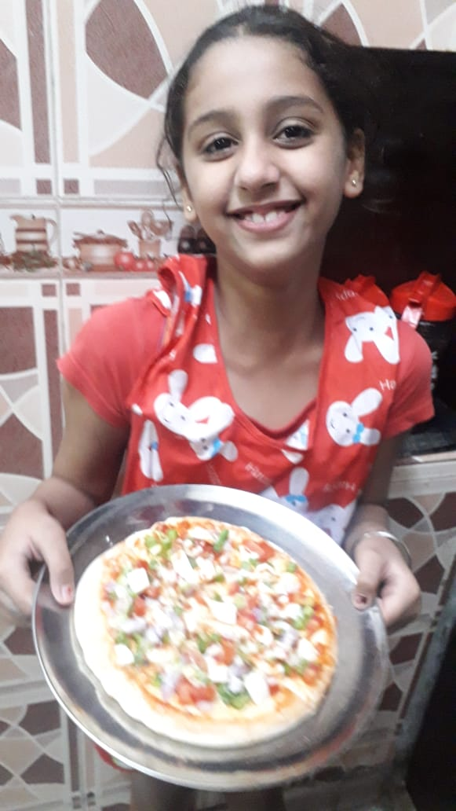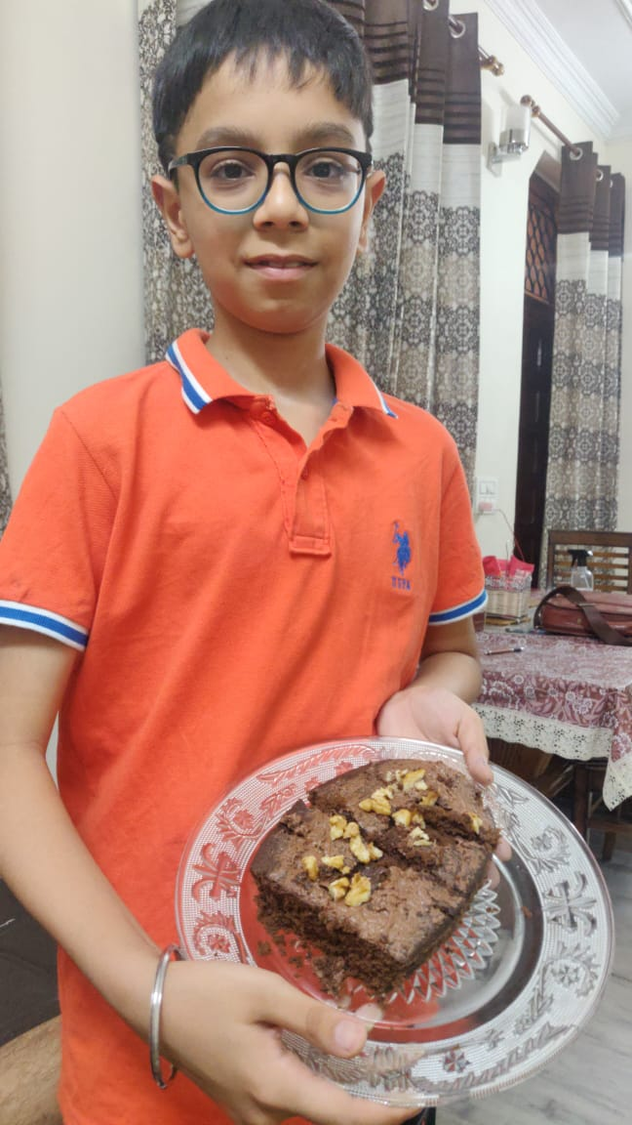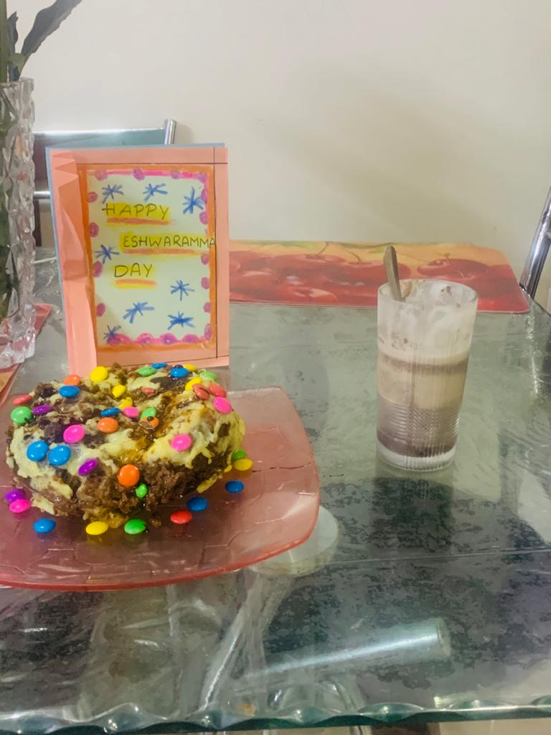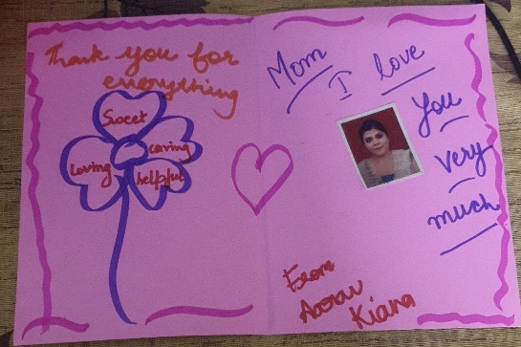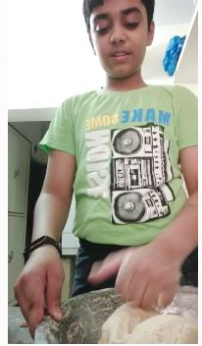

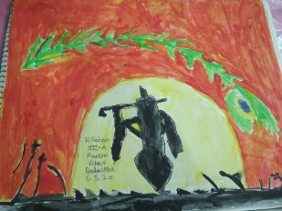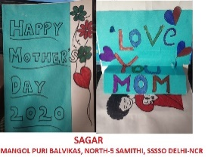
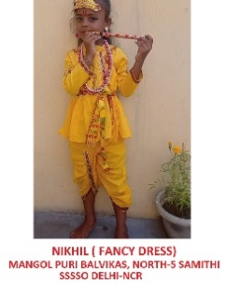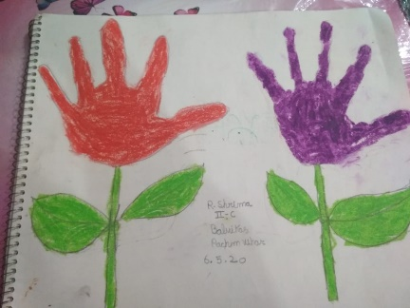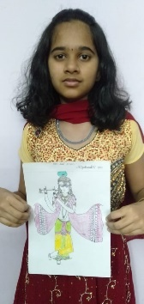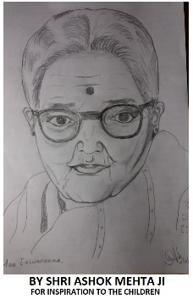

8. East District:
With the immense grace of Bhagawan, West District celebrated the Easwaramma Day during 1-6 May 2020. Various events like:
Bhajan Singing

Cultural Programme - https://drive.google.com/file/d/15z5autG-v2wAu4LtxpSSIt8JqMCdS_Fa/view?usp=sharing
Art & Crafts

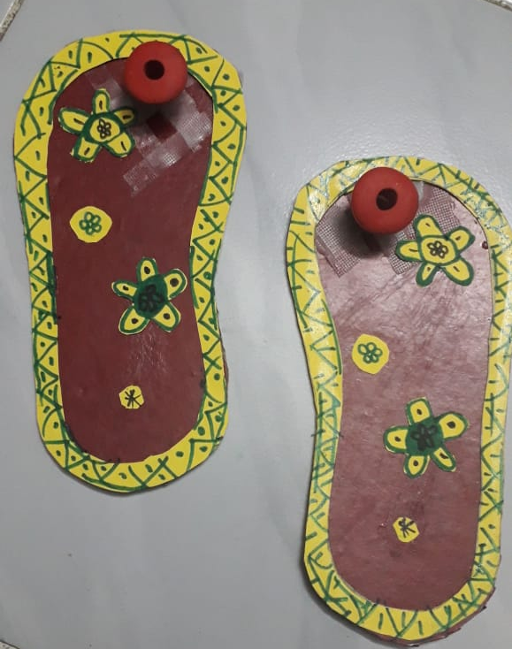

9..Noida District:

With blessings of our Divine Master, the Balvikas students of Gautam Budh Nagar District- Delhi NCR celebrated Eshwaramma Day and displayed a splendid show wherein they performed Veda chanting, offered bhajans, extended prayers through Vedam, recited poems, played instrumental music, gave talks on mother , presented their art works and also few of them lovingly cooked something for their mother. Some glimpses of the same are given below.
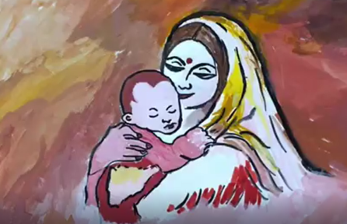
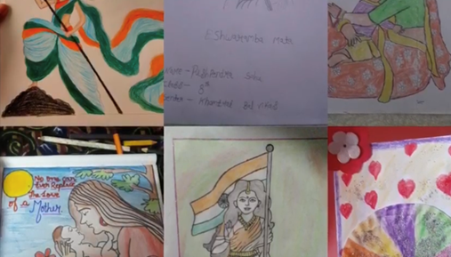

10. Gurgaon District:
By immense grace of Bhagawan Baba the Balvikas students of Gurgaon District- Delhi NCR took part in Eshwaramma Day celebrations with great devotion. Various activities were performed. Veda chanting, offered Bhajans, did Matru Puja recited poems, played instrumental music, Planted trees, presented their art works and gave a beautiful programme on Ashtapushpam and Pancha Mathas. For rural Balvikas children fruits were distributed taking utmost care and social distancing.
Some glimpses of the same: Bhajan Singing:
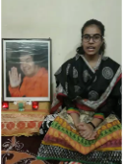

Cultural programme:

AsthtaPushpam

Frfr

Fruits Distribution

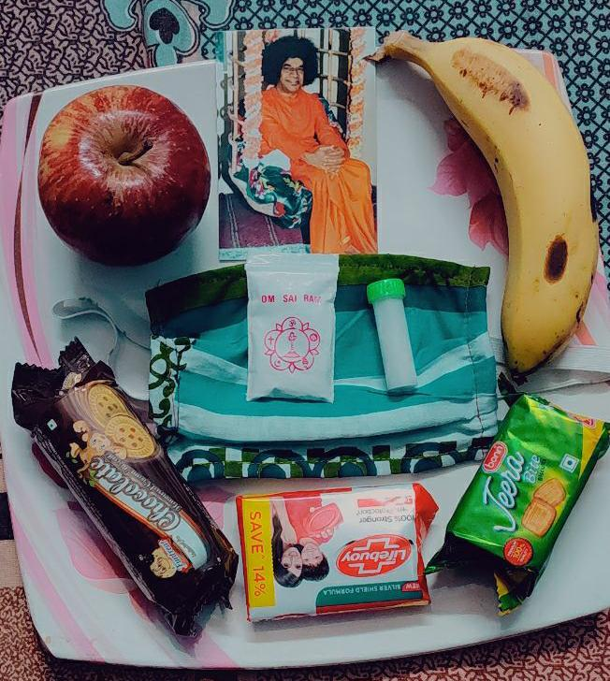
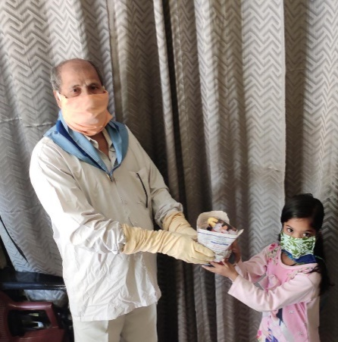

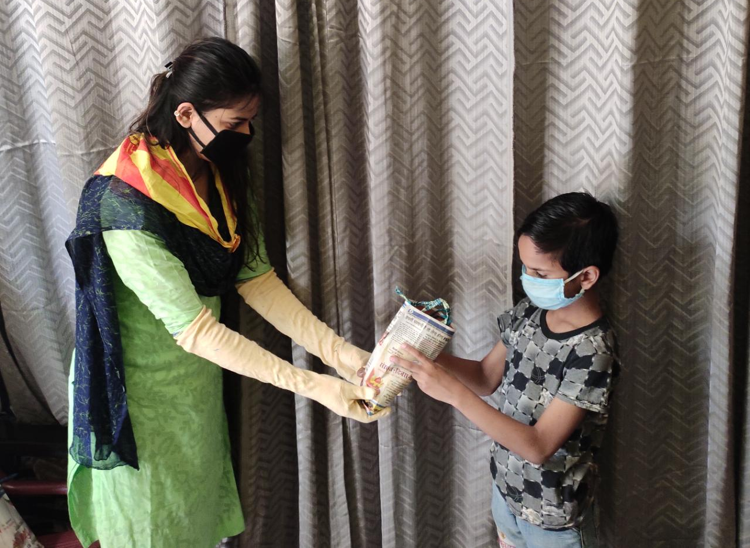

Drawings
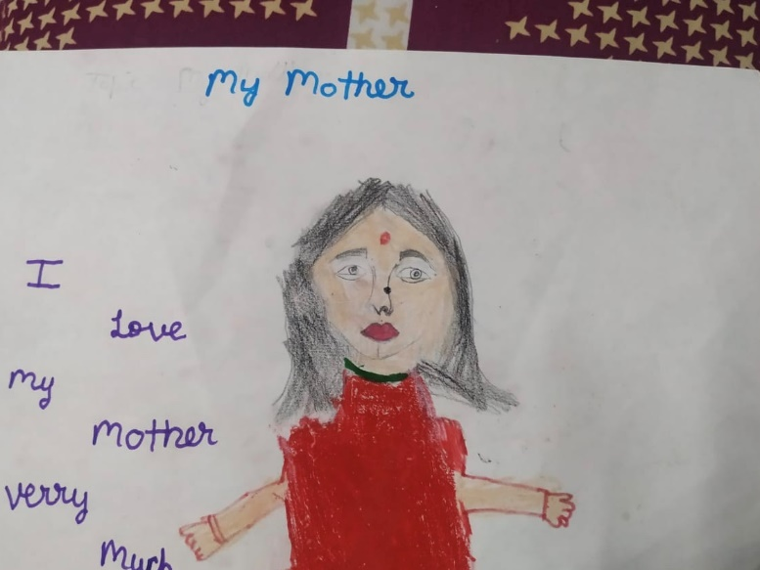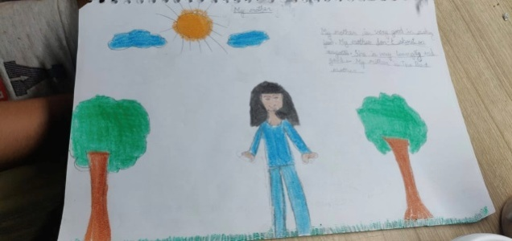
Virtual Programme:

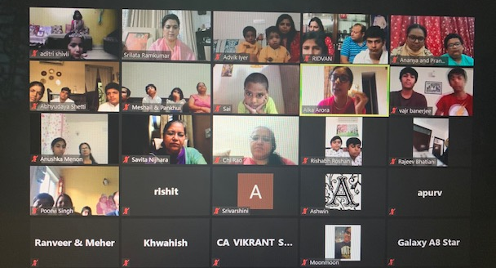
Alumni Talk

All the districts of Delhi NCR celebrated Easwaramma Day 2020 with devotion and discipline.

We pray Swami to keep us in HIS service always.

Sairam

